**BPS Elementary Art Curriculum**

Antarctica

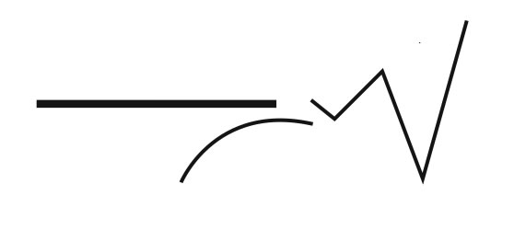

Content Connections:

Continent Studies – Antarctica

Animal Groups

Art Standards: 4.1.5

Alignment Standards:

Materials:

Water color paper, crayons, colored Sharpies, water color paints and brushes, painter’s tape, How to draw penguins sheet,

|  |  |
| --- | --- |
| **Art Elements** | **Art Principles** |
| _x_Line | _x_Pattern |
| _x_Shape/Form | __Rhythm/movement |
| _x_Color | __Proportion/Scale |
| __Value | _x_Balance |
| _x_Texture | __Unity |
| __Space/Perspective | _x_Emphasis |

Grade: 2nd

Time: 1 hour

Preparation

1. Gather supplies and books with penguin pictures.
2. Tape paper to desks with painter’s tape to form a border.

Vocabulary: line, shape, gliding, tobogganing, porpoise, blending

I Cans

I can use a blending technique with watercolor paints.

I can use shapes to make a drawing of a penguin.

I can use a variety of media to make art.

Lesson description:

Create a watercolor penguin and background in addition to crayons and Sharpie.

Teacher Background Knowledge

1. Penguin information
2. See *Antarctic Antics* on Discovery Education.

Lesson

1. Show books and pictures. Discuss verbs connected with penguins.
2. Feather light pencil sketching of penguins and background.
3. Sharpie or crayon selected parts.
4. Watercolor the rest so that there is no white left.
5. Sharpie the outlines of the shapes.
6. Peel the painter’s tape. A border of unpainted white will remain.
7. Title the artwork. Sign the work.

Name___________________Lesson______________________

*Assessment*

|  |  |  |  |
| --- | --- | --- | --- |
| **Thumbs Down** | **Don’t Know** | **Thumbs Up** | **Assessment Question** |
|  |  |  | Did you use your personal best during this lesson? |
|  |  |  | Did you actively listen and follow directions? |
|  |  |  | Did you use your creativity? (is it original?) |
|  |  |  | Did you complete your project? |
|  |  |  | Did you incorporate the art media? |
|  |  |  | Does the artwork show the elements and/or principles discussed? |
|  |  |  |  |
|  |  |  |  |
|  |  |  |  |

Source