BPS Elementary Art Curriculum

Butterflies and Bugs
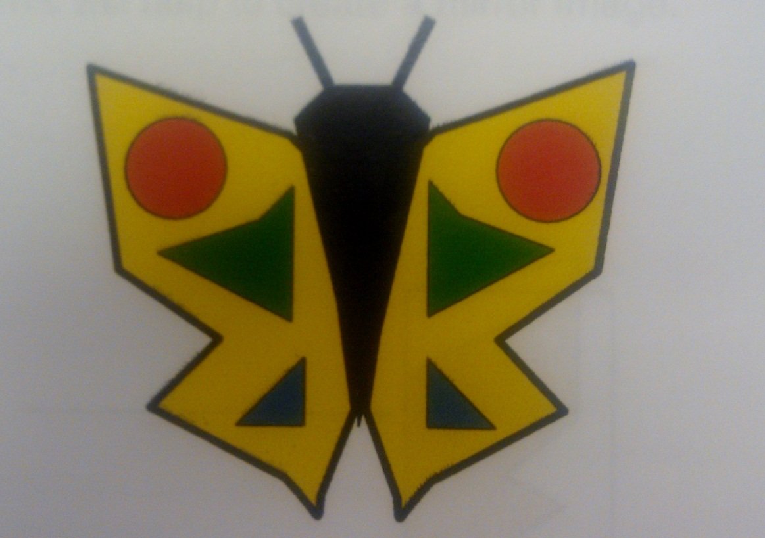
Content Connections:
Science and Math:
Symmetry
THEMES: Nature
Art Standards: 4.1.1, 4.1.2, 4.1.3, 4.1.4, 4.1.5, 4.1.6, 4.2.1, 4.2.2, 4.2.3, 4.3.1, 4.5.1, 4.5.2, 4.6.2
Alignment Standards: ND Science Standards
2.5.3
Materials:
construction paper 9x12” many colors
smaller pieces many colors
6x9” black
glue - scissors

Art Elements | Art Principles
_x Line | __Pattern
_x_Shape/Form | __Rhythm/movement
_x_Color | __Proportion/Scale
__Value | _x_Balance
__Texture | __Unity
__Space/Perspective | __Emphasis

Grade: 2nd
Time: One Sessions
Preparation:
1. Select many colors of 9x12” construction paper. Cut black construction paper on 6x9”. Review lesson before teaching and make sample if needed to understand process and potential problems.
Vocabulary:
Symmetry, Shapes, Lines

I Cans/ Objectives:
1. I can study symmetry in nature by observing butterflies and bugs.
2. I can explain what symmetry means.
3. I can cut out a symmetrically shaped butterfly or bug.
4. I can cut duplicate shapes and add them on the butterfly or bug in a symmetrical manner.
Lesson :
- Introduce the idea of symmetry. Symmetry occurs in nature in many things. Have students name some things that are the same on both sides. Eventually land on butterflies and bugs as excellent examples.
- Look carefully at the butterflies on the teaching board (internet). Point out the shapes in each butterfly. Notice the shapes on each wing are the same. We call this a mirror image. It is symmetrical.
- Select a piece of 9x12” paper and fold the paper in half the short way. This will help to create a mirror image.
- Cut a design for the wings but do NOT cut along the fold.
- Open the shape.
- Fold a piece of black in half and cut a butterfly body. Glue the body onto the butterfly and make two antennae for it.
- Using smaller pieces of paper fold and cut shapes for wings… getting 2! Add shapes to the wings symmetrically. Have student lay and look before gluing. Remember: whatever you do on one side, do on the other side also.
- Do the same for bugs as well.
- Bugs have three parts: the head, the abdomen and the thorax.
- They have six legs that come out of the thorax.
- Bugs also have two antennae to feel the world.
- After adding antennae and legs, add symmetrical patterns, and designs.
Teacher Background Knowledge:
Knowledge of symmetry, shapes, and lines
Lesson description: Students look at butterflies and bugs in nature to learn about symmetry. Each individual student will make a butterfly or bug using symmetry.
Name___________________Lesson______________________
Assessment
Thumbs Down | Don’t Know | Thumbs Up | Assessment Question
 |  |  | Did you use your personal best during this lesson?
 |  |  | Did you actively listen and follow directions?
 |  |  | Did you use your creativity? (is it original?)
 |  |  | Did you complete your project?
 |  |  | Did you incorporate the art media?
 |  |  | Does the artwork show the elements and/or principles discussed?
 |  |  | Can you tell me what symmetry looks like?

