BPS Elementary Art Curriculum

Dinosaur Collage
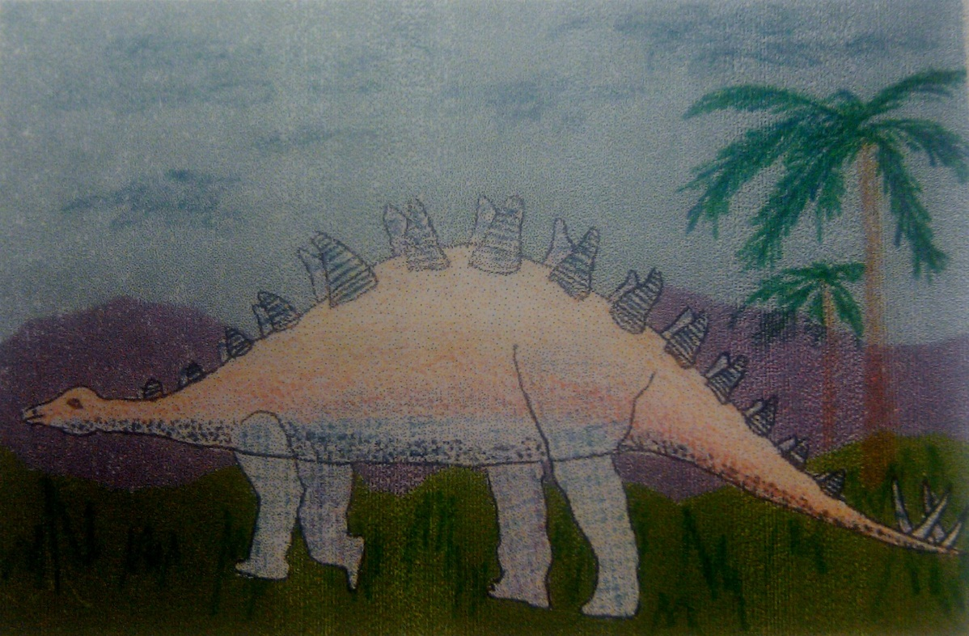

Art Elements | Art Principles
_x Line | __Pattern
_x_Shape/Form | __Rhythm/movement
_x_Color | __Proportion/Scale
__Value | __Balance
_x_Texture | __Unity
_x_Space/Perspective | __Emphasis

Materials:
Drawing Paper 12 x 18”
Construction Paper several colors – 6x18”
Blue Construction Paper – 12x18”
Pencil, black marker (sharpie)
Oil Pastels - Crayons
Glue - Scissors
Art Standards: 4.1.1, 4.1.2, 4.1.3, 4.1.4, 4.1.5, 4.1.6, 4.4.1, 4.5.1, 4.5.2
Alignment Standards: ND Science Standards
2.5.3
Content Connections:
Earth Science
Themes:
Dinosaurs and Fossils
Grade: 2nd
Time: Two Sessions
Preparation:
1. Cut several colors of the construction paper to 6x18” lengths.
2. Set out oil pastels, crayons, glue, and scissors as needed for the student to pick up.
3. Consider breaking up this lesson into two days.
Day 1: Studies of dinosaurs and fossils bring you right into these lessons. Show and discuss dinosaur visuals so students may choose and draw a dinosaur.
Day 2: Prepare a background paper for the dinosaur collage. Students tear land layers and use oil pastels for any drawing in the sky and trees on the land.
Vocabulary: Contour line, texture, foreground, middle ground, background, paleontologist, fossil

I Cans/ Objectives:
1. I can make contour line drawings of a dinosaur.
2. I can use implied texture on a dinosaur with oil pastel rubbing technique.
3. I can tear paper for foreground and middle ground.
5. I can use art and dinosaur vocabulary as I discuss my collage.
Lesson: Today we will make a collage of a dinosaur and where it lived long ago. We will think about their shapes and the texture on their bodies. Hand out the white 12 x 18” paper and a pencil.
1. Talk about drawing the dinosaur.
Dinosaurs should not look like photo copies. Their drawings should show the special way that the students see the dinosaur.
2. Draw the dinosaur with a contour line.
(Contour line is drawing the outline shape of the dinosaur.) Then outline the body with a black marker or sharpie.
3. Rub the texture on the dinosaur body with a crayon or oil pastel.
Talk about the skin of a dinosaur and how it might feel lumpy and bumpy.
4. Carefully cut out the dinosaur.
Cut around the dinosaur leaving on the black maker outline.
5. Prepare background paper for the dinosaur. Choose two 6”x18” colored papers, one for the foreground and one for the background. Tear down the middle of each (keep the tearing under control) to create a jagged edge.
6. Place the middle ground paper on top of the background paper. Take your foreground paper and place on top of the middle ground paper. Make sure the foreground paper covers the bottom of the middle ground paper.
7. Glue only the bottom torn paper first (foreground). Along the straight edge of the blue background paper, glue the second paper (middle ground) along the bottom straight edge. Slip it under the torn part of the first land. Be careful you slip it low enough so the straight edge is hidden.
8. Use oil pastel to fill detail in the foreground such as grass or large trees. Background items would be smaller.
9. Glue the dinosaur so the feet are touching the foreground paper. If you have a small dinosaur, you might glue it in the background.
10. Sign your name in the lower right hand corner.
Teacher Background Knowledge:
Being familiar with different types of dinosaurs, climate of dinosaurs, use of oil pastels, use of collage techniques.
Lesson description: Students look at many dinosaur species and then concentrate on their shapes as they draw a dinosaur. The texture on the dinosaur’s body is rubbed using the side of the oil pastel or crayon on their dinosaur image. They create the background, middle ground, and foreground with construction paper to depict the landscape. Feel free to add any other environmental objects such as trees into your collage with your oil pastels or crayons.
Name___________________Lesson______________________
Assessment
Thumbs Down | Don’t Know | Thumbs Up | Assessment Question
 |  |  | Did you use your personal best during this lesson?
 |  |  | Did you actively listen and follow directions?
 |  |  | Did you use your creativity? (is it original?)
 |  |  | Did you complete your project?
 |  |  | Did you incorporate the art media?
 |  |  | Does the artwork show the elements and/or principles discussed?

