Roosevelt Elementary SALT Integrated Lesson Plan

Content Connections:
Science and Language Arts

Medium Used – Watercolor and Permanent Markers

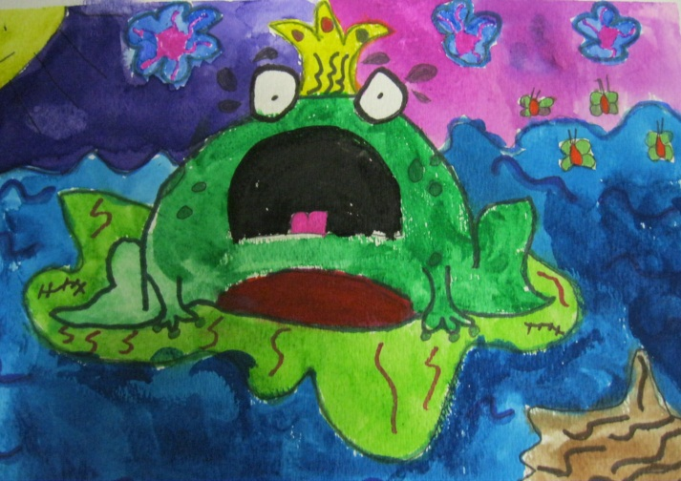
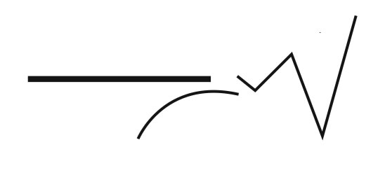

Art Elements | Art Principles
__Line | __Pattern
_X Shape/Form | __Rhythm/movement
_X_Color | _X_Proportion/Scale
__Value | _X_Balance
__Texture | __Unity
_X_Space/Perspective | _X_Emphasis

Alignment Standards:
ART-2.1.2 Know the different techniques used to create visual art. Use different mediums to create artwork.
ART-2.3.1 Understand how a variety of subjects, themes, symbols, and ideas are incorporated in a selection of works of art.
21st Century Skills
☐ Global Awareness
☒ Creativity and Innovation
☐ Critical Thinking and Problem
Solving

☐ Communication and Collaboration

☐ ICT Literacy

☐ Flexibility and Adaptability
☒ Initiative and Self-Direction
☐ Productivity and Accountability

☐ Understand the Art World

Artists Habits of Mind
☒ Engage & Persist
☐ Envision
☒ Express
☒ Observe
☐ Reflect
☒ Stretch & Explore
☐ Understand the Art World

Grade: 2
Time: Two to three hours.
Materials:
* Book - Frogs
By Gail Gibbons
* Video Clip on Discovery Ed. (Frogs and
Toads)
* Pictures of Cartoon Frog
* Watercolors
* Watercolor Paper
* Sharpie Markers
* Paint Brushes (flat, detail, brushes with a
variety of widths)
* Painter’s Tape

Vocabulary:

habitat, amphibian, lifecycle,
proportion, composition, environment
Preparation:
Create a PowerPoint of cartoon frog drawings. Also run the pictures off so the students have these pictures as a resource when drawing their frogs.

I Cans
RL.2.7 I can use illustration and text to tell about characters, setting, and plot.
ELA 2.2.7I can retell a story in order with details W.2.2 I can write my thoughts and ideas about a book or topic I have read.
SCI-2.2.2 I can explain my observations by telling, drawing, and writing.
SCI 3.4.2 – Gr. 2 I can create the life cycles of plants and animals.

Teacher Background Knowledge
Before the lesson review the lifecycles of insects, chickens, and plants such as pumpkins.
Review different habitats of animals. Discuss why the pond or river would be the habitat for a frog. Compare and contrast the habitat of a frog and of a toad.
Lesson description:
Students will use Sharpies to outline their frog. They will then use watercolors to create a pond scene with a cartoon frog. They will paint in a horizon line and their frog, pond and sky.

Lesson Inform the students that they will be creating a composition that illustrates the habitat of a frog.
Anticipatory Set- Explain that all living things have life cycles, or a series of events that happen in a certain order. Ask the students what they know about animal life cycles. Ask where they could observe the lifecycle of a frog.
Complete a KWL chart on Frogs.
Watch the video clip Frogs and Toads from Discovery Education..
Literature Connection Read Frog by Gail Gibbons, This story is in the Scott Foresman Grade 2 Reading Book. (Unit 4) and discuss. Fill in facts they learned from the story on the KWL chart.
Art Lesson – Together review frog cartoon pictures taken from images on the internet. Together look for basic shapes and practice drawing a few frogs together.
Then have the students select a frog drawing to observe and draw. After the students are ready, they will use a pencil to draw a frog on their watercolor paper.
Next, the students will use Sharpie markers to outline their frog and add details to illustrate the habitat of where a frog lives. (lily pad, cat tails, log, grass, water, horizon line, etc.)
Then the students will use watercolor to paint their picture. Before the students start painting, tape their watercolor paper to their desk using painters tape around the entire border. This creates a nice framed look when the tape is removed after the painting is finished.
Reflection – “One thing I am proud of is ………”
Or
“A new technique I uses was ……..”
Writing Connection – Students will create a story about their frog in their painting. Students will give the character and setting in the story. What is the problem in the story? Was the problem solved?

Name___________________Lesson______________________
Assessment
Thumbs Down | Don’t Know | Thumbs Up | Assessment Question
 |  |  | Did you use your personal best during this lesson?
 |  |  | Did you actively listen and follow directions?
 |  |  | Did you use your creativity? (Is it original?)
 |  |  | Did you complete your project?
 |  |  | Did you incorporate the art media?
 |  |  | Does the artwork show the elements and/or principles discussed?
Source

