**BPS Elementary Art Curriculum**

Lines

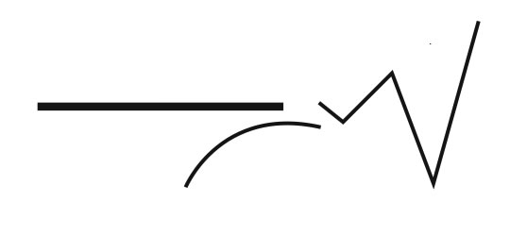

Content Connections:

Math-symmetry

Art Standards: 2.2.1 Know the difference among visual art structures and functions

Alignment Standards:

2.G.1 (Math- Geometry) recognize and draw shapes having specified attributes

Materials:

2 Mitten cut-outs, geometric shape (pattern block cut outs), glue, string, hole puncher

|  |  |
| --- | --- |
| **Art Elements** | **Art Principles** |
| __Line | _x_Pattern |
| _x_Shape/Form | __Rhythm/movement |
| __Color | __Proportion/Scale |
| __Value | _x_Balance |
| __Texture | __Unity |
| _x_Space/Perspective | __Emphasis |

Grade: 2

Time: 60 minutes

Preparation

Cut out or prepare two mittens for each student

Glue

Cut string to attach mittens together

Vocabulary:

Symmetry

I Cans

I can demonstrate symmetry using pattern block shapes.

Lesson description:

Students will create a pattern using geometric shapes and replicate shape on other mitten using symmetry.

Teacher Background Knowledge

* Geometric pattern block shape names
* Symmetry- what it is and how to show students

Lesson

1. Introduce/review symmetry- what it is and how to take pattern block shapes and put them together to create other shapes
2. Have students take a few of each pattern block shapes back to their workplace
3. Have them position the shapes on mitten (encouraging them to create an organic/realistic shape)
4. Glue down shapes if symmetrical
5. Position shapes on other mitten
6. Verify and check if it is symmetrical to the other
7. Glue shapes down
8. Punch out hole on each mitten
9. Thread string through and tie the mittens together

Name___________________Lesson______________________

*Assessment*

|  |  |  |  |
| --- | --- | --- | --- |
| **Thumbs Down** | **Don’t Know** | **Thumbs Up** | **Assessment Question** |
|  |  |  | Did you use your personal best during this lesson? |
|  |  |  | Did you actively listen and follow directions? |
|  |  |  | Did you use your creativity? (is it original?) |
|  |  |  | Did you complete your project? |
|  |  |  | Did you incorporate the art media? |
|  |  |  | Does the artwork show the elements and/or principles discussed? |
|  |  |  |  |
|  |  |  |  |
|  |  |  |  |

Source