BPS Elementary Art Curriculum

Musical Mandalas
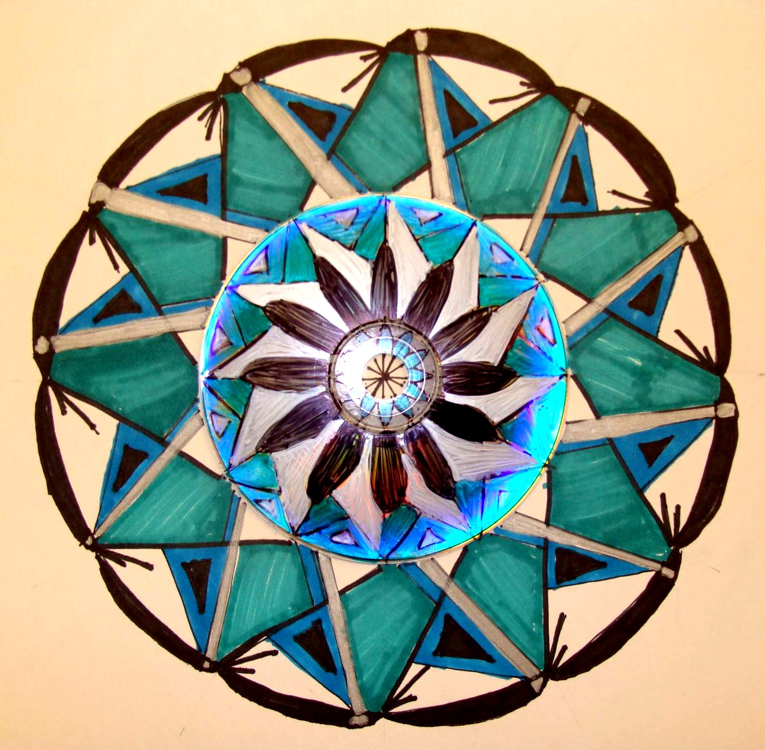
Content Connections:
- Native American cultures
- Geometry and angles

Art Standards:
ART: 4.1.1, 4.1.2, 4.4.1, 4.5.1
MATH: 4.G.1, 4.G.2, 4.MD.5

Materials: images of Mandalas, posterboard or matboard scraps for background (I use the back of Flawboard), ice cream lid and cool whip lid to make circles, old CDs, hot glue gun, pencil, protractor (larger ones work best), ruler, permanent markers- thin black and regular sized colored

Art Elements | Art Principles
_X_Line | _X_Pattern
_X_Shape/Form | __Rhythm/movement
_X_Color | _X_Proportion/Scale
__Value | _X_Balance
_X_Texture | __Unity
_X_Space/Perspective | __Emphasis

Grade: 4th
Time: 2-3 45 minute lessons
Preparation: Discuss Mandalas and show examples. Some great resources are Mandalas of the World, Mandala coloring book, and The Mandala Project online.
Lesson
Step 1: Using pencil, trace around the two lids to make concentric circles- these will be used as guidelines and may be erased later.
Step 2: Hot glue an old CD (blank side up) in the center of the circles, making sure it is centered.
(Notice that there are no circles drawn around the CD in the photo below? I realized much later that it is easier to draw the circles BEFORE gluing on the CD.)
Step 3: Using the fine tip permanent marker, draw a dot in the center of the CD line a ruler up with the door and draw a line across the CD.
Step 4: Find the hole at the bottom of the protractor (shown by the arrow in the 1st photo below) and line it up with the dot in the center of the CD. Make sure that the black lines on the protractor's bottom line up with the black line that has been drawn across the CD (shown in 2nd photo).
Step 5: Keep the protractor in this position and make a mark at every 30 degrees (30, 60, 90, 120, 150, 180). Flip the board around and repeat steps 5 and 6 so that the CD is marked every 30 degrees all the way around, as shown in the 2nd photo below.
Step 6: Using the ruler, connect the marks at 90 degrees so that you now have perpendicular lines (math term!)
Step 7: Continue connecting the marks all the way around to make 12 equal 30 degree sections. *Note: be sure to remind students that when they line up the two marks, they also should line the ruler up with the center dot. I have had students connect the wrong marks! If a mistake occurs, whiteboard cleaner on a Kleenex will remove the permanent marker.
Step 8: For this step, use the fine line permanent black marker. Focusing on one wedge, draw a simple design using lines and shapes. Use the center circles to help space out your design.
Step 9: Repeat this same design in the remaining sections. Remind students that the design uses Radial Symmetry (math term!), meaning that it is the same all the way around. Again, use the circles as a guide to line up the design.
Step 10: Using the ruler and PENCIL, lightly extend the sections out on to the board, past the edges of the previously drawn circles. Remember, these are guidelines and may not be kept, depending upon the design.
Step 11: Using the previously drawn lines as guides, draw another design in one of the sections. I have the students use pencil at this point.
Step 12: Once the design is decided upon, trace the lines to be kept with the fine line permanent marker.
Step 13: Continue the design in the remaining sections, making sure to line everything up as carefully as possible. Use the guidelines to help space things out. (Oops! Someone got antsy about coloring before taking the photo!)
Step 15: Have students choose 5 or 6 colors to use in their design. Explain that dark colors should not be placed next to other dark colors.
*Note: Have the students make a mark using each color on the BACK of their board so that they may match them up during the next week.
*Note: Colors will show up lighter on the CD than on the board.
**To see pictures go to http://mrspicassosartroom.blogspot.com/search/label/math

Vocabulary:
-Media - concentric circles -degree
-Perpendicular lines -symmetry
-mandala -protractor -radial symmetry

I Cans
I can understand the difference between visual art media
I can create visual arts using different techniques
I can use visual arts to show the relationship of history and culture
I can create works of art for many purposes

Teacher Background Knowledge
- Under the preparation section, look at the resources to see examples ideas before presenting to students.

Name___________________Lesson______________________
Assessment
Thumbs Down | Don’t Know | Thumbs Up | Assessment Question
 |  |  | Did you use your personal best during this lesson?
 |  |  | Did you actively listen and follow directions?
 |  |  | Did you use your creativity? (is it original?)
 |  |  | Did you complete your project?
 |  |  | Did you incorporate the art media?
 |  |  | Does the artwork show the elements and/or principles discussed?

