**BPS Elementary Art Curriculum**

Patterns and Names

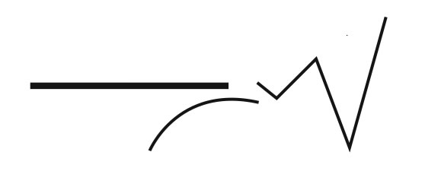

Content Connections:

Art 4.1.2- Know the different techniques used to create visual art.

*Use different mediums to create artwork.

*Compare mediums (crayons, color pencils, chalk, pastels etc.)

Art 4.2.1 Know the differences among visual art structures and functions.

*Identify and use patterns

Math 2.5.2 Algebra, Functions and Patterns

MAT 2.G.2 Partition rectangles into rows and columns of same size squares

Art Standards: 4.1.2, 4.2.1

Alignment Standards:

MAT 2.5.2, 2.G.2 and 2.G.1

Materials: Medium of choice, Construction paper( probably white), rulers if needed and pencil

|  |  |
| --- | --- |
| **Art Elements** | **Art Principles** |
| __Line | _x_Pattern |
| __Shape/Form | __Rhythm/movement |
| _x_Color | __Proportion/Scale |
| __Value | __Balance |
| __Texture | __Unity |
| __Space/Perspective | __Emphasis |

Grade: 2

Time: 1 hour

Preparation:

* Teacher will need to gather materials including various mediums.

Vocabulary: Repeating pattern and growing pattern, mediums,

I Cans

*I can state the rule that describes a given repeating pattern and growing pattern.

Lesson description:

*This student will create repeating /growing patterns using the letters of their name, a shape and various backgrounds.

Teacher Background Knowledge:

*Geometry knowledge of how to teach children how to divide large shapes into small shapes.

*Knowledge of different mediums.

Lesson :

1. Gather materials after choosing a particular medium.
2. Fold 9x13 paper into 16 equal squares. May want to do this as a whole class.
3. Demonstrate filling in the squares with letters of names followed by 1 shape. Each letter needs its own square.
4. Each square will then be filled in with a background.
5. The letters and specific backgrounds will be repeated in the 16 squares.

Name___________________Lesson______________________

*Assessment*

|  |  |  |  |
| --- | --- | --- | --- |
| **Thumbs Down** | **Don’t Know** | **Thumbs Up** | **Assessment Question** |
|  |  |  | Did you use your personal best during this lesson? |
|  |  |  | Did you actively listen and follow directions? |
|  |  |  | Did you use your creativity? (is it original?) |
|  |  |  | Did you complete your project? |
|  |  |  | Did you incorporate the art media? |
|  |  |  | Does the artwork show the elements and/or principles discussed? |
|  |  |  |  |
|  |  |  |  |
|  |  |  |  |

Source