BPS Elementary Art Curriculum

Lines
Content Connections: Science observations

Art Standards: 2.1.2, 2.2.1
- Use symmetry in artwork Recognize and use organic shapes in artwork
- Use different mediums to create artwork

Materials: various fruits, vegetables, pretzel sticks, crackers, peanut butter

Art Elements | Art Principles
__Line | __Pattern
_X_Shape/Form | __Rhythm/movement
_X_Color | __Proportion/Scale
__Value | __Balance
_X_Texture | __Unity
_X_Space/Perspective | __Emphasis

Grade: 2
Time: 30 minutes
Preparation: Have students bring a variety of fruits, vegetables, crackers, and pretzel sticks.
Vocabulary: symmetry, shape

I Cans
- use symmetry in artwork
- recognize and use organic shapes in artwork
- use different mediums to create artwork

Lesson description: Students will create insect sculptures from various edible items.

Teacher Background Knowledge: symmetry, knowledge of shapes
Lesson :
- Have students use a paper plate or piece of white paper as a canvas. Students choose a variety of food items to create a scene that includes an insect.
- Students add background pieces to show the habitat of the insect.
- Teacher takes a picture of the insect art. The students eat their art.
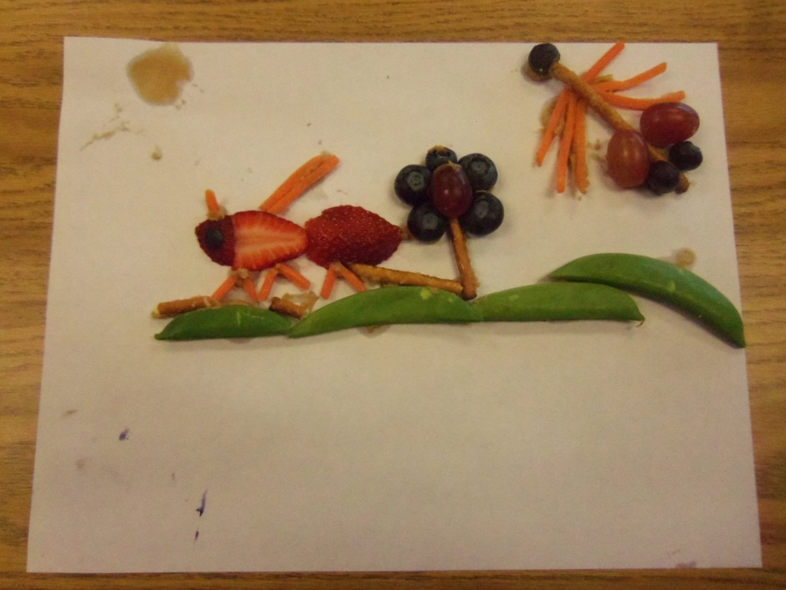
Name___________________Lesson______________________
Assessment
Thumbs Down | Don’t Know | Thumbs Up | Assessment Question
 |  |  | Did you use your personal best during this lesson?
 |  |  | Did you actively listen and follow directions?
 |  |  | Did you use your creativity? (is it original?)
 |  |  | Did you complete your project?
 |  |  | Did you incorporate the art media?
 |  |  | Does the artwork show the elements and/or principles discussed?
Source

