BPS Elementary Art Curriculum

Symmetry
Content Connections:
Math – Symmetry
Science- insect parts
Social Studies- environment/habitat for an insect

Art Standards: 4.1.5
ART-2.1.2 Know the different techniques used to create visual art
ART-2.2.1 Know the differences among visual art structures and functions
Alignment Standards: See math and science standards
Materials:
* water color paper * Brushes
* Oil Pastels * Example or outline
* Pencil of objects
* Water color *Austin’s Butterfly (video)
*

Art Elements | Art Principles
__Line | _X_Pattern
_X_Shape/Form | __Rhythm/movement
_X_Color | _X_Proportion/Scale
__Value | __Balance
__Texture | __Unity
__Space/Perspective | __Emphasis

Grade: 2
Time: 2 hours
Preparation:
1. You need to have Austin’s Butterfly ready to watch, water color paper, pencils, outline designs and oil pastels to start.
2. For the second portion you need oil pastels, water color, water cups, brushes, paper towels.
3. You may need all of the above for others to finish their work.
Vocabulary: Symmetrical, background, oil pastels, body parts, habitat, environment, contrast

I Cans :
*I can create an insect using symmetry
* I can create a background that relates to my insect
* I can use water color to help bring color to my project.

Lesson description:
You will be creating insect art using symmetry and background to create a life-like depiction of an insect.

Teacher Background Knowledge:
- Body parts of an insect
- Symmetry and terms
- Habitat/environment
- Use of art materials from above
- How to run a video using youtube.com (Austin’s Butterfly)
Lesson : (This could take up to a week to finish)
- Watch Austin’s Butterfly (youtube video)
- Discuss how you as students can help others form their insect using polite language
- Start the art piece:
- Take your paper and fold it in half (doesn’t matter what direction)
- With you pencil draw only half of your insect keeping in mind (size, shape, perspective, body parts, etc.)
- When you are done with this have students go out and make only half their insect using pencil only
- Then have them visit with one another and encourage them to make changes where they need to be
- Use pencil to add a little detail and pattern/design
- Trace the one half with pencil with oil pastels (dark brown or black)
- Then fold over on the crease and have them smear it to the other side (Hold the paper down firmly so it doesn’t move and carefully smooth over it to transfer a faint image onto the other side.
- Open up and see the faint transfer. Have student trace over this with their dark oil pastels.
- Use water color to fill in the insect (first) then last have them create a background for their insect that is real.
- You can choose to have it laminated and framed if you would like. Then, Display
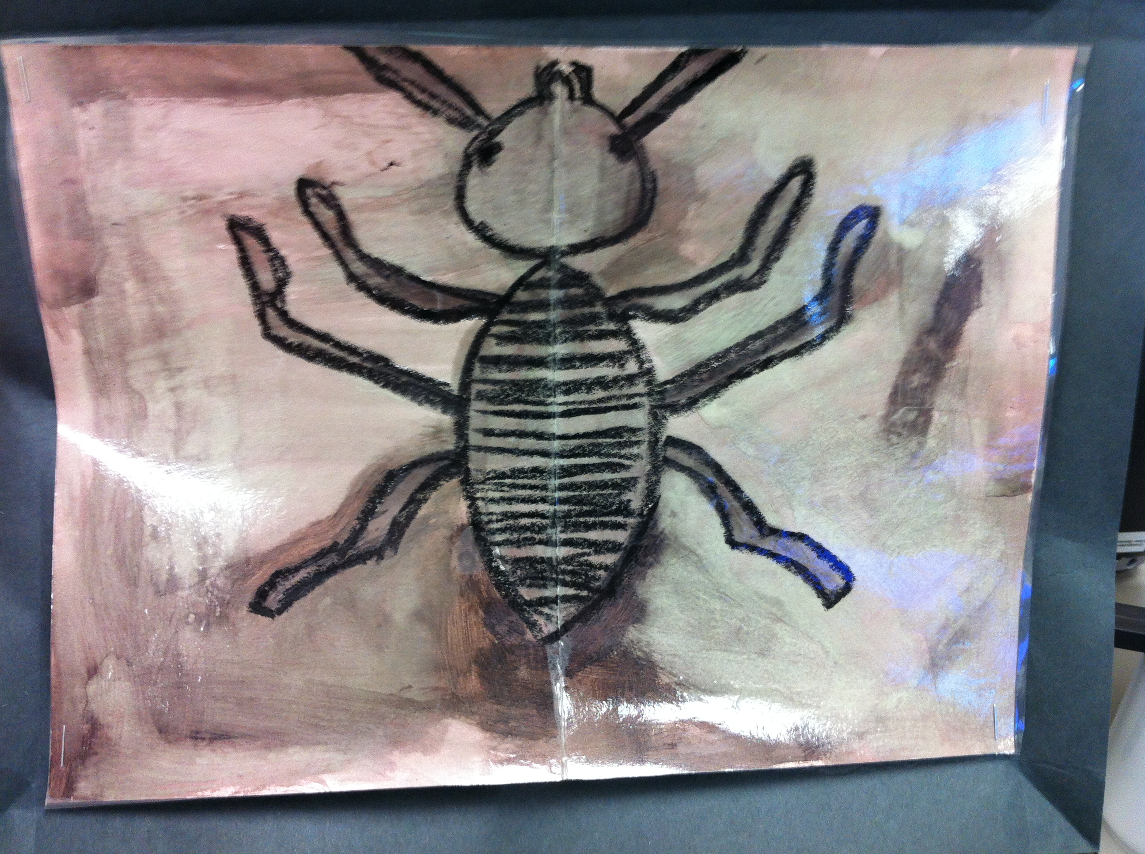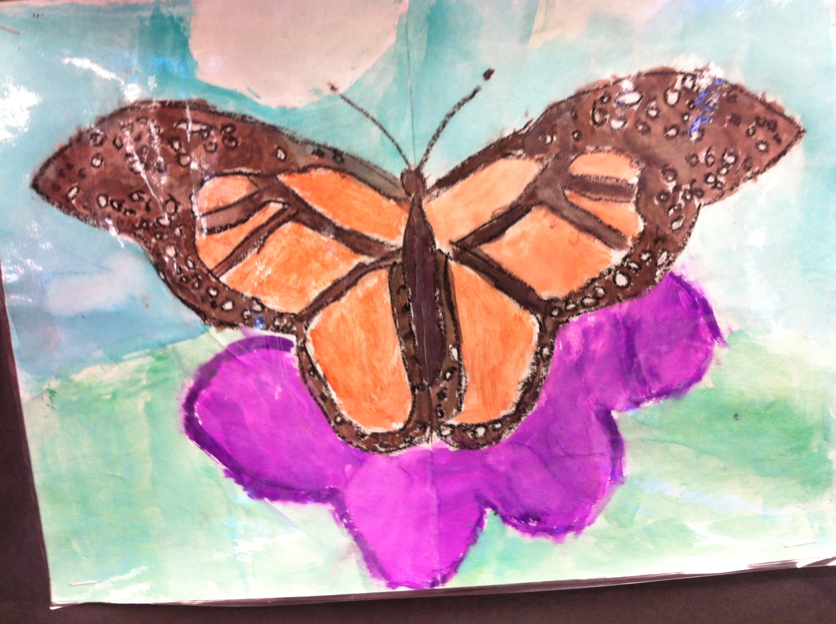
Name___________________Lesson______________________
Assessment
Thumbs Down | Don’t Know | Thumbs Up | Assessment Question
 |  |  | Did you use your personal best during this lesson?
 |  |  | Did you actively listen and follow directions?
 |  |  | Did you use your creativity? (is it original?)
 |  |  | Did you complete your project?
 |  |  | Did you incorporate the art media?
 |  |  | Does the artwork show the elements and/or principles discussed?
Source

