Roosevelt Elementary SALT Integrated Lesson Plan

Content Connections
Science and Language Arts
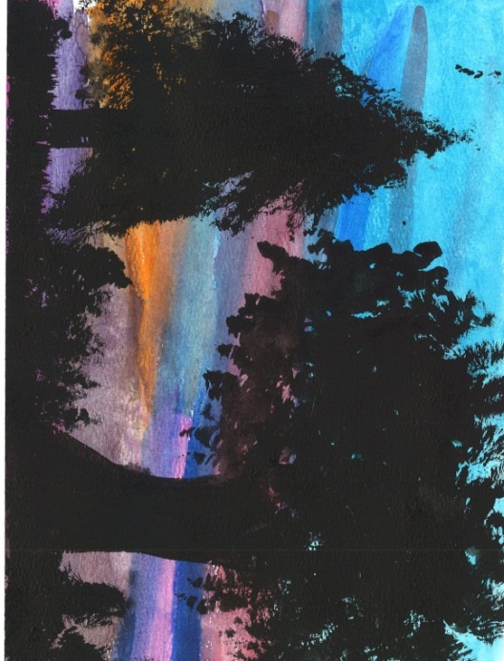
Medium Used – Watercolor and Acrylic Paint
Art Standards:
ART-2.1.2 Know the different techniques used to create visual art. Use different mediums to create artwork.
ART-2.3.1 Understand how a variety of subjects, themes, symbols, and ideas are incorporated in a selection of works of art. Recognize landscapes in artwork

Alignment Standards:
Materials:
* Book - Twilight Comes Twice
By Ralph Fletcher
* Pictures of Trees at Sunset and Sunrise
* Watercolors
* Watercolor Paper
* Black Acrylic Paint
* Paint Brushes ( Fan, detail, brushes with a
variety of widths)
* Painter’s Tape

Grade: 2
Time: Two Hours
21st Century Skills
☐ Global Awareness
☒ Creativity and Innovation
☐ Critical Thinking and Problem
Solving

☐ Communication and Collaboration

☐ ICT Literacy

☒ Flexibility and Adaptability
☐ Initiative and Self-Direction
☐ Productivity and Accountability

☐ Understand the Art World

Artists Habits of Mind
☒ Engage & Persist
☐ Envision
☐ Express
☒ Observe
☒ Reflect
☒ Stretch & Explore
☐ Understand the Art World

Art Elements | Art Principles
__Line | __Pattern
_X_Shape/Form | __Rhythm/movement
_X_Color | __Proportion/Scale
__Value | __Balance
__Texture | _X_Unity
_X_Space/Perspective | __Emphasis

Vocabulary: Twilight, Dusk, Horizon, Landscape, Silhouette, Acrylic Paint,
Preparation:
Prepare a slide show with pictures of trees taken at different times of day. Have more pictures of sunrise and sunset.
Tape the watercolor paper to the students’ desks with painters’ tape. This will create a border. Remove the tape when the painting is finished.

I Cans
RL.2.7 I can use illustration and text to tell about characters, setting, and plot.
W.2.2 I can write my thoughts and ideas about a book or topic I have read.
SCI-2.2.2 Communicate observations to others

Lesson Inform the students that they are going to learn about how the colors in the sky change with the time of day.
Anticipatory Set- What is your favorite time of day? Why?
Look at pictures of trees from sunrise to sunset. Then look at the pictures one more time and see if they can guess the time of day that the picture was taken. Have them explain their answers.
Literature Connection Before you read Twilight Comes Twice, ask students to listen for the author’s best word choices. After the book is read, have the students record three or four words that they heard that are good word choices. Have them share their list with a partner and make a list together. Create a class list to be used in the writing sections after the art project.
Review Vocabulary Words. Refer to the images of the trees at twilight from the story and slideshow. Inform the students that they are going to create a landscape scene where the trees form silhouettes images like the ones they just saw. Remind them of the trees lesson in which they learned to paint trees.
Art Lesson – Demonstrate how to create a twilight sky and to paint trees on their landscape scene with black acrylic paint.
Students will create their silhouette landscape painting.
Reflection – “The time of day in my painting is… and you can tell this by…..
One thing I am proud of is …..
Writing Connection – Students will be placed in groups of two or three. They will create a Start and Stop Poem that begins and ends with the sentence "Twilight comes Twice." Discuss how good word choice in poetry is about choosing the best words that say interesting things in a few sentences.
Remind students that poetry paints pictures with words. Good readers can form these pictures in their minds to understand the poem.
They may use the class chart of excellent words as a resource, or come up with their own words that describe the details about Twilight in the story or their paintings.
Example Twilight comes twice.
It stays for a short time.
Objects fade to shadows.
The colors in the sky change quickly.
Mosquitoes and bats love this time of day.
Twilight comes twice.

Teacher Background Knowledge

This lesson follows a lesson where students sketched and painted trees of many varieties. They have also learned about the horizon line and landscapes.

Demonstration of Twilight
In a dark room, point an overhead or slide projector at the side of a globe. Orient the globe to any season you like and give your model Earth a spin. Confirm for yourself that the twilight zone exists by examining the continuous circle and identifying where morning and evening occur. Notice that the twilight zone stays in the same place: Your part of the Earth has to come to it for day to turn to night and back to day again.

Lesson description:
Students will use watercolors to create a sky at Twilight. They will paint in a horizon line and paint trees as they appear as silhouettes at Twilight.
Name___________________Lesson______________________
Assessment
Thumbs Down | Don’t Know | Thumbs Up | Assessment Question
 |  |  | Did you use your personal best during this lesson?
 |  |  | Did you actively listen and follow directions?
 |  |  | Did you use your creativity? (is it original?)
 |  |  | Did you complete your project?
 |  |  | Did you incorporate the art media?
 |  |  | Does the artwork show the elements and/or principles discussed?
Source

