Scien
Roosevelt Elementary SALT Integrated Lesson Plan

Content Connections:
Science & Language Arts

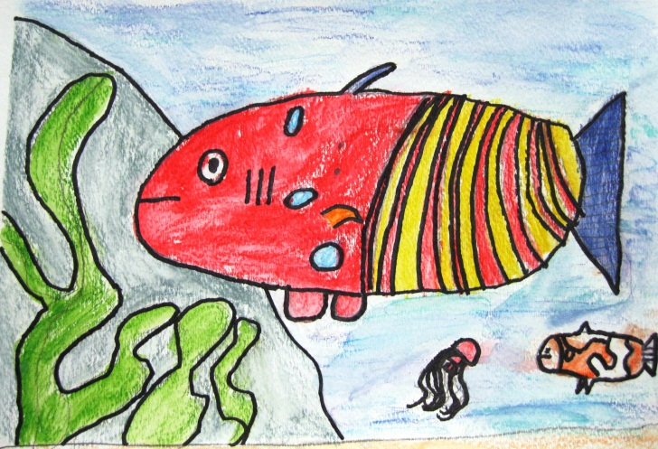
Grade: 2
Time: 2-3 hours
Materials:
Books on Fish Sharpie Markers
PowerPoint of fish pictures.
Watercolor Paper Watercolor Pencils
Painting Tape to frame the picture.
Flat brushes and small round brushes.

Art Standards:
4.1.2 Know the different techniques used to create visual art.
4.1.3 Know differences between visual art processes*.
4.1.5 Know how different visual art media, techniques, and processes are used to
communicate ideas, experience, and stories.

Alignment Standards: Science
2.4.1 Identify how plants and animals are alike and different (e.g., in the way they look, in their behaviors)
2.4.2 Identify various things that are found in different environments (e.g., cactus, lizard – desert; shark, coral- ocean)

Art Elements | Art Principles
__Line | __Pattern
_X_Shape/Form | __Rhythm/movement
_X Color | _X_Proportion/Scale
__Value | __Balance
__Texture | __Unity
_X_Space/Perspective | _X_Emphasis

21st Century Skills
☐ Global Awareness
☒ Creativity and Innovation
☐ Critical Thinking and Problem
Solving

☐ Communication and Collaboration

☐ ICT Literacy

☒ Flexibility and Adaptability
☒ Initiative and Self-Direction
☒ Productivity and Accountability

☐ Understand the Art World

Artists Habits of Mind
☐ Engage & Persist
☒ Envision
☒ Express
☒ Observe
☐ Reflect
☐ Stretch & Explore
☐ Understand the Art World

Watercolor Pencils
Vocabulary:
Tropical ocean habitat freshwater
contour lines details
Preparation
Read books to the class about fish and their habitats.
Prepare a slide show with pictures of fish.
Tape the watercolor paper to the students’ desks with painters’ tape. This will create a border. Remove the tape when the painting is finished.

I Cans
Reflection
SCI-2.2.2 Communicate observations to others.

Writing of a Poem

I can correctly choose between using adjectives and adverbs. .

I can correctly use collective nouns.
Lesson description:
Student will create a picture of a sea creatures . Then they will create the scene and add other sea creatures in the background. They will use watercolor pencils for this project.

Lesson
- Show a PowerPoint of Tropical Fish. Point out colors and distances of objects in the scene.

- Demonstrate to students how to focus on one fish. Draw a fish for them while you point out the basic shapes. Discuss the contour lines and then add details to this fish. Draw a few more fish while the students observe.

- Have the students practice in their sketchbooks or on scratch paper. Sometimes it is helpful to give them a resource page containing many different fish.

- After the students have drawn one fish talk about how this fish is the main character in this scene. It should fill up most of the paper. Then demonstrate on the watercolor paper how to color with watercolor pencils and then paint over them with water to create watercolor.

- The students will then draw their fish on their watercolor paper and use watercolor pencils to color it. Then they will use water and paint brushes to finish their fish.

- Then demonstrate how to add the background to their scene. Add plants, shells, other sea creatures in the background.

- The students will then add the details of the background to their scene using watercolor pencils.

Writing Connection – Poetry
Adjective Poem Example

Line 1 – Noun Angelfish
Line 2 – Two Adjectives Striped, beautiful
Line 3 – Three Adjectives Blue, gold, textured
Line 4 –Sentence about the noun. It’s the most beautiful fish in the sea.

Teacher Background Knowledge
Brainstorm with the class the different kinds of water and what fish we can find in each.
*Rivers
*Lakes
*Tropical Waters
* Ocean
As you look at the pictures in the book and PowerPoint, discuss the colors you see in the fish and the shapes. Also point out the background (plants, coral, sand, etc.)
Name___________________Lesson______________________
Assessment
Thumbs Down | Don’t Know | Thumbs Up | Assessment Question
 |  |  | Did you use your personal best during this lesson?
 |  |  | Did you actively listen and follow directions?
 |  |  | Did you use your creativity? (is it original?)
 |  |  | Did you complete your project?
 |  |  | Did you incorporate the art media?
 |  |  | Does the artwork show the elements and/or principles discussed?
Source

