**BPS Elementary Art Curriculum**

Shoebox Ponds

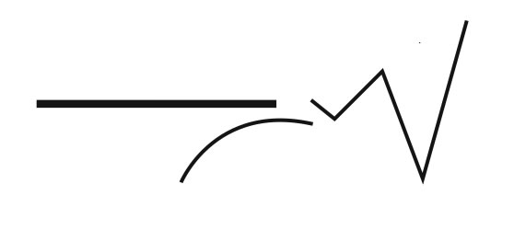

Content Connections:

Habitat Science

Scott Foresman Story:

Turtle’s Race with Beaver

Art Standards: 2.2.1 I know the differences between visual art structures and functions. 2.3.1 I can understand how a variety of subjects, themes, symbols, and ideas are incorporated in a selection of works of art.

Alignment Standards:

Materials: shoeboxes, model magic clay, tempera paint, craft sticks, toothpicks, or any craft material to make plants and animals

|  |  |
| --- | --- |
| **Art Elements** | **Art Principles** |
| X__Line | __Pattern |
| X__Shape/Form | __Rhythm/movement |
| __Color | x__Proportion/Scale |
| __Value | __Balance |
| X__Texture | __Unity |
| __Space/Perspective | __Emphasis |

Grade: 2nd

Time: approximately 2 hours

Preparation

Collect a shoe box for each student.

Collect clay, paint, newspaper, craft supplies

Vocabulary:

Horizon line, background, habitat, depth perception

I Cans

I can paint a horizon line using different colors.

I can use various shapes with materials to create realistic plant and animal life.

Lesson description:

The students will read and listen to stories about ponds, watch videos, and go to Pebble Go to learn about habitats. Then they will create a pond out of a shoebox.

Teacher Background Knowledge

Pond habitat

Using different materials

How to break apart this project into two days

Lesson

Build background about ponds. KWL

Listen to the Scott Foresman story “Turtle’s Race with Beaver” and other stories about ponds. Read both fiction and nonfiction.

Students can go to Pebble Go online or Encyclopedia Britannica to learn about ponds. Build vocabulary.

Paint shoeboxes with a blue sky background and greenish blue water on the bottom. Let dry.

Next day, paint trees in background.

Following day, add plants and animals.

Lily pads, cattails out of toothpicks, beavers, fish, frogs, ducks, etc. out of clay

Final day: Present as a museum for other classes or parents. Display on conferences or program night.

Name___________________Lesson______________________

*Assessment*

|  |  |  |  |
| --- | --- | --- | --- |
| **Thumbs Down** | **Don’t Know** | **Thumbs Up** | **Assessment Question** |
|  |  |  | Did you use your personal best during this lesson? |
|  |  |  | Did you actively listen and follow directions? |
|  |  |  | Did you use your creativity? (is it original?) |
|  |  |  | Did you complete your project? |
|  |  |  | Did you incorporate the art media? |
|  |  |  | Does the artwork show the elements and/or principles discussed? |
|  |  |  |  |
|  |  |  |  |
|  |  |  |  |

Source