BPS Elementary Art Curriculum

Weather
Content Connections:
Weather

Art Standards:
ART-2.1.2, ART-2.1.6
Alignment Standards: SCI-2.4.1 Identify how plants and animals are alike and different.
SCI-2.5.1 Describe the patterns and characteristics of the four seasons, and how these changes in weather influence plant, animal, and human activities.

Materials:
Watercolor, watercolor, paper pencil, glue bottles mixed ½ glue and ½ black paint, salt, leaf examples .
Grade: 2nd
Time: 1.5 hours

Art Elements | Art Principles
__Line | __Pattern
_x_Shape/Form | __Rhythm/movement
_x_Color | __Proportion/Scale
__Value | _x_Balance
_x_Texture | __Unity
__Space/Perspective | __Emphasis

Preparation
Have materials ready for students. They should have a background knowledge in weather and the different seasons.
Vocabulary: shape/form, color, texture, balance

I Cans …
Identify how plants and animals are alike and different.
Describe the patterns and characteristics of the four seasons, and how these changes in weather influence plant, animal, and human activities.

Lesson description: Watercolor Leaves

Teacher Background Knowledge:
You can use this lesson to teach children about using the wet on wet strategy for painting.
Lesson
- After teaching students about the different seasons and weather patterns, have them observe the changing leaves (ideally done in the fall).
- Start with watercolor paper and pencils. Have students sketch out their leaves.
- Outline their leaves with the black paint in the glue bottles.
- Let the paint dry, up to 1 hour; (use your discretion depending on thickness of paint).
- Start using watercolor to create a background. Then fill in the leaves. While the watercolor is still wet students sprinkle on salt on it. I had the children us wet on wet for the background, letting the colors really blend together.
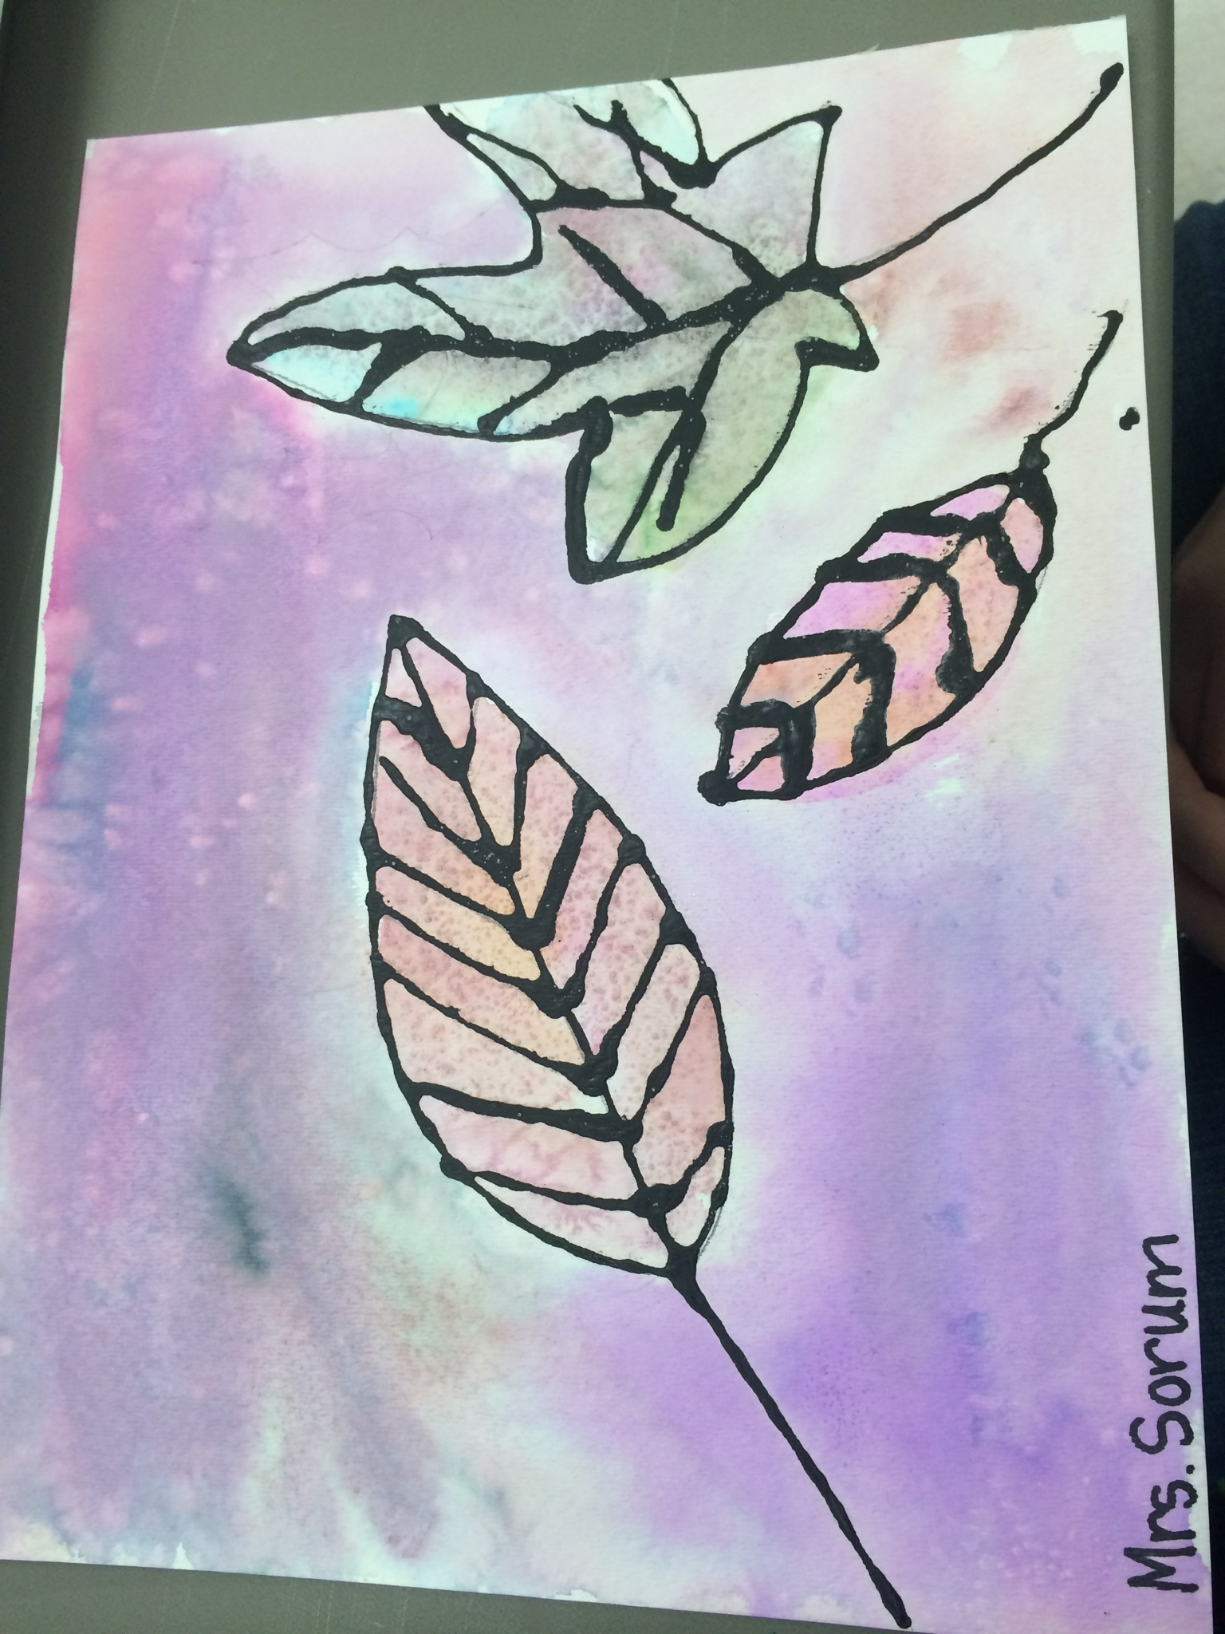
Name___________________Lesson______________________
Assessment
Thumbs Down | Don’t Know | Thumbs Up | Assessment Question
 |  |  | Did you use your personal best during this lesson?
 |  |  | Did you actively listen and follow directions?
 |  |  | Did you use your creativity? (is it original?)
 |  |  | Did you complete your project?
 |  |  | Did you incorporate the art media?
 |  |  | Does the artwork show the elements and/or principles discussed?
Source

