BPS Elementary Art Curriculum

Snowflake Resist Watercolor Grid
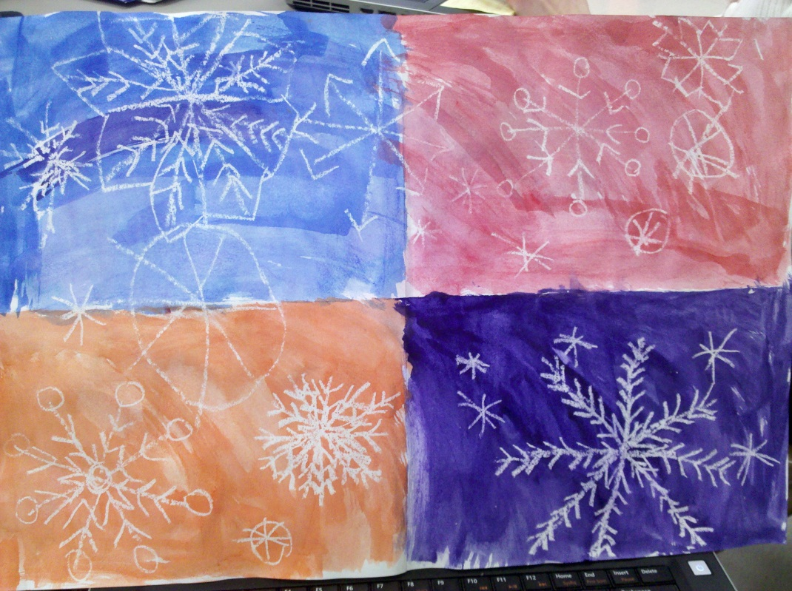
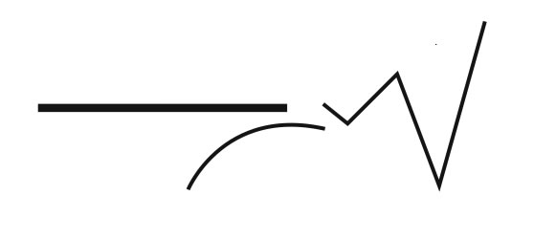
Content Connections:
Reading/Writing – read story about snowflakes – write about snowflakes
Math – fractions

Art Standards: 4.1.5
Alignment Standards:
Know the different techniques used to create visual art.

Materials:
Large white paper, white crayon, watercolors, water cups, paint brushes

Art Elements | Art Principles
_X_Line | __Pattern
_X_Shape/Form | __Rhythm/movement
_X_Color | __Proportion/Scale
__Value | __Balance
__Texture | __Unity
__Space/Perspective | __Emphasis

Grade: 2nd
Time: 30 minutes
Preparation
Gather materials

Vocabulary:
Lines, patterns, designs

I Cans
Know the different techniques used to create visual art.

Lesson description:
Snowflake Resist Watercolor Grid

Teacher Background Knowledge
Lesson
1. Start with a sheet of white paper. Fold in half and in half again to make 4 sections.
2. Using a white crayon draw lots of snowflakes, taking care to have some large and some small and some overlapping the panels. I like to make a large “X” and then add a horizontal line to form a six-sided frame, and then added circles and arrows to decorate. Pressure is needed to make sure that thick, white lines are drawn with the crayon.
3. Use watercolors to color each section a different color.

Name___________________Lesson______________________
Assessment
Thumbs Down | Don’t Know | Thumbs Up | Assessment Question
 |  |  | Did you use your personal best during this lesson?
 |  |  | Did you actively listen and follow directions?
 |  |  | Did you use your creativity? (is it original?)
 |  |  | Did you complete your project?
 |  |  | Did you incorporate the art media?
 |  |  | Does the artwork show the elements and/or principles discussed?
Source

