**BPS Elementary Art Curriculum**

3-D shapes

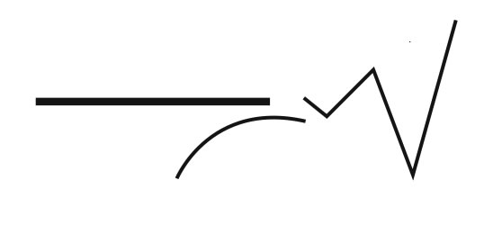

Art Standards: 2.1.2 Know the different techniques used to create visual art

Alignment Standards: 2.G.03

Content Connections: Math- 3D shapes

Materials: Green construction paper, oil pastels, pencil

|  |  |
| --- | --- |
| **Art Elements** | **Art Principles** |
| __Line | __Pattern |
| __Shape/Form | __Rhythm/movement |
| *__Color | _*_Proportion/Scale |
| __Value | _*_Balance |
| __Texture | _*_Unity |
| __*Space/Perspective | __Emphasis |

Grade: 2

Time: 40 minutes

Preparation: Introduce vocabulary.

Vocabulary: Shading, proportion, sphere, 3 dimensional

I Cans

I can use different mediums to create artwork

I can draw 3D shapes

Lesson description: Students used pastels to create drawings of pumpkins during the fall season. They were encouraged to look at the way the light landed on the pumpkin. They experimented with blending the pastels to make shadows.

Teacher Background Knowledge: Knowledge in shading and how to use oil pastels.

Lesson : Go to this website and click on the picture for the lesson <http://www.mrsbrownart.com/2nd.htm>

Name___________________Lesson______________________

*Assessment*

|  |  |  |  |
| --- | --- | --- | --- |
| **Thumbs Down** | **Don’t Know** | **Thumbs Up** | **Assessment Question** |
|  |  |  | Did you use your personal best during this lesson? |
|  |  |  | Did you actively listen and follow directions? |
|  |  |  | Did you use your creativity? (is it original?) |
|  |  |  | Did you complete your project? |
|  |  |  | Did you incorporate the art media? |
|  |  |  | Does the artwork show the elements and/or principles discussed? |
|  |  |  |  |
|  |  |  |  |
|  |  |  |  |

Source