**BPS Elementary Art Curriculum**

Lines

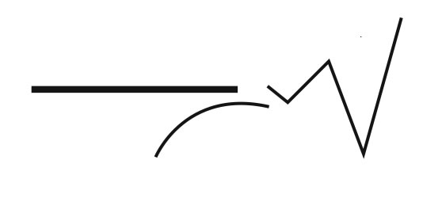

Content Connections:

Using pastels to create 3 dimensional circles

Art Standards: 4.1.5

Alignment Standards:

Materials: Pastels, construction paper

|  |  |
| --- | --- |
| **Art Elements** | **Art Principles** |
| _x_Line | __Pattern |
| _x_Shape/Form | __Rhythm/movement |
| __Color | _x_Proportion/Scale |
| __Value | __Balance |
| __Texture | __Unity |
| _x_Space/Perspective | __Emphasis |

Grade: 2

Time: 45 min

Preparation –teach about dimension and shading

Vocabulary: Sphere, three dimensional, shading, shadow

I Cans make a pumpkin scene using a sphere

Lesson description: See lesson

Teacher Background Knowledge

Shading

Dimension

High lighting

Lesson

1. Using pastels to draw an outline of three pumpkins
2. Using a second color trace the outline of the pumpkin and use a shading technique to add dimension.
3. Use another shade of pastels and a create another layer leaving a highlighted spot
4. Add details to pumpkins….stems, vines,leaves

Name___________________Lesson______________________

*Assessment*

|  |  |  |  |
| --- | --- | --- | --- |
| **Thumbs Down** | **Don’t Know** | **Thumbs Up** | **Assessment Question** |
|  |  |  | Did you use your personal best during this lesson? |
|  |  |  | Did you actively listen and follow directions? |
|  |  |  | Did you use your creativity? (is it original?) |
|  |  |  | Did you complete your project? |
|  |  |  | Did you incorporate the art media? |
|  |  |  | Does the artwork show the elements and/or principles discussed? |
|  |  |  |  |
|  |  |  |  |
|  |  |  |  |

Source