**BPS Elementary Art Curriculum**

Lines

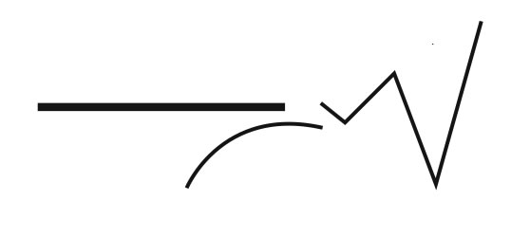

Content Connections:

Writing Process: Students will write one facet about on interesting place in the world

Literature Connection:

Hottest Coldest Highest Deepest by Steve Jenkins. This is from Unit 4.2 in Scott Foresman reading series.

Art Standards: 4.5.1 I know various purposes for creating works of art

4.6.2 Know connections between the visual arts and other disciplines in the curriculum.

3.w.2 Informational writing

Alignment Standards:

Materials: flipbooks made with from 3 9x12 sheets of white construction paper

Reading text, writer’s notebook, crayons, markers, sharpies

|  |  |
| --- | --- |
| **Art Elements** | **Art Principles** |
| _x_Line | __Pattern |
| _x_Shape/Form | __Rhythm/movement |
| _x_Color | _x_Proportion/Scale |
| __Value | _x_Balance |
| __Texture | __Unity |
| __xSpace/Perspective | __Emphasis |

Grade: 3, Myhre Elementary teachers

Time: approx. 2 one hour sessions

Preparation

Prepare flipbooks

Have sample ready to share of sentence and illustration

Vocabulary: line, shape, form, space, perspective, proportion, scale, and balance

I Cans

I can write informative sentences from expository nonfiction.

I can illustrate my informative writing.

Lesson description:

Students will write informative sentences after reading the selection. Students will make an illustration about the sentence in their flipbook.

Teacher Background Knowledge

Read selection Hottest Deepest Coldest Highest

Lesson

Read and discuss and discuss story.

Have students choose five interesting places they want to write about and illustrate.

Write sentences. Discuss the proportion of their printing in the allotted space in the flipbook.

Illustrate their sentence on each page.

Design the title page.

Share their books with each other.

Name___________________Lesson______________________

*Assessment*

|  |  |  |  |
| --- | --- | --- | --- |
| **Thumbs Down** | **Don’t Know** | **Thumbs Up** | **Assessment Question** |
|  |  |  | Did you use your personal best during this lesson? |
|  |  |  | Did you actively listen and follow directions? |
|  |  |  | Did you use your creativity? (is it original?) |
|  |  |  | Did you complete your project? |
|  |  |  | Did you incorporate the art media? |
|  |  |  | Does the artwork show the elements and/or principles discussed? |
|  |  |  |  |
|  |  |  |  |
|  |  |  |  |

Source