BPS Elementary Art Curriculum
SALT lesson

A Bad Case of…….
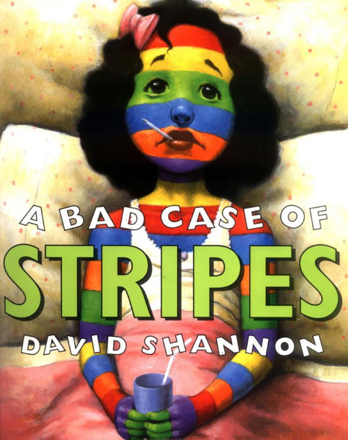
Materials: full size watercolor paper; watercolor sets, flat brushes, round brushes, detail brushes, fan brushes, paper towels, overhead projector
Grade: 3
Time: 2 class periods
Art Standards: 3.1.2
Know the difference between visual art structures and functions.
Content Connections:
Students have been working on narrative writing. As a culminating activity students will have the chance to create their own narrative piece of writing that uses the book Bad Case of Stripes as their guide. They will then visually represent their Bad Case on a watercolor profile cutout of themselves. They will represent their bad case by using a variety of watercolor techniques.

Art Elements | Art Principles
_X_Line | _X_Pattern
_X_Shape/Form | __Rhythm/movement
_X_Color | __Proportion/Scale
__Value | __Balance
__Texture | __Unity
__Space/Perspective | __Emphasis

Preparation: You will need to check out the book A Bad Case of Stripes. You will also need to gather paint brushes, watercolor pallets, bowls for water to rinse brushes, paper towels, and an overhead projector for tracing each students profile onto the water color paper.

Vocabulary: wet-on wet, wash with salt, wash with saran wrap, lift technique

I Cans
Use proper techniques with given art medium
Use art tools in a variety of ways.
Know how to use and maintain art tools

Lesson
DAY ONE: Teacher will read the book A Bad Case of Stripes. Students will then write their own narrative piece of writing about their own bad case and what happened to their face with the aliment they choose. They have to be very descriptive in their story as they will be visually representing their case in the next stage of the activity. Students will then have their profile traced onto large water color paper to be used for their culminating art activity. Students will then be introduced to a wide array of watercolor techniques as well as a variety of brushes. They will then be given a smaller piece of water color paper to experiment with the different techniques and brushes they have been introduced to. They will decide on the patterns and color scheme they would like to use for their final project.
- Also, do a quick review to see what students may remember from previous lessons and connect them again to the process of watercolor painting:
  - Who remembers what to do first when we get the watercolor sets? (put water in them to loosen them up)
  - What are the names of these brushes?
  - What is the technique called when you wet the paper before painting on it?
- Share with students that they will be practicing different painting techniques
  - sweeping with flat brush,
  - wet-on-wet,
  - watercolor wash,
  - making lines and taps with the round brush-heavy to light,
  - tapping and sweeping with fan brush,
  - layering with flat or round brush
DAY TWO: Students will do a quick recap of different techniques they have been introduced to. They will then receive their profile on large watercolor paper. They will decide how they want to use the space provided. They need to make sure their watercolor portfolio correlates with their description of their case in the narrative they created. Students will be given ample amount of time to paint their portfolio. Once their portfolio is dried they will cut it out and glue it to a large piece of black construction paper to make their artwork pop.
Lesson description: To learn and use watercolor techniques to visually represent a piece of writing.
Teacher Background Knowledge
Know the following techniques:
- Sweeping with flat brush
- Wet-on wet
- Watercolor wash
- Making lines and taps with the round brush-heavy to light
- Tapping and sweeping with fan brush
- Layering with flat or round brush

Name___________________Lesson______________________
Assessment
Thumbs Down | Don’t Know | Thumbs Up | Assessment Question
 |  |  | Did you use your personal best during this lesson?
 |  |  | Did you actively listen and follow directions?
 |  |  | Did you use your creativity? (Is it original?)
 |  |  | Did you complete your project?
 |  |  | Did you incorporate the art media?
 |  |  | Does the artwork show the elements and/or principles discussed?

