BPS Elementary Art Curriculum

Watercolor Character Traits
Content Connections:
This lesson connects to the reading standard on character traits.
Art Standards:4.1.2 Know the different techniques used to create visual art 4.2.1 Know the differences among visual art structures and functions.
Alignment Standards: Rl.3.3 Describe characters
Materials: White construction paper, water colors, brushes, sharpies, newspaper,

Art Elements | Art Principles
__Line | __Pattern
__Shape/Form | __Rhythm/movement
_X_Color | _X_Proportion/Scale
__Value | __Balance
__Texture | __Unity
_X_Space/Perspective | __Emphasis

Grade: 3
Time: 2-40 minute sessions
Preparation
Lay down newspaper and prepare cups of water and water colors
Display list of examples of character traits
Vocabulary: Character traits

I Cans
I can describe a character.
Lesson description: The student will create a watercolor piece listing their own character traits.

Teacher Background Knowledge
Example found on Pinterest:
http://artclassworks.blogspot.com/2012/05/self-esteem-portraits.html
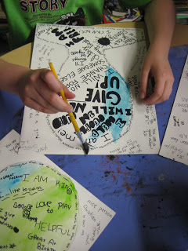
Teach lesson on character traits
Lesson
- Students brainstorm a list of character traits that they are proud of. IE: I am a good friend, humorous, considerate. Words should be spelled correctly.
- Students then get a white piece of construction paper. They will draw in pencil a basic outline of their head and neck. The head should take up most of the page.
- Students then fill up their “head” with phrases and words of the character traits that they brainstormed. If students are stuck it is always interesting to have a share out session. Students should be encouraged to be creative when writing the words. They may change their writing style (cursive, block letters, flowers for dots) and they should try to fill in their head while making it look appealing.
- Students outline the words and shape of the head in black permanent marker.
- Students then use watercolors to paint their entire page.
- When the paint is dried, other students may write down compliments on the outside part of the head.
Name___________________Lesson______________________
Assessment
Thumbs Down | Don’t Know | Thumbs Up | Assessment Question
 |  |  | Did you use your personal best during this lesson?
 |  |  | Did you actively listen and follow directions?
 |  |  | Did you use your creativity? (is it original?)
 |  |  | Did you complete your project?
 |  |  | Did you incorporate the art media?
 |  |  | Does the artwork show the elements and/or principles discussed?
Source

