BPS Art Curriculum

Landscapes with David Mollett
Content Connections:
Science: Land Forms
Art Standards:
4.1.2, 4.1.4, 4.1.5, 4.3.1, 4.6.2
Alignment Standards:
Social Studies: 3.5.1
Materials: tempera paints, 9x12 white paper, 12x18 black paper , water bowls, brushes, black crayons, glue, paper towels

Art Elements | Art Principles
_X_Line | __Pattern
_X_Shape/Form | __Rhythm/movement
_X_Color | __Proportion/Scale
__Value | _X_Balance
__Texture | __Unity
_X_Space/Perspective | __Emphasis

Grade: 3
Time: Two Sessions
Lesson
- Look at David’s work and discuss the idea of foreground, middle ground, and background.
- Foreground: With a black crayon make a line that is curvy or bumpy across the page near the bottom. Be sure to touch both edges of the paper with all lines.
- Middle ground: Near the middle of the page make a line that is horizontal and fairly straight.
- Background: Above the middle line draw a line or two to represent hills or mountains. Don’t go too high-be sure to leave some sky!
- Now go back into the area below the middle ground and add a couple of more interesting lines that will help break up space and give students areas in which to paint.
- Brainstorm with students different kinds of lines they could use in their landscape and remind them to vary their own lines because it adds interest to the painting (what would it look like if all the lines were straight? If they were all curved…)

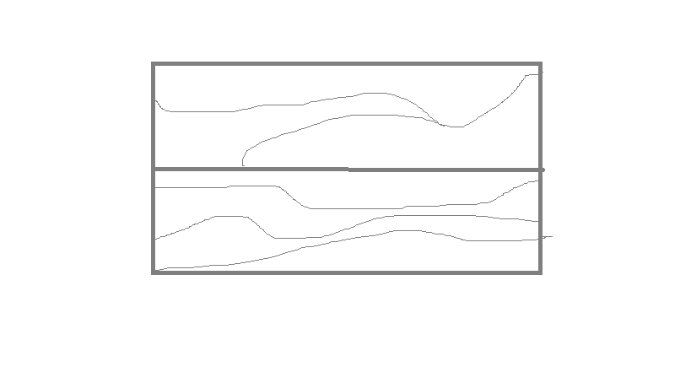
- Recalling that things closer have a lot of detail, add some trees or bushes to the foreground.
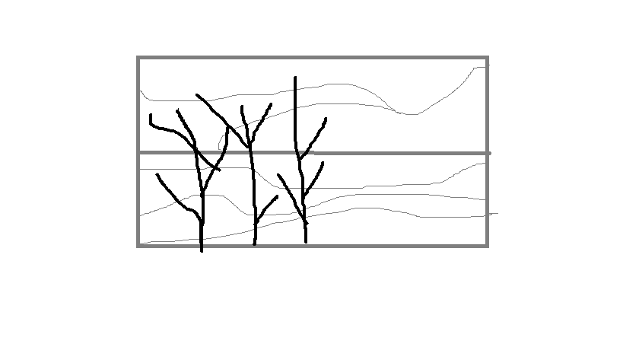
Session 2
- Pull out the color wheel and review the basics of color. Show students that when they mix lots of colors together they will get brown. Show them Mollett’s work and remind them that we want other colors and maybe a little brown in the pictures. Also tell them that they can be imaginative in their choice of colors.
- Review painting techniques:
  - Hold brush like a pencil
  - Holding closer to the brush provides more control
  - Start with light colors and work towards dark
- Let students paint their landscapes
Preparation: Glue the white paper on the black paper so that there is a nice even black margin. Prepare sets of tempera cake paints with primary and secondary colors by placing them on a tray or cardboard box lid. Collect flat easel brushes, either one half or 1 inch wide. Set one out of each student. A table of four uses 2 water bowls . Have paper towels for students for dabbing brushes.
Vocabulary: Landscape, foreground, middle ground, background, space

I Cans
I can learn about artist David Mollett
I can learn that things close up show more detail and things far away shows little detail
I can draw lines to create landscape with fore, middle, and background.
I can use art materials appropriately.

Teacher Background Knowledge:
David Mollett is an artist and a professor of art at the University of Alaska Fairbanks. Since the fifth grade, David has lived in Fairbanks and has wanted to be an artist. David tries many different types of art, but he has spent a lot of time painting landscapes or pictures of the land. He says the most important thing is to practice.
A landscape shows an area that has space. To show space a landscape has three parts: The foreground, the background, and the middle ground. The foreground is the closest to the bottom of the page and the closest to the viewer. The middle ground is in the middle of the page and the background is near the top of the page. Find these areas in Mollett’s paintings, tracing ground lines with fingers.
Google David Mollett to see many examples of his art pieces.
Lesson description: Students examine landscapes by artist David Mollett looking at fore, middle, and backgrounds. They then paint a landscape demonstrating what they learned.
Name___________________Lesson______________________
Assessment
Thumbs Down | Don’t Know | Thumbs Up | Assessment Question
 |  |  | Did you use your person best during this lesson?
 |  |  | Did you actively listen and follow directions?
 |  |  | Did you use your creativity? (is it original?)
 |  |  | Did you complete your project?
 |  |  | Did you incorporate the art media?
 |  |  | Does the artwork show the elements and/or principles discussed?

Sources:
Project Articulate

