BPS Art Curriculum

Fraction Fish
Materials:
12"x18" blue construction paper
assorted colored construction paper
pencils
circle tracers
Elmer's glue
googley eyes
Grade: 3rd
Time: Two 60 minute
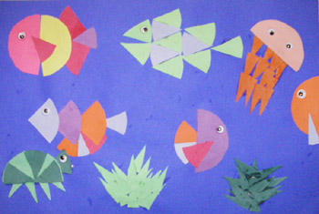t here
Content Connections:
Math: Fractions
Art Standards: 4.1.4, 4.1.6, 4.2.1, 4.3.1
Alignment Standards:
Math: 3.G.2

Art Elements | Art Principles
__Line | __Pattern
_X_Shape/Form | _X_Rhythm/movement
_X_Color | _X_Proportion/Scale
__Value | _X_Balance
_X_Texture | __Unity
__Space/Perspective | __Emphasis

Preparation:
Students will need various sizes of circles available as tracers.
You will need one piece of blue construction paper per student for the ocean background.
You will need various colors of construction paper for the fish and other sea life.
You will need googley eyes available for sea creatures.

Vocabulary: Fraction, halves, fourths, eighths, movement, proportion

I Cans/ Objectives:
I can create an underwater picture using cut paper circles.
I can fractions in their pictures, such as 1 whole, 1/2, 1/4, 1/8.
I can have a good time making their pictures while reviewing their Math concepts.

Lesson :
- View various pictures of underwater sea life for inspiration.
- Trace and cut 5 circles of various sizes.
- Leave one circle whole.
- Cut one circle in half.
- Cut the third circle in fourths.
- Cut another in eighths.
- The last circle is your choice.
- Create fish, under sea creatures, and seaweed from your fraction pieces.
- Once the creatures formed on your construction paper glue them down.
- Fish and sea creatures can be placed going a variety of directions in order to show movement.
- Lastly, glue googley eyes onto sea creatures.
Lesson description:
Students will learn about fractions in their Math class and use their knowledge of fractions to create an underwater picture.
Name___________________Lesson______________________
Assessment
Thumbs Down | Don’t Know | Thumbs Up | Assessment Question
 |  |  | Did you use your personal best during this lesson?
 |  |  | Did you actively listen and follow directions?
 |  |  | Did you use your creativity? (is it original?)
 |  |  | Did you complete your project?
 |  |  | Did you incorporate the art media?
 |  |  | Does the artwork show the elements and/or principles discussed?
 |  |  | Can you distinguish between ½, ¼, 1/8?

