BPS Elementary Art Curriculum

Lines
Content Connections:
Art Elements

Art Standards: 4.1.5
Alignment Standards:
Materials: Drawing paper, pencils

Art Elements | Art Principles
_x_Line | __Pattern
__Shape/Form | _x_Rhythm/movement
__Color | __Proportion/Scale
__Value | __Balance
__Texture | __Unity
__Space/Perspective | __Emphasis

Grade: 3rd
Time: 1 session
Lesson
Discussion
When discussing the variety of lines that we encounter in our daily lives, ask the students to think about telephone lines, clotheslines, battle lines, lines of poetry or music, lines of people in a queue, the line of scrimmage. What others can you think of?
What do we associate with lines on a face? Age? Experience?
Have you learned your lines for the play?
Where do you see long pairs of parallel lines? Highways? Railroad tracks?
Directional Lines and Mood
Draw and discuss vertical, horizontal, curved, diagonal, spiral, zigzag, wavy
Explore line and mood with the students through questions such as these
-vertical
What do you see in our environment that is made up of vertical lines?
(skyscrapers, trees, telephone poles, rain, Gothic cathedrals, soldiers standing at attention)
What moods or feelings do a series of verticals convey?
(Heavenward, of the sky, strong, straight, dignified)
Have you ever learned against a vertical?(Yes, a wall, a tree, a lamppost)
When is your body vertical?(when standing)
-Horizontal
What in the environment is predominantly horizontal?
(the horizon, the floor, a bed, a table, a still lake or pool)
What mood do these horizontals convey?
(Grounded, of the earth, relaxed, a rest, calm, serene, expansive)
When is your body horizontal?(When lying down, asleep)
-Diagonals
Where do you see diagonals? (slide, plane taking off, a ramp)
What feeling is conveyed by diagonals? (action, movement)
-Wavy Lines
Where do you see wavy lines in the environment? (ocean, lake, snake, hills)
What feelings do they convey?
-zigzag
Where do you see zigzag lines? (lighting, jagged tear, crimped hair)
What mood do they convey? (Tense, anxious, frenzied)
When does your body form a zigzag? (jumping on a pogo stick)
-spirals
What do you see that is shaped in a spiral? (spring, slide tornado, coiled, drain)
What feeling do spirals convey? (spinning, swirling, energetic)
When is your body in a spiral? (twirling)

Preparation
Book: Look Again! By Tana Hoban
Vocabulary: Vertical, Horizontal, curved, diagonal, spiral, wavy, zigzag

I Cans pick out different types of lines in both natural and man-made objects.

Teacher Background knowledge

Lesson description: Lines are everywhere in our environment, both in natural and in man-made objects. Lines can point a direction, set boundaries, and measure distances. Lines which are organized into symbols form the basis of written language and musical notation. Lines which join together or intersect become shapes, and for the artist they are the basis of drawing and means of expression.

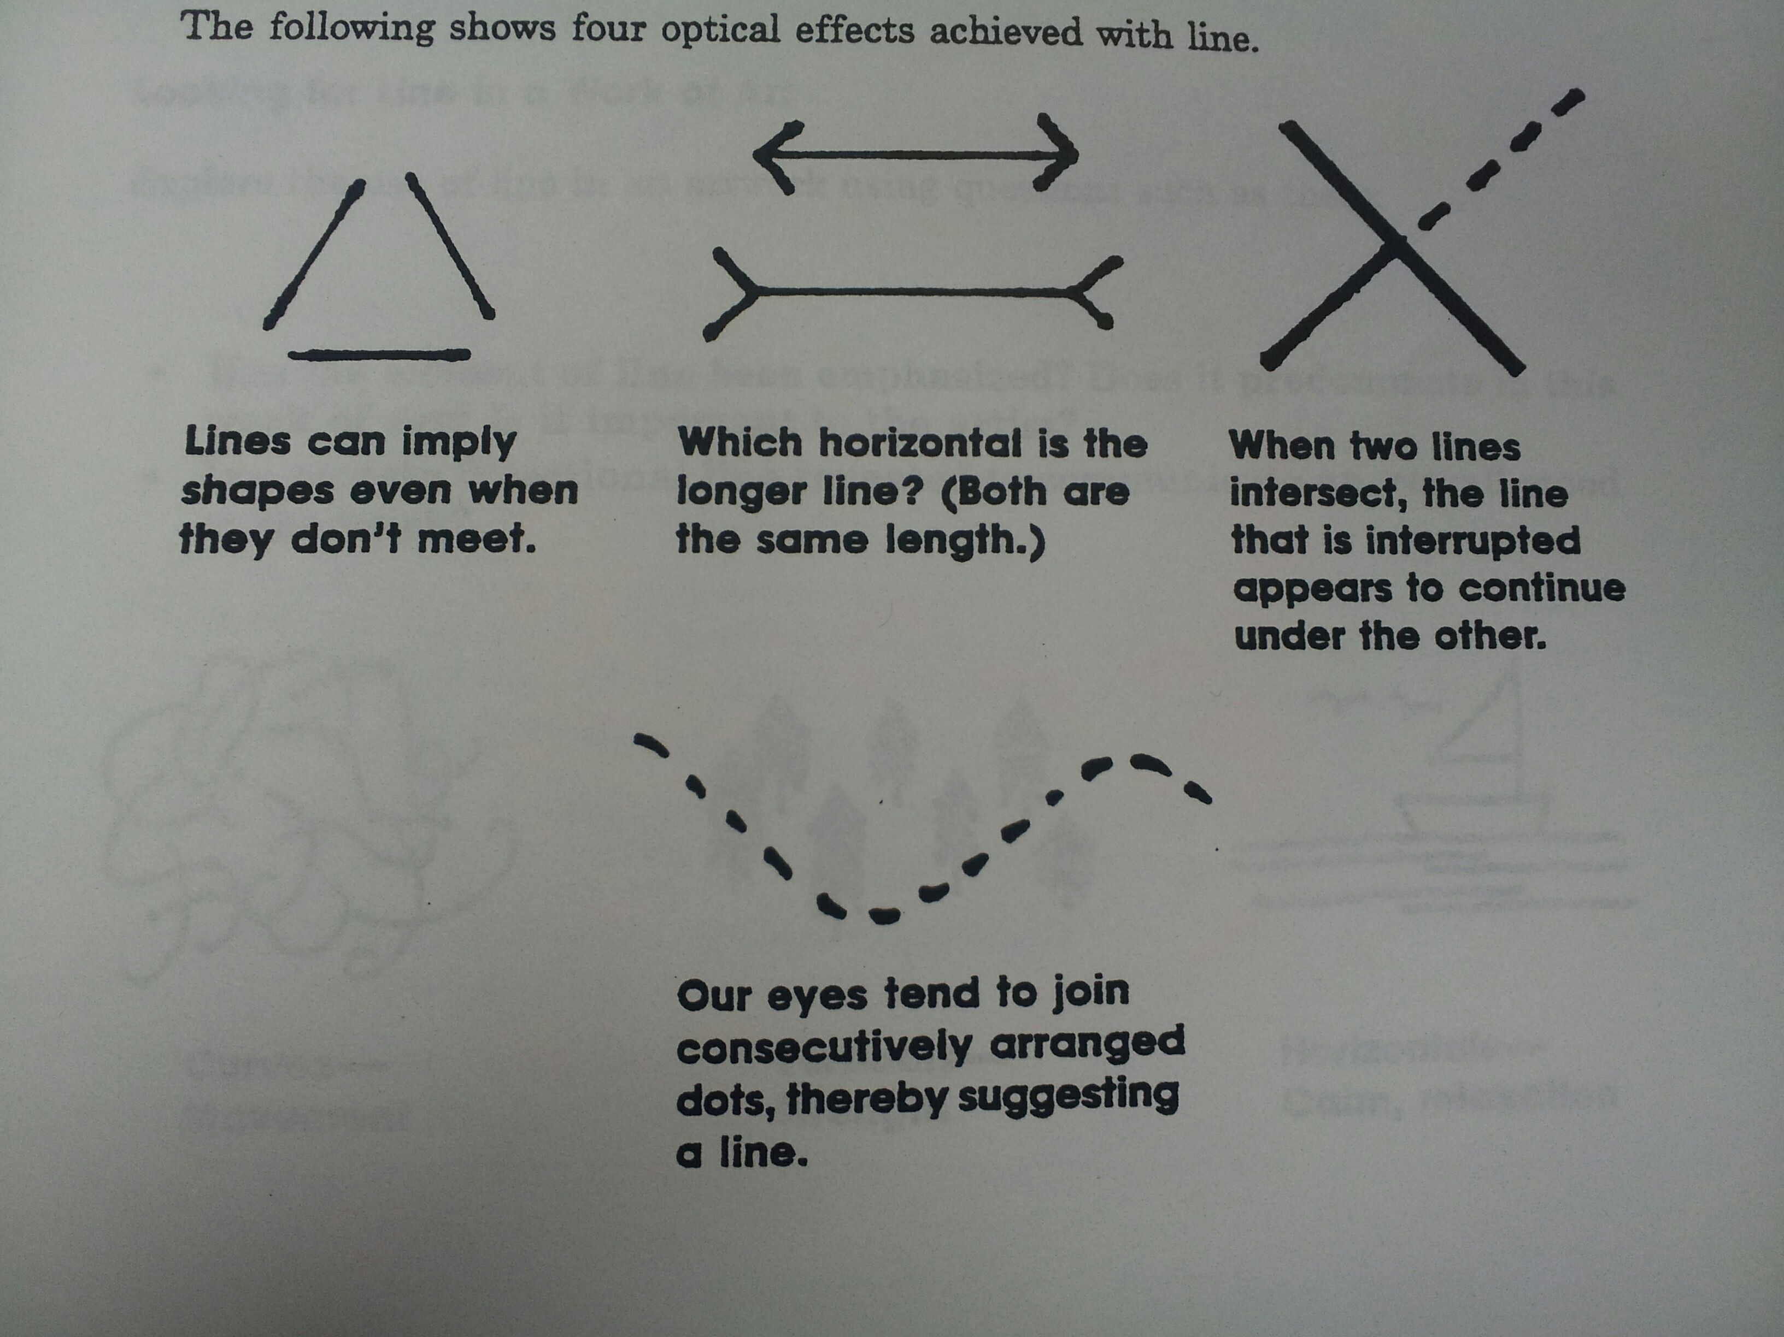
Quality of Line
Lines may vary in quality depending on the method or materials used. Compare a line made with a piece of chalk with one of oil paint made with a brush. Lines made with pen and ink are very different from lines carved in a block of wood or lines in a field made with a plow. Lines can be graceful as an arabesque or coarse and rough.
Lines as Symbols
Positive sign, x, negative sign, arrow, equal, victory
Patterns
Lines can be repeated to form patterns. You can show the students examples in fabrics.
Stripes, plaids

Look At art
Look at different artwork and locate the different lines discussed. Has the element of line been emphasized? Does it predominate in this work of art? Is it important to the artist? Is the certain directional line repeated to communicate an overall mood to the work?

Create Art
Have the student draw a picture using at least three different lines discussed.

Name___________________Lesson______________________
Assessment
Thumbs Down | Don’t Know | Thumbs Up | Assessment Question
 |  |  | Did you use your personal best during this lesson?
 |  |  | Did you actively listen and follow directions?
 |  |  | Did you use your creativity? (is it original?)
 |  |  | Did you complete your project?
 |  |  | Did you incorporate the art media?
 |  |  | Does the artwork show the elements and/or principles discussed?

