BPS Art Curriculum

Murals of our Towns and Villages
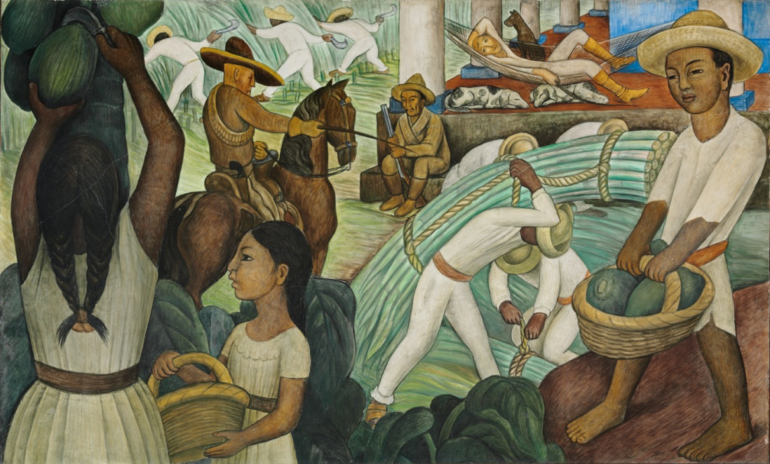
Materials: mania or white construction paper: 9”x12” (8), 6”x9” (25), 4.25”x6” (50)
Black markers, dark blue (or other dark) banner paper (about 6 feet), oil pastels, scissors, glue, digital camera to take photos of your town
Art Standards: 4.1.1, 4.1.2, 4.1.3, 4.1.5, 4.1.6, 4.2.1, 4.2.2, 4.2.3, 4.3.1, 4.4.1, 4.5.1
Alignment Standards: Social Studies 3.1.2, 3.1.6, 3.5.1, 3.5.2
Content Connections:
Social Studies

Art Elements | Art Principles
__Line | __Pattern
_x_Shape/Form | __Rhythm/movement
__Color | _X_Proportion/Scale
__Value | __Balance
__Texture | __Unity
_x_Space/Perspective | __Emphasis

Grade: Third Grade
Time: 2 Sessions
Vocabulary: mural, muralist
Perspective words: foreground, middle ground, background, size, overlapping and placement
Preparation:
Take digital photos of the major resources in your town. Locate any animal photos or objects important to where you live. If students have cameras, they could take pictures as well to down load and share. Photocopy the photos of resources, landmarks and buildings in your community. Cut construction paper to size and gather the rest of the materials.

I Cans/ Objectives:
I can learn the elements of perspective from the painting, Sugar Cane by Diego Rivera.
I can learn about murals and discuss any murals they might have in their community.
I can draw the most important buildings and landmarks in our community.
I can show perspective by knowing when to change an object’s size and by overlapping objects.

Lesson descriptio : Students learn about muralist Diego Rivera and how he used perspective to show near and far. A mural of their own town or village is drawn after planning the important resources, buildings, animals and landmarks that need to be included in the mural.
Teacher Background Knowledge:
*It will be helpful to be familiar with their community.
*Research Diego Rivera.

Lesson:
- Gather in a small group on the floor and display Sugar Cane by Diego Rivera. Explain that this is a reproduction (copy) of a painting that is about Mexico. A MURAL is painted directly on a wall or ceiling, but nowadays they are often painted on wood or clay and attached to the wall. Do you have a mural in your school or community? Why are murals different from paintings on canvas?
- Look closely at the Sugar Cane painting by Diego Rivera. Describe what you see in this painting. What are the people doing? We will look carefully at this painting to understand how perspective creates an illusion of space. An artist can use size, overlapping and placement to show perspective.
- Things NEAR or close to us are in the FOREGROUND. Both the man on the far right and the woman on the far left are placed at the bottom to the top of the painting to emphasize how NEAR they are in the foreground. PLACEMENT of objects in a painting is important to show perspective. Objects in the FOREGROUND often OVERLAP or are in front of the objects behind them.
- What foreground objects are overlapping the MIDDLE GROUND objects? The middle ground is found in the middle or center area of a painting.
- The sugar cane workers are far away so they appear very small in SIZE. They are placed in the BACKGROUND near the top of the painting.
- SIZE ILLUSION EXPERIMENT: Teacher should stand at the opposite end of the room from the students. Students should extend their arms with fingers spread out to look through their fingers at the teacher. Which is larger – the students hand or the teacher? Let the students explain why their hands are larger than the teacher.
- Diego Rivera was a Mexican artist who painted murals about the people of Mexico. The painting on the right is a self-portrait of Diego. The photograph on the left shows Diego with his palette and brushes as he paints the hands of someone in his mural. Notice the size of the fingers.

- As a group, brainstorm and list the resources and important landmarks in your town or village.
- It helps students to begin drawing their own homes first with the small 4.5”x6” manila or white paper. Use black markers to draw outlines and color in with crayons and cut out. Demonstrate how to draw their homes very simply, thinking of square and rectangle shapes with the triangular roof. Their homes will be placed along both ends of the mural like a border.
- The buildings in this mural will be positioned according to importance. The largest and most important buildings will be in the foreground. Other buildings will be arranged around them according to the most important human resources in your town. Homes can be placed along the side borders, as shown in the drawing below.
- Using the resource list the class made above, allow the students to think about what they want to draw and then assign them one thing. Begin with the most important human resource buildings and let them draw these with the largest paper because they will be placed at the bottom or foreground. The rest of the students will pick from the capital resources and so on. These will be in the middle ground and need the medium size paper.
- All mural drawings will be made on white or manila paper. Draw with the black marker first, and then color in areas with crayons. Colors can be overlapped for interesting effects.
- Students continue working on the mural adding more until it is full. They should think about where their drawing will be placed to determine the size of the paper and how large or small their objects should be. They might even draw people doing things. Threes or other natural landscape features can be added to fill in areas. Students will get more ideas as the mural progresses. This could be worked on for several days in their spare time.
- At first it will be important for the teacher to consult with students as to where objects should be glued to the mural. Once the main pieces are placed, students should be able to make decisions as to where their drawing should be glued.
- Important Hints:
  - Let students volunteer for the object they draw, for if they choose what they feel comfortable drawing, they will have more confidence to do the drawing. Us the resource list you developed about your community to make sure they are all assigned.
  - Encourage more confident artists to choose the more difficult buildings.
  - If students that didn’t get their first choice, let them think of one of the many other things needed.
  - Remind students that buildings and animals all begin with simple shapes. Then add detail.
  - Demonstrate how to draw on a different paper if students are having problems.

Brainstorm: What is important to include in a mural of your town?
Include categories such as human resources, capital resources, natural resources, historical buildings or places, landmarks, outdoor recreation – all seasons, population signs.

Mural Layout:
The placement of objects in the mural does not depend upon the actual layout of resources in your town. Choose objects of importance for the foreground and make them larger in size. Using your resource chart, enrich your mural with additional details. Glue down objects keeping perspective in mind.
Capitol resource area– use medium size paper.
Downtown area
University
Missouri River
Airport

Foreground – use large paper to draw buildings. Human resources would fill this area.
Homes (small paper)
Place along sides surrounding the community.
Assessment

Thumbs Down | Don’t Know | Thumbs Up | Assessment Question
 |  |  | Did you use your personal best during this lesson?
 |  |  | Did you actively listen and follow directions?
 |  |  | Did you use your creativity? (is it original?)
 |  |  | Did you complete your project?
 |  |  | Did you incorporate the art media?
 |  |  | Does the artwork show the elements and/or principles discussed?

