BPS Art Curriculum

Outer Space Water Color Resist
Materials:
12"x18" white paper
pencils
Sharpie markers
oil pastels
black watercolor paint
Grade: 3rd
Time: One 60 minute sessions
Ins 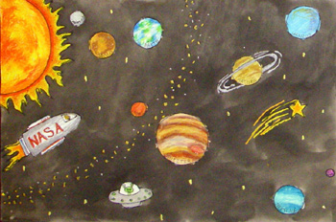here
Content Connections:
Science

Art Standards:
Alignment Standards:
Science: 3.5.5

Art Elements | Art Principles
__Line | __Pattern
__Shape/Form | _X_Rhythm/movement
_X_Color | _X_Proportion/Scale
__Value | _X_Balance
__Texture | __Unity
__Space/Perspective | __Emphasis

Preparation:
Have construction paper, oil pastels, and black watercolor paints available to students.
Vocabulary:
Oil pastel resist

I Cans/ Objectives
I can create an outer space picture.
I can use sharpie markers to draw space.
I can paint with watercolors to create an oil pastel resist picture.
Notes:
Lesson :
- Students will draw an outer space picture on a piece of white
12 X 18 construction paper.
- Students trace around space objects with a black sharpie.
- Color the inside of space pictures with oil pastels.
- Now, using black water color paint; paint over the picture. The oil pastels will resist the black watercolor paint.
Lesson description:
Students will create an outer space picture being as creative as they want to be using a watercolor resist technique.
( May use aliens, planets, stars, etc.)
Name___________________Lesson______________________
Assessment
Thumbs Down | Don’t Know | Thumbs Up | Assessment Question
 |  |  | Did you use your person best during this lesson?
 |  |  | Did you actively listen and follow directions?
 |  |  | Did you use your creativity? (is it original?)
 |  |  | Did you complete your project?
 |  |  | Did you incorporate the art media?
 |  |  | Does the artwork show the elements and/or principles discussed?

