BPS Elementary Art Curriculum

Title
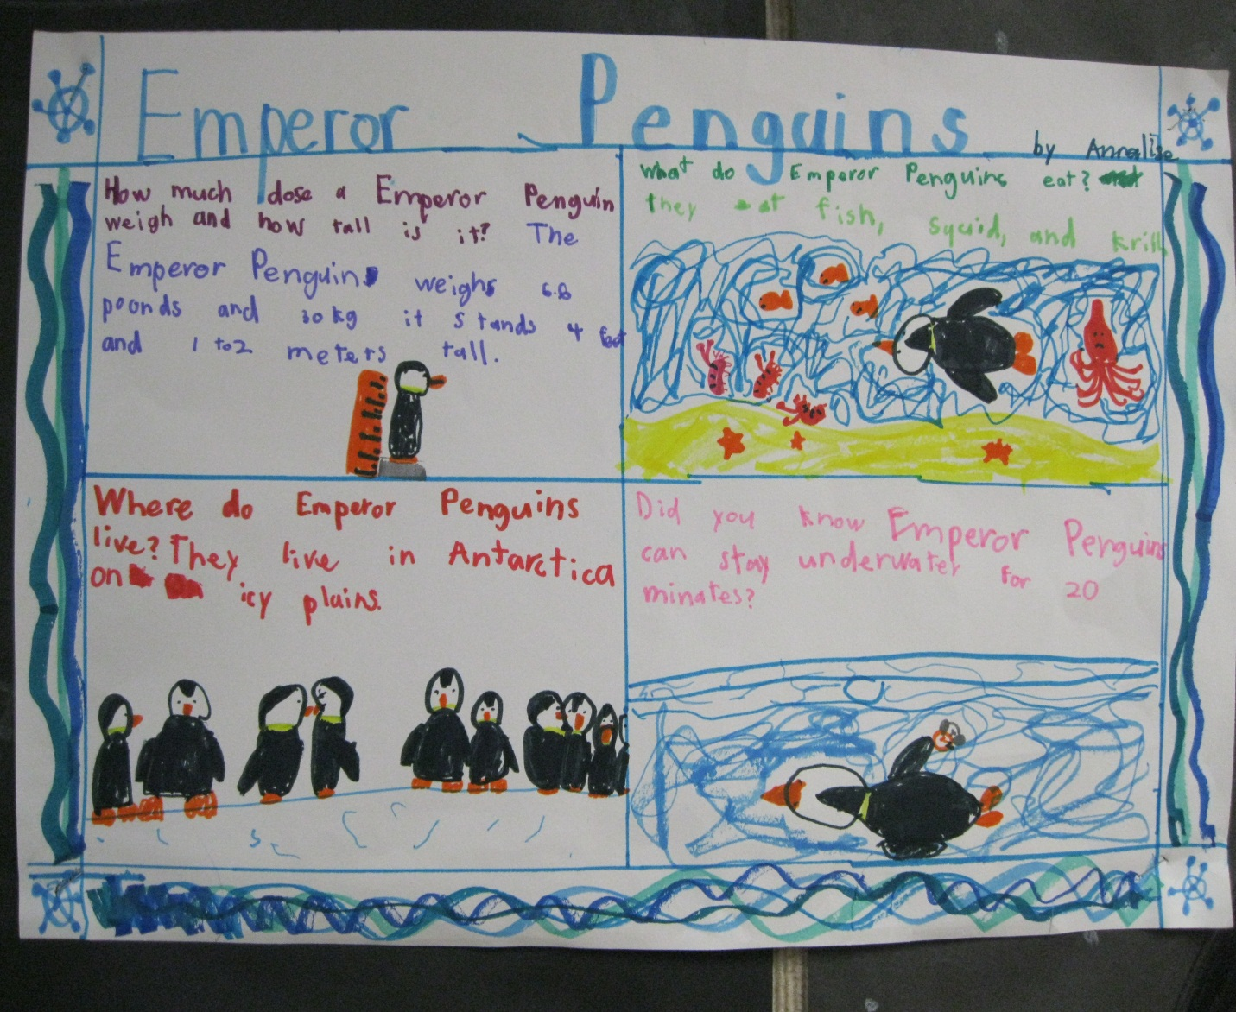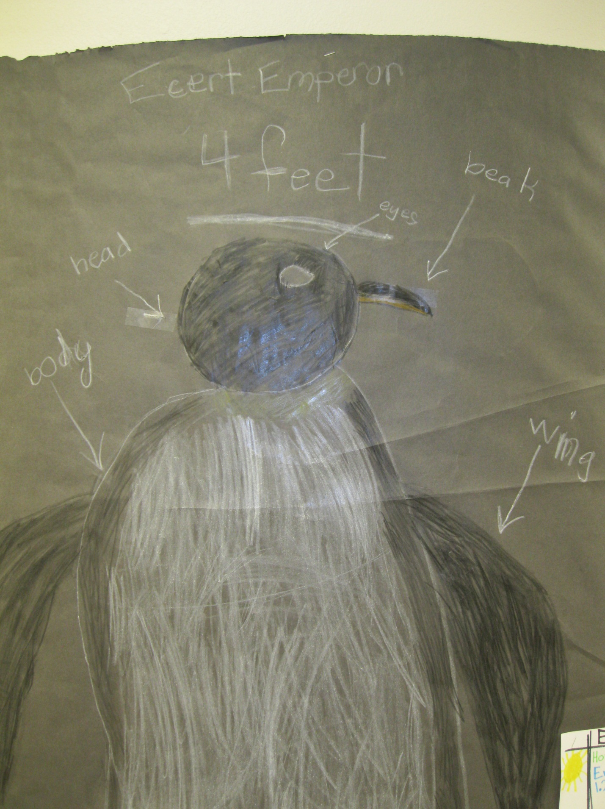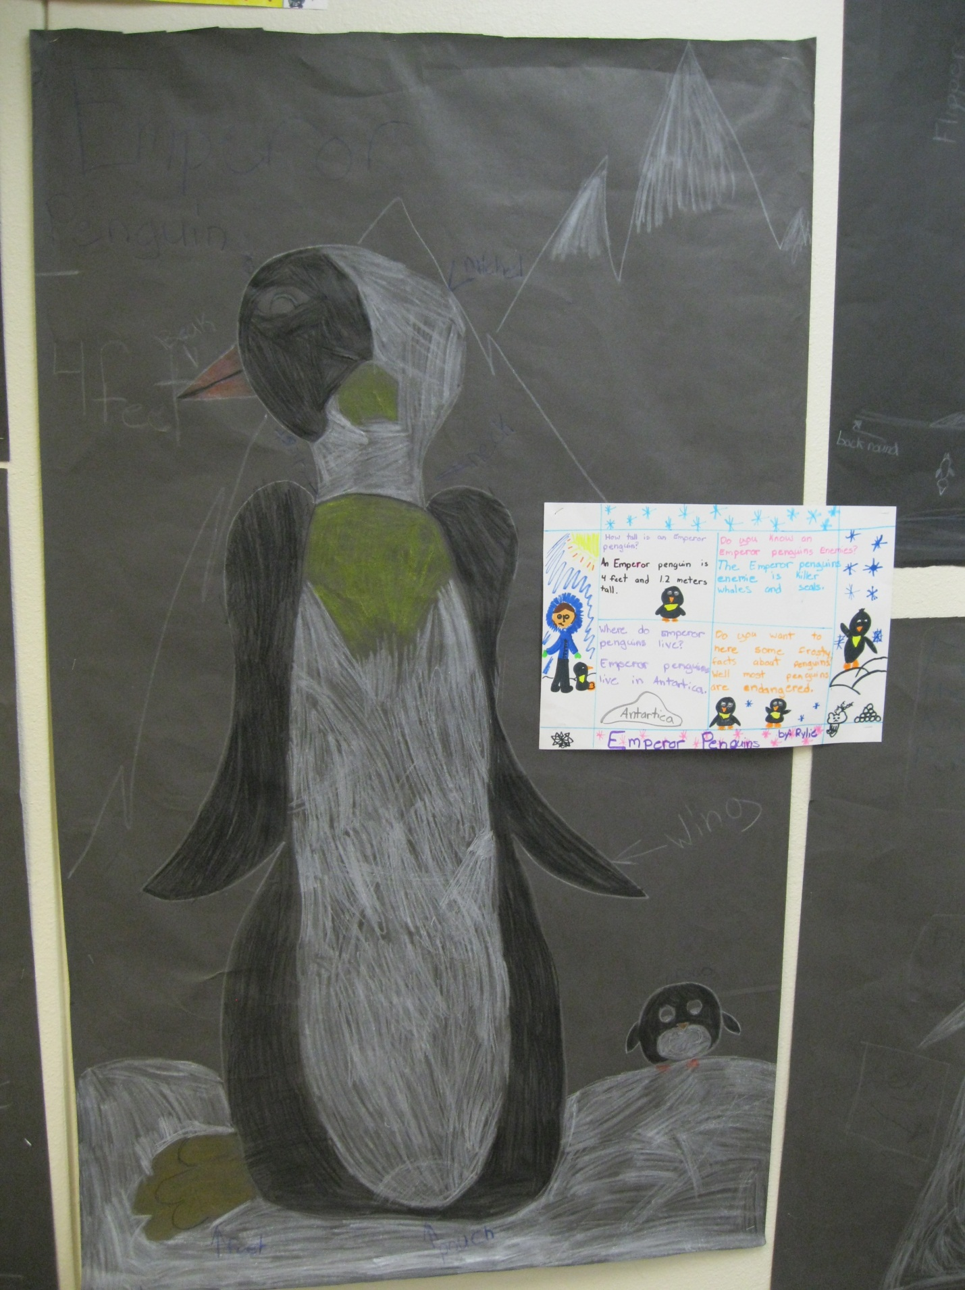
Art Standards: 4.1.5 Know how different visual art materials, techniques, and processes are used to communicate ideas, experiences and stories.
4.3.1 Understand how a varitet of subjects, themes, symbols and ideas are incorporated in a selection of works of art

Picture
Content Connections: 3.W.2.a Informative Writing
Reading: Students will write an informative text with topic of penguins.

Materials: Butcher paper, construction paper, crayons, markers, sharpies, rulers, yardsticks

Art Elements | Art Principles
_X_Line | __Pattern
_X_Shape/Form | __Rhythm/movement
_X_Color | _X_Proportion/Scale
__Value | X__Balance
__Texture | __Unity
__Space/Perspective | __Emphasis

Grade: 3
Time: 2 hours
Lesson :1. Students read Penguin Chick in Scott Foresman.
2. Student research with Pebble go, choose type of penguin.
3. Drawing actual dimensions of life-size penguin, and reporting and drawing penguin facts.
4. Add color and depth to drawings.
5. Publish for audience.

Preparation: Researching penguins, Pebble Go, RAN charts, getting art materials ready to go.
Vocabulary: line, shape/form, color, proportion/scale, balance

Nderstands the line, shape, color, proportiona
I Cans: I can draw lines and shapes that have depth, length and width. I can use proportion and balance to make penguins life-size according to their dimensions. Use symmetry to make them pleasing to the eye.

Teacher Background Knowledge:
Teacher understands line, shape/form, color, proportion/scale and balance.

Name___________________Lesson______________________
Assessment
Thumbs Down | Don’t Know | Thumbs Up | Assessment Question
 |  |  | Did you use your personal best during this lesson?
 |  |  | Did you actively listen and follow directions?
 |  |  | Did you use your creativity? (is it original?)
 |  |  | Did you complete your project?
 |  |  | Did you incorporate the art media?
 |  |  | Does the artwork show the elements and/or principles discussed?

