BPS Art Curriculum

Symmetrical Anemones
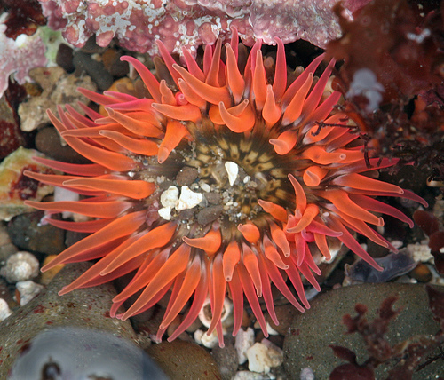
Content Connections:
Science: Sea life
Math: radial symmetry
Art Standards: 4.6.2, 4.1.1, 4.1.2, 4.1.3, 4.1.4, 4.1.5, 4.1.6, 4.2.1, 4.2.2, 4.6.2
Alignment Standards:
Math:
Science: 3.4.3
Materials: 12x18 construction paper assorted “sea” colors, oil pastels, liquid tempera (yellow, blue, white, magenta, orange, green, violet), sponge brushes

Art Elements | Art Principles
_x_Line | __Pattern
_x_Shape/Form | _x_Rhythm/movement
_x_Color | __Proportion/Scale
__Value | _x_Balance
_x_Texture | __Unity
__Space/Perspective | __Emphasis

Grade: 3
Time: 1 session
Preparation: Select 12x18 construction paper in ‘sea colors’ assorted blues, greens, grays,… Display colors for students. Have oil pastels available-students only need one color.
Vocabulary: contrast, radial design, primary colors

Lesson:
- Explain the term contrast. Contrast means two objects are very different in color and in lightness/darkness. Test them with different color combinations. If they use dark paper then use light oil pastel, and vice versa.
- Explain that the paper color will represent the sea and the oil pastel will be the water. Show them that it can be vertical or horizontal.
- Demonstrate how to draw the water lines. Be sure to use an oil pastel, touch each edge, and draw interesting wavy lines across the page. Press hard with the pastel and move hand slowly as you press and draw lines. The goal is for strong lines.
- Now have students get one paper, one contrasting oil pastel and draw their water lines.
- Place a blob of paint (size of a 50 cent piece) in or near center of paper.
- Put a smaller blob of paint in another size the same color on top of that blob.
- Demonstrate holding the foam brush and pulling from the middle outward.
- Give students paint trays with three colors to share. Some will have primary colors and some will have secondary colors.
- Using the same color as in center dab, touch the brush to the end of each leg. Use big dabs for fat legs and small ones for thin legs.
- Pick up a bit of each on the end of the brush, dab in the water area to make little multi-colored fish.

I Cans
I can create a radial design.
I can create symmetry.
I can use a brush in different ways.
I can discuss art with a partner.
Teacher Background Knowledge:
Sea anemones are invertebrates that live in the sea. They attach themselves to rocks, coral, and other permanent objects, but can move slowly along these. There are over 1000 known different types in the world that come in all shapes, sizes, and colors. In appearance, sea anemones are an example of radial design or radial symmetry. They have a tube-like body with a mouth in the center that is surrounded by tentacles. The tentacles protect the anemone and catch its food. They are studded with very small stingers at the tips. Sea anemones are usually about 1 to 4 inches, but a few grow to be 6 feet across! Sea anemones are carnivores that eat fish, shellfish and other sea life. They catch their food using their tentacles which have poisonous stingers.
Symmetrical arrangement of parts of an organism around a single main axis, so that the organism can be divided into similar halves by any plane that contains the main axis. The body plans of echinoderms, ctenophores, cnidarians, and many sponges and sea anemones show radial symmetry.

Lesson description:
Students look at pictures of sea anemones and discuss radial design. They learn primary colors and then paint a large anemone with a wave-line background.
Name___________________Lesson______________________
Assessment
Thumbs Down | Don’t Know | Thumbs Up | Assessment Question
 |  |  | Did you use your personal best during this lesson?
 |  |  | Did you actively listen and follow directions?
 |  |  | Did you use your creativity? (is it original?)
 |  |  | Did you complete your project?
 |  |  | Did you incorporate the art media?
 |  |  | Does the artwork show the elements and/or principles discussed?
 |  |  | Did you create radial symmetry?

