Winter Olympic Athlete Art
BPS Elementary Art Curriculum

Olympics
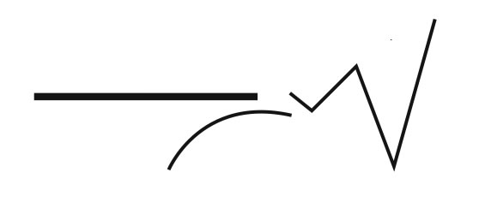
Grade: Third Grade
Time: 1-2 times a month
Content Connections:
Students are connecting the Winter Olympic sport with researching, informative writing, prepositional phrases, and mediums of art.
Art Standards: 4.1.5
Alignment Standards:
Materials: Black or blue construction paper, oil pastels, chalk, variety of colors of construction paper, faces of students and prepositional phrases template

Art Elements | Art Principles
__Line | __Pattern
_x_Shape/Form | __Rhythm/movement
_x_Color | __Proportion/Scale
__Value | _x_Balance
__Texture | __Unity
_x_Space/Perspective | __Emphasis

Preparation
Students will have researched a specific Winter Olympic sport to find out important facts about what they wear and use for their sport. They will also learn about what that sport is and its difficulty.
Vocabulary: Winter Olympic sports, athlete, prepositional phrases

I Cans
I can use different mediums of art to create my background.
I can use prepositional phrases to describe my winter Olympic scenery.

Lesson description:
Students use a picture of their face to create a Winter Olympic athlete. They create 5 prepositional phrases to describe where they are in the Winter Olympics.

Teacher Background Knowledge
Lesson
Give each student a picture of their face. They are to design their Olympic sporting wear to fit their Winter Olympic sport. They will be using oil pastels, chalk, and/or watercolor paints to create the background on black or blue construction paper. They will be using a variety of colors of construction paper to make their outfit before they put their face on.
Students may write their prepositional phrases before or after creating their athlete. Type up and have on display with their Winter Olympic athlete.
Name___________________Lesson______________________
Assessment
Thumbs Down | Don’t Know | Thumbs Up | Assessment Question
 |  |  | Did you use your personal best during this lesson?
 |  |  | Did you actively listen and follow directions?
 |  |  | Did you use your creativity? (is it original?)
 |  |  | Did you complete your project?
 |  |  | Did you incorporate the art media?
 |  |  | Does the artwork show the elements and/or principles discussed?
Source

