**BPS Elementary Art Curriculum**

Lines

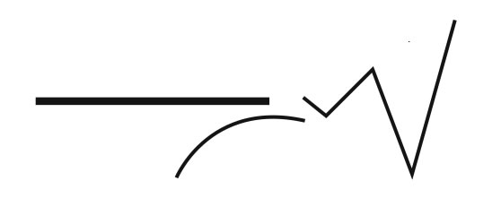

Materials:

Bedhead Story by Margie Palentini , I Want One Too by Brenda Ehrmantraut, White Construction Paper, Circle Templates, Pencil, Color Pencils, Crayons, Oil Pastels, Kleenexes

W

Content Connections:

Persuasive Writing

Self Portraits Of Major Meltdowns

Art Standards: ART-ES.1.05

Alignment Standards: Persuasive Writing

|  |  |
| --- | --- |
| **Art Elements** | **Art Principles** |
| _X_Line | __Pattern |
| _X_Shape/Form | __Rhythm/movement |
| _X_Color | _X_Proportion/Scale |
| __Value | __Balance |
| __Texture | __Unity |
| __Space/Perspective | _X_Emphasis |

Grade: Second Grade

Time: 45 minutes to 60 Minutes

Preparation: Gather Up Read Aloud Books and Materials . Perhaps just prepare an art example to have the students see a final product in advance.

Vocabulary: Lines, Circles, Feelings, Behaviors, Persuasion

I Cans : Standard 1: Students understand and apply visual art media, techniques, and processes. ART-ES.1.05 Know how different visual art media, techniques, and processes are used to communicate ideas, experience, and stories.

Lesson description: Refer To Lesson Description.

Teacher Background Knowledge:

Lesson: Read the stories Behead by Margie Palantini and I Want One Too by Brenda Ehrmantraut aloud to the class. After reading the story aloud, have a discussion with the class about any possible connections between both stories and how the characters looked and perhaps felt. Ask them if perhaps they ever have experienced a not so good day when they weren’t feeling their personal best or perhaps looking their personal best. Perhaps they have had a major meltdown moment. Today they will bringing what they look like when they are at their worst instead of looking like what they look like when they are at their personal best or having a perfect picture taken for student photo day. Perhaps they will have their eyes closed and crying, mouths open and screaming, hands over their faces holding tissues, or perhaps caught in the moment throwing a terrible tantrum shouting out words. Pass out materials and have the students get started. Once finished, the next step would be to have them write a persuasive writing about something they have thrown a meltdown or a tantrum for.

Name___________________Lesson______________________

*Assessment*

|  |  |  |  |
| --- | --- | --- | --- |
| **Thumbs Down** | **Don’t Know** | **Thumbs Up** | **Assessment Question** |
|  |  |  | Did you use your personal best during this lesson? |
|  |  |  | Did you actively listen and follow directions? |
|  |  |  | Did you use your creativity? (is it original?) |
|  |  |  | Did you complete your project? |
|  |  |  | Did you incorporate the art media? |
|  |  |  | Does the artwork show the elements and/or principles discussed? |
|  |  |  |  |
|  |  |  |  |
|  |  |  |  |

Source