BPS Elementary Art Curriculum

Animal Journal Entry
Content Connections:
Lewis and Clark Journals
North Dakota Animals
Informative Writing

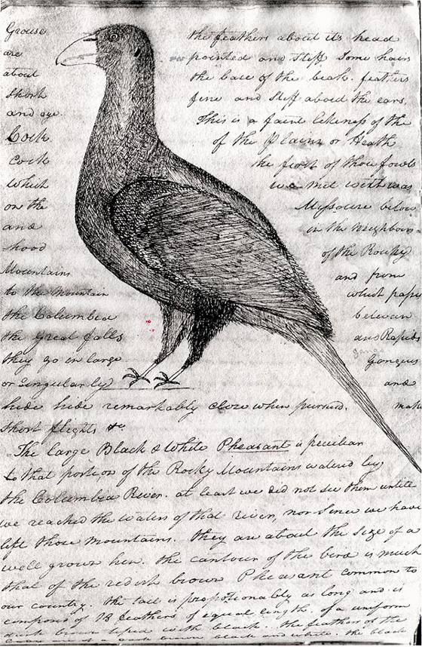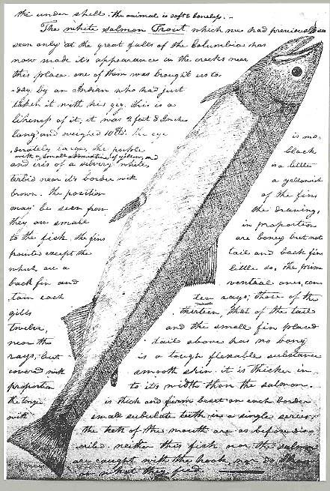
Art Standards:
4.1.1-4.1.6
Alignment Standards:
4.W.2, 4.2.8

Materials:
Pictures of ND animals, pencils, paper, black ink pens.

Art Elements | Art Principles
_X_Line | _X_Pattern
_X_Shape/Form | __Rhythm/movement
__Color | __Proportion/Scale
_X_Value | __Balance
__Texture | __Unity
__Space/Perspective | __Emphasis

Grade: 4th Grade
Time: 2-3 Sessions

Preparation:
- Find resources on North Dakota animals.
- Have examples of Lewis and Clark journal entries.
- Pictures of North Dakota animals.

Vocabulary: Observe, Value, Shading

I Cans
I can draw a realistic picture of an animal.
I can write an informative piece about the animal I chose.

Lesson
First Session:
- Each student chooses an animal from ND to research and draw.
- Students will read a variety of journal entries about new animals.
- Students research facts about their animal and start writing their journal entry.
Second Session:
- Students can peer edit and revise their writing.
- Show examples of observing a picture and drawing what you see. Also explain how to shade with a pencil.
- Have students experiment using these techniques.
- Students will start sketching their animal.
Third Session:
- Students finish their writing and drawing.
- Students will copy their journal writing around their animal drawing so it looks similar to the journals.

Teacher Background Knowledge
Observe- noticing shapes and patterns in a picture.
Value- relative lightness and darkness. Value is perceived in terms of varying levels of contrast.
Shading- the representation of the different values of color or light and dark in a painting or drawing.
Lewis and Clark sketched animals in their journals and wrote descriptions around them.
Name___________________Lesson______________________
Assessment
Thumbs Down | Don’t Know | Thumbs Up | Assessment Question
 |  |  | Did you use your personal best during this lesson?
 |  |  | Did you actively listen and follow directions?
 |  |  | Did you use your creativity? (is it original?)
 |  |  | Did you complete your project?
 |  |  | Did you incorporate the art media?
 |  |  | Does the artwork show the elements and/or principles discussed?
 |  |  | Does your writing accurately describe the animal?
 |  |  | Does your animal look realistic?

