BPS Elementary Art Curriculum

Life of an Affiliated Tribe Member
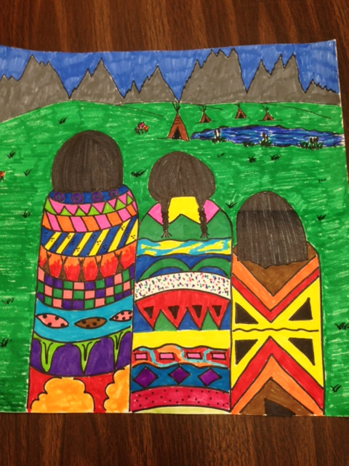
Content Connections:
*Scott Foresman story called “Lewis & Me”
*Social Studies Units – American Indians of ND and Frontier Era of ND
*Informative Writing on different ND tribes

Art Standards: ART-4.2.1, ART-4.1.2
Alignment Standards:
SST-04.2.06, SST-04.2.08
ELA-04.W.02

Materials: white construction paper, markers, and black permanent marker

Art Elements | Art Principles
_X_Line | __Pattern
__Shape/Form | __Rhythm/movement
_X_Color | _X_Proportion/Scale
__Value | _X_Balance
__Texture | __Unity
_X_Space/Perspective | __Emphasis

Grade: 4
Time: 1 or 2 sessions
Preparation:
Teach the Social Studies Unit on American Indians of ND before doing this lesson.

Vocabulary:
Symmetry, Geometric Design, Lines, Shading, Complimentary and Supplementary Colors

Lesson
- Each child will draw three circles on their paper with a pencil. These circles will represent the head of their three Native Americans.
- Make an upside down U from the circle to the bottom of the page. This will represent the shawl they have wrapped around themselves.
- Demonstrate how to make these circles into back of heads. Show the different hairstyles that they could use.
- Discuss symmetry and geometric designs. Show how to make patterns on the shawl. Talk about complimentary and supplementary colors. The brighter colors the better! When your drawing is done, go over it with a black permanent marker.
- After the Native Americans are done, they should add a background. They should use their Social Studies knowledge to add the right habitat, dwelling, etc…
- Color your picture, with markers. Remember to color in one direction.

Extension:
In small groups have students make a color wheel to give them and idea of mixing colors.
Write an informative writing piece about a Mandan, Hidatsa, and/or an Arikara Indian.

Thank you to Karla Slind for showing this wonderful art lesson when she was an art teacher. It has come in very handy with 4th grade curriculum.
I Cans
I Can choose complimentary or supplementary colors for the Native American shawl.
I Can demonstrate the correct dwelling or background setting for my artwork.

Teacher Background Knowledge

Complementary colors: Are colors that are opposite of each other on the color wheel.
Supplementary colors: Are colors that are next to each other on the colors wheel.

Background knowledge of a tipi, earth lodge and/or a wigwam.

Name___________________Lesson______________________
Assessment
Thumbs Down | Don’t Know | Thumbs Up | Assessment Question
 |  |  | Did you use your personal best during this lesson?
 |  |  | Did you actively listen and follow directions?
 |  |  | Did you use your creativity? (is it original?)
 |  |  | Did you complete your project?
 |  |  | Did you incorporate the art media?
 |  |  | Does the artwork show the elements and/or principles discussed?

