BPS Elementary Art Curriculum

Multiplication City Art

Art Elements | Art Principles
__Line | __xPattern
_x_Shape/Form | __Rhythm/movement
_x_Color | _x_Proportion/Scale
__Value | __Balance
__Texture | __Unity
__xSpace/Perspective | __Emphasis

Content Connections:
Math: Arrays/Multiplication fact families

Art Standards: ART-ES.1.04

Math Standard: MAT-04.NBT.05

Materials: Construction Paper, Glue, Scissors, Rulers, See attached Multiplication City sentences worksheet
Grade: 4th Time: 1 Session
Time:
Preparation: Construction paper, Amanda Bean’s Amazing Dream, Attached Sentence Worksheet
Lesson
*Read Amanda Bean’s Amazing Dream
* use a ruler to create straight lines
*create a cityscape
*on each building include an array (using windows or items in a window)
*complete the chart describing the art using multiplication sentences
*Students completed two charts - one with answers and one without - so that people could find the correct object and then check their answers on the second page.

Vocabulary:
Array

I Cans
- I can multiply a whole number up to four digits by a one digit by using strategies based on illustrations, equations, rectangular arrays, and/or area models.
- I can create different visual art materials by using different techniques and processes causing different responses.

Teacher Background Knowledge:
We started by reading this book, focusing on how the pictures showed multiplication!
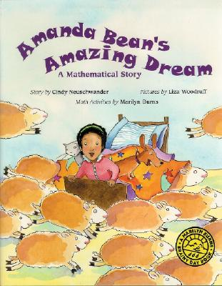

Name___________________Lesson______________________
Assessment
Thumbs Down | Don’t Know | Thumbs Up | Assessment Question
 |  |  | Did you use your personal best during this lesson?
 |  |  | Did you actively listen and follow directions?
 |  |  | Did you use your creativity? (is it original?)
 |  |  | Did you complete your project?
 |  |  | Did you incorporate the art media?
 |  |  | Does the artwork show the elements and/or principles discussed?

