BPS Elementary Art Curriculum

Feelings Wash Over
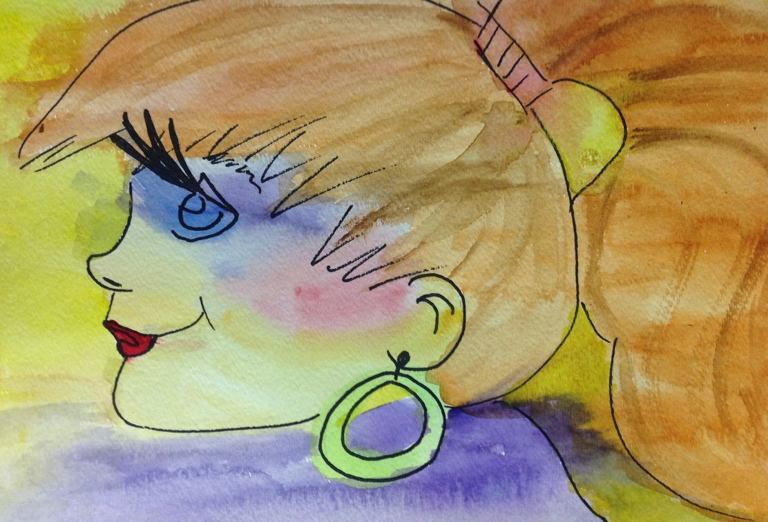
Content Connections: Health

Art Standards: 4.5.1, 4.52

Materials: Copies of expressions, Crayons, colored pencils, or permanent markers, sharpies, white drawing paper, masking tape, tempera paint thinned with water or watercolors, soft paintbrush, paper towel

Art Elements | Art Principles
__Line | __Pattern
__Shape/Form | __Rhythm/movement
_x_Color | _x_Proportion/Scale
__Value | __Balance
__Texture | __Unity
__Space/Perspective | __Emphasis

Grade: 4th
Time: 50 minutes
Preparation
You can practice drawing facial expressions with students. You can also do a prior lesson about facial proportion (where facial features are located on the face).
Vocabulary:
Expressions

I Cans
I can express how I feel in my drawings.
I can use watercolors to create an effect.
Teacher Background Knowledge
Edward Hopper was a Realist who painted pictures of America during the first half of the 1900’s. While many artists of his time were exploring abstract art and pure design, Hopper chose to paint scenes of real American life-everyday ordinary scenes that became very powerful with Hopper’s vision. Hopper grew up in the Hudson River town of Nyack, New York. He loved the boats along the river and once wanted to be a ship builder but decided on a career as an artist. In 1900, he moved to New York City to study art and to become a professional illustrator and painter. For a period of time, he was part of the group of artists who called themselves the Ashcan School. He lived in Paris for several years and then he returned to New York where he lived and worked the rest of his life. Hopper is best-known for artwork that portrays a feeling of loneliness. His paintings often picture an open window in the corner of an empty room, a lone person sitting by a window, or several people together yet lost in thought and separated from each other. His landscapes show isolated houses in the country or bleak city streets. Yet Hopper’s paintings are rich with simple shapes and colors and glowing light. His unique style and the emotional power of his paintings make Edward Hopper a true American artistic genius.
Lesson
- Think of an emotion to express through drawing. Facial expressions are a good beginning way to draw emotional expression. Smiling, crying, frowning, and smirking are examples.
- Draw and color the picture on white paper with sharpie. Any style of drawing will do, weather fully detailed or simple and bold.
- When the drawing is complete, tape all four sides to the table or workspace with masking tape lightly pressed to the paper.
- Think about what color paint-wash will express the emotion of the drawing. Mix a little paint in a container of clear water. /The water should have color, but only enough to color the paper lightly.
- Wash over the drawing with the thinned paint, using a soft brush that holds a generous amount of the wash. Cover the entire drawing with thin color. Extra puddles may be soaked away with paper towels, tissue, or a clean sponge. Then let dry.
- Carefully peel the masking tape from the paper. A clean unpainted ‘frame’ will remain.
- Discuss how the facial features make you feel.
Name___________________Lesson______________________
Assessment
Thumbs Down | Don’t Know | Thumbs Up | Assessment Question
 |  |  | Did you use your personal best during this lesson?
 |  |  | Did you actively listen and follow directions?
 |  |  | Did you use your creativity? (is it original?)
 |  |  | Did you complete your project?
 |  |  | Did you incorporate the art media?
 |  |  | Does the artwork show the elements and/or principles discussed?
 |  |  | How do the colors in your painting make you feel?
 |  |  | How does the person in your drawing feel?

