BPS Elementary Art Curriculum

Meet the Artist: Frank Stella
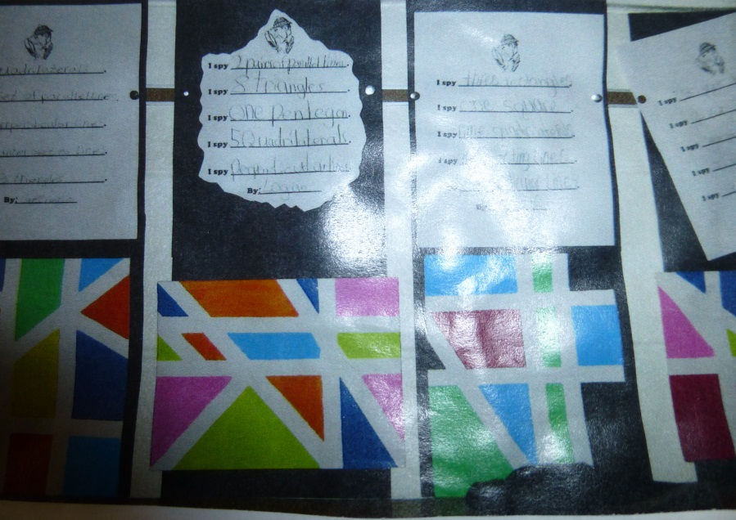
Content Connections:
Math: Shapes, Geometry

Art Standards: 4.6.1,4.6.2.,4.1.1-4.1.6, 4.2.1, 4.2.3
Alignment Standards: ELA: L.2, Math: 4.G.2
Materials: White 9 x 12 paper, masking tape or blue painter’s tape, paint, paint brushes,
I Spy sheet

Art Elements | Art Principles
_x_Line | _x_Pattern
__Shape/Form | __Rhythm/movement
_x_Color | __Proportion/Scale
__Value | __Balance
__Texture | __Unity
__Space/Perspective | __Emphasis

Grade: 4
Time: 1 hour
Preparation
Students need to have a background on 2D figures( polygons, triangles, parallelagrams, etc.)
Gather paint , brushes, masking tape, paper

Vocabulary: line, 2D figures ( polygons, triangles, parallelagrams, etc.)

I Cans :
I can identify shapes in a piece of art.
Teacher Background Knowledge
Lesson description:
Students will identify shapes in their art piece.
Lesson
1. Give each student a white sheet of construction paper and some masking tape.
2. Students place masking tape down on paper in straight lines to create shapes. Press firmly.
3. Students paint the shaped areas with different colors of paint.
4. Let dry.
5. Remove the tape slowly being careful not to tear the paper.
6. Students use the I Spy paper to write down shapes that they see in their design.
Name___________________Lesson______________________
Assessment
Thumbs Down | Don’t Know | Thumbs Up | Assessment Question
 |  |  | Did you use your personal best during this lesson?
 |  |  | Did you actively listen and follow directions?
 |  |  | Did you use your creativity? (is it original?)
 |  |  | Did you complete your project?
 |  |  | Did you incorporate the art media?
 |  |  | Does the artwork show the elements and/or principles discussed?
Source

