BPS Elementary Art Curriculum

North Dakota Map Flip Book
Content Connections:
- North Dakota Map Skills
- Researching Strategies
- Visual Representations
- Visual Understandings
- Teamwork
Art Standards:
4.1.2: Know the visual techniques to create visual art
4.2.3: Know functions of works of visual art to communicate ideas

Materials:
Scissors, construction paper, thin black marker, stapler, research materials

Art Elements | Art Principles
X Line | __Pattern
X Shape/Form | __Rhythm/movement
__Color | X Proportion/Scale
__Value | __Balance
__Texture | X Unity
X Space/Perspective | __Emphasis

Grade: 4th Grade
Time: 1 week, 20 min./day
Preparation:
Gather the following materials:
Large12 x 18 construction paper. (light blue, green, white, gray).
Scissors for every student.
Thin black marker & pencil for every student.
Long arm stapler
Vocabulary:
Red River Valley, Missouri Plateau, Drift Prairie
Devils Lake, Lake Sakakawea, Missouri River, Red River
I-94, I-29, US-83, US-85, US-2
Bismarck, Fargo, Grand Forks, Williston, Dickinson, Minot
Outline, Line, Size, Relative Location, Shape, Color, Scale, Direction

Lesson
- Students should create their region map first. Fold the green construction paper in half hamburger style. Cut out the east side of the map similar to the pattern of the Red River. This map will be used as a template for the other maps to be created.
- Students will then cut from the south end of the map (unfolded side) where the regions actually are located, up to the top of the map. When you flip the regions, you will be able to see what cities are in each region.
- On the back inside of the map, students will research facts about each region to place in their book.
- Continue on with the city map, major bodies of water map, and political feature (highway) map of ND using above formats. The region map will be the top map and the only map that is cut through the middle. The other maps will only be cut along the Red River side.
- See Pictures below…
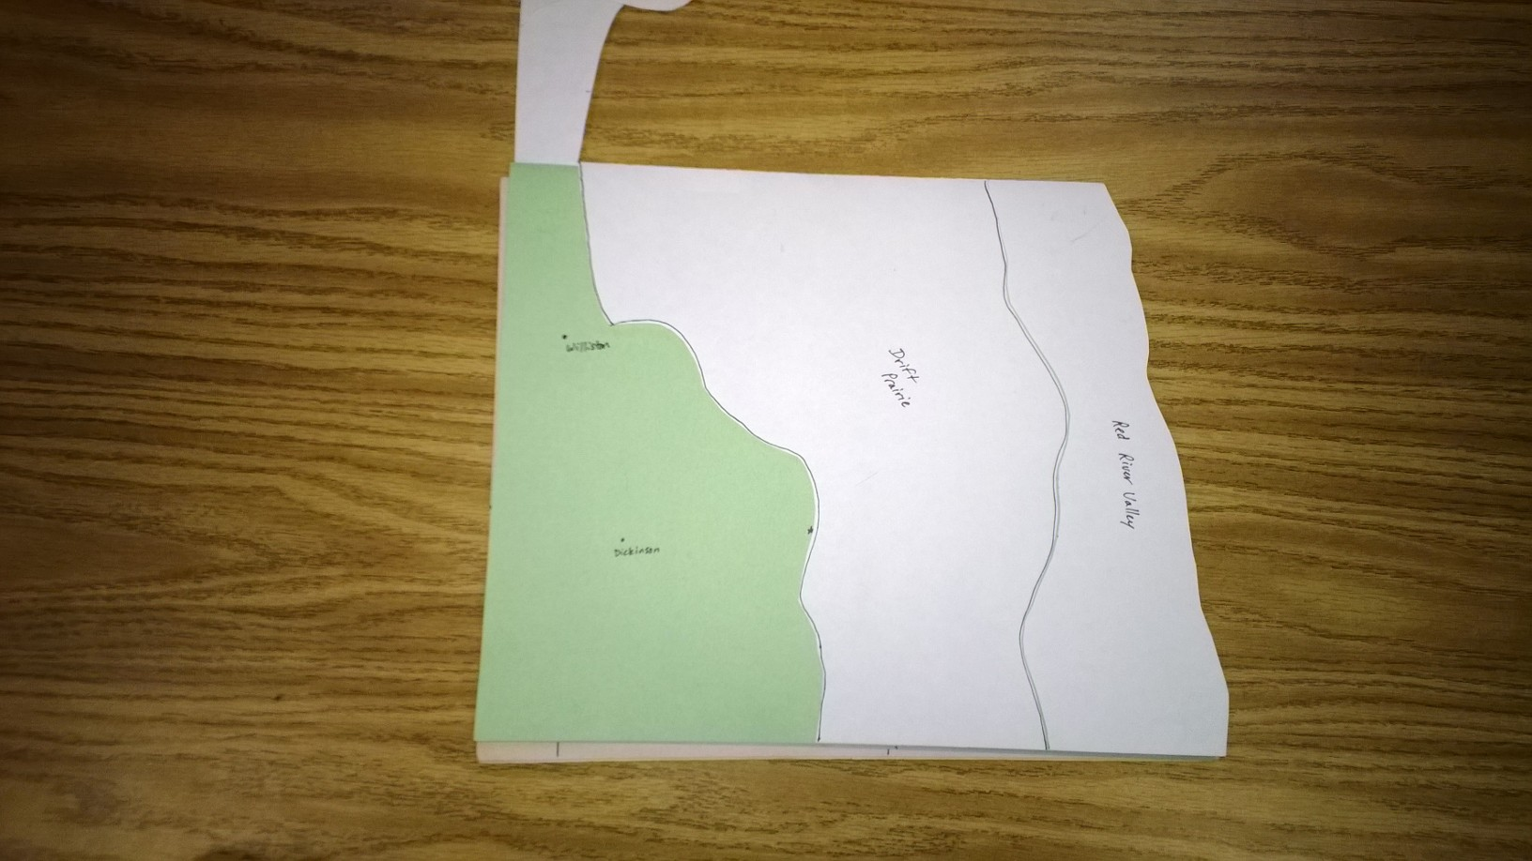
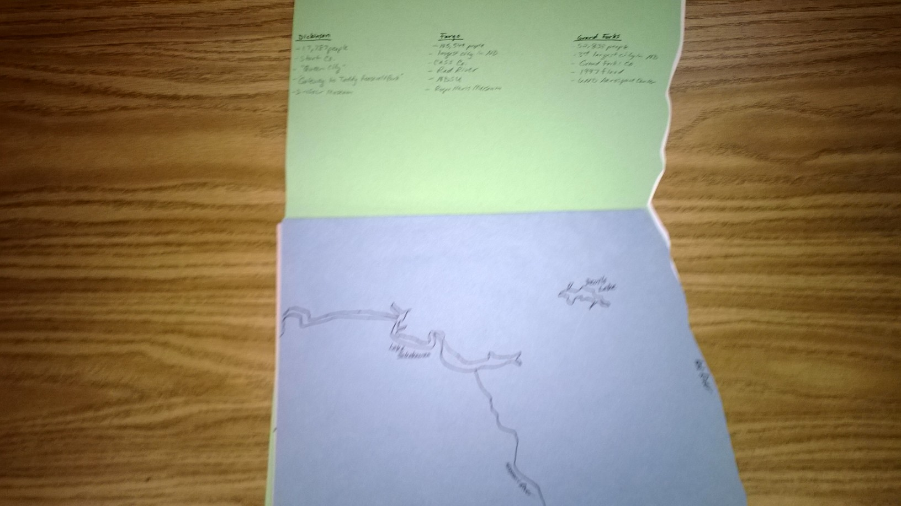
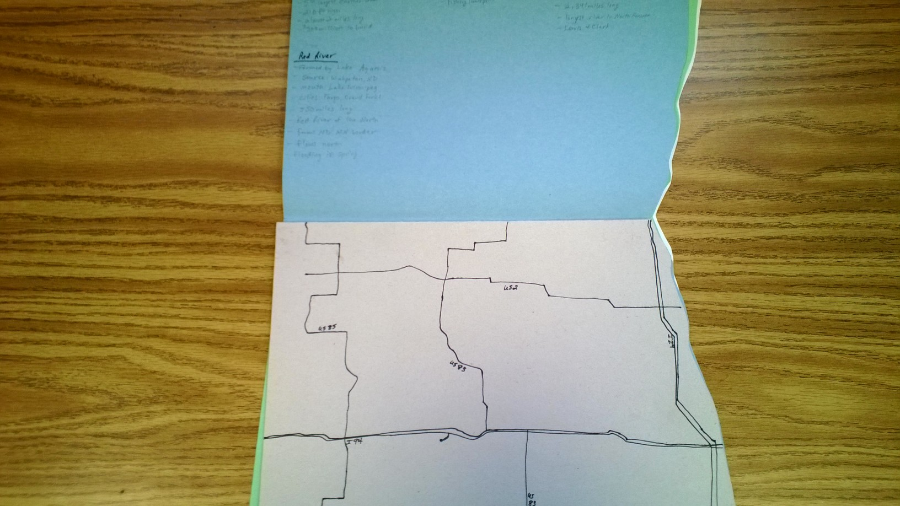

I can locate at least six major cities: Fargo, Bismarck, Grand Forks, Minot, Dickinson, And Williston on ND a map (i.e., ND Highway Map).
I can locate major bodies of water in North Dakota. (i.e. Missouri River, Red River, Lake Sakakawea, Devils Lake).
I can create a map of North Dakota then identify the three main geographic features; Red River Valley, Drift Prairie, and Missouri Plateau.
I can create a map with political features. (i.e. the six major cities, I 94 & 29 Hwy 2, 83, 85.
I can draw an outline of ND from memory.
Teacher Background Knowledge
Teacher should have an understanding of the shape of ND, the 6 major cities of ND, the major bodies of water of ND, and the political features of ND.

Name___________________Lesson______________________
Assessment
Thumbs Down | Don’t Know | Thumbs Up | Assessment Question
 |  |  | Did you use your personal best during this lesson?
 |  |  | Did you actively listen and follow directions?
 |  |  | Did you use your creativity? (is it original?)
 |  |  | Did you complete your project?
 |  |  | Did you incorporate the art media?
 |  |  | Does the artwork show the elements and/or principles discussed?

