BPS Elementary Art Curriculum

Quilting with Fractions and Symmetry
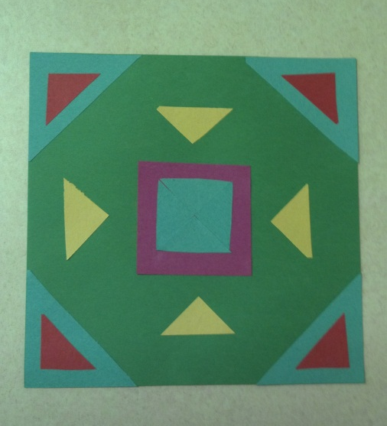
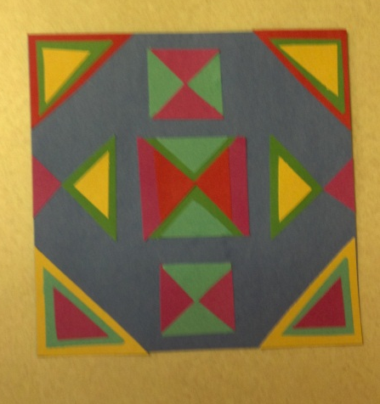
Content Connections:
Math: equivalent fractions, lines of symmetry
Social Studies: historical events, settlement of ND

Art Elements | Art Principles
_x_Line | _x Pattern
_x_Shape/Form | __Rhythm/movement
_x_Color | __Proportion/Scale
__Value | _x_Balance
__Texture | __Unity
__Space/Perspective | __Emphasis

Grade: 4 Time: 1 sessions
Art Standards: 4.1.1, 4.1.2, 4.1.3,4.4.1,4.5.1, 4.6.2
Alignment Standards:
Math: 4.NF.1, 4.G.3
Social Studies: 4.2.9

Materials: 9” x 12” construction paper of various colors
Glue
Scissors
Ruler
Vocabulary:
Symmety: horizontal, diagonal, vertical
Equivalent fractions
Pattern
Slide, Rotate
Quilt block

Preparation:
Cut various colors of 9 x 12 paper into squares of 9” x 9”.
Cut various colors into squares of 3” x 3”
Make a sample to show students
Research the history of quilting

Teacher Background Knowledge
Quilt making was common in the late 18th century and early years of the 19th. Most women were busy spinning, weaving and sewing in order to clothe their family. Commercial blankets or woven coverlets were a more economical bedcovering for most people. Only the wealthy had the leisure time for quilt making so Colonial quilting was done by only a few.
Obviously quilts were not made of left over scraps or worn clothing as a humble bedcovering during this period. Instead they were decorative items that displayed the fine needlework of the maker such as the Baltimore album quilts.
Whole cloth quilts, broderie perse and medallion quilts were the styles of quilts made during the early 19th century.

I Cans /Objectives:
I can identify symmetry as I arrange squares, rectangles, and triangles into a quilt block.
I can cut squares into equal geometric shapes and identify equivalent fractions.
I can create a quilt block.

Lesson description: Students learn about the history of quilt making. They cut shapes from squares using equivalent fractions and design a quilt square block using symmetry.

Lesson :
- Share some history on quilting .
- Show students a sample of a some quilt blocks. Discuss how the designs have used the equivalent fractions and the lines of symmetry.
- Demonstrate how the 3” x 3” squares can be cut into 1/2, 1/4, and 1/8. Folding the squares can help make equal cuts.

- Let each student chose a 9” x 9” colored square as well as some 3” x 3” squares.
- Students symmetricly arrange the pieces on the 9” x 9” piece of paper.
- They should design the quilt square checking to make sure their design has at least one line of symmetry.
- Students check their own quilt block for symmetry, then have the teacher double check before gluing the design.
- Glue the design down.
- When the entire class is done, hold up each quilt block and as a class, locate the line of symmetry. Also discuss if the pieces used are 1/2, 1/4,or 1/8.
- Use a large piece of roll paper and glue the blocks down to form a class quilt.

Name___________________Lesson______________________
Assessment
Thumbs Down | Don’t Know | Thumbs Up | Assessment Question
 |  |  | Did you use your personal best during this lesson?
 |  |  | Did you actively listen and follow directions?
 |  |  | Did you use your creativity? (is it original?)
 |  |  | Did you complete your project?
 |  |  | Did you incorporate the art media?
 |  |  | Does the artwork show the elements and/or principles discussed?

