BPS Elementary Art Curriculum

Rainforest Art

Art Elements | Art Principles
X Line | X Pattern
X Shape/Form | __Rhythm/movement
X Color | X Proportion/Scale
__Value | __Balance
__Texture | __Unity
X Space/Perspective | __Emphasis

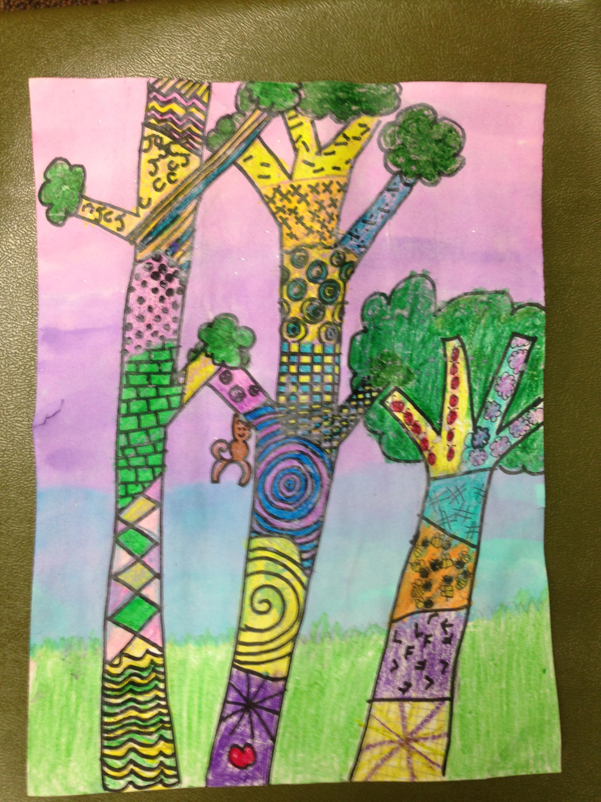e
Content Connections:
Reading:
The Great Kapok Tree
Encantado: Pink Dolphin of the Amazon

Writing: Persuasive writing about why or why not to save the rainforest

Art Standards:
4.1.2
4.1.6.

Materials:
White paper, crayons, Sharpie marker, water color kit, and brush
Grade: 4
Time:
Vocabulary: Rainforest, canopy, understory, forest floor, emergent layer

Lesson
- Draw the outline of the trees using pencil.
- Divide the trees into sections and create a different pattern in each section: squiggly lines, triangles, dots, etc…
- Trace over each tree and pattern with Sharpie markers.
- Color in with crayons each section- Press down hard with crayons and do not leave any white space.
- Choose 3 colors (water color kits) to paint the background in three sections.
- Write a persuasive paragraph about why or why not to save the rainforest. (Include evidence to support your opinion)

Preparation: Read and discuss the stories.
I Cans: Use techniques in art
Use different materials to create dimensional forms
Use art tools in a variety of ways
Use and maintain art tools responsibly

Teacher Background Knowledge
Reading Street stories:
The Great Kapok Tree & Encantado: Pink Dolphin of the Amazon
Name___________________Lesson______________________
Assessment
Thumbs Down | Don’t Know | Thumbs Up | Assessment Question
 |  |  | Did you use your personal best during this lesson?
 |  |  | Did you actively listen and follow directions?
 |  |  | Did you use your creativity? (is it original?)
 |  |  | Did you complete your project?
 |  |  | Did you incorporate the art media?
 |  |  | Does the artwork show the elements and/or principles discussed?

