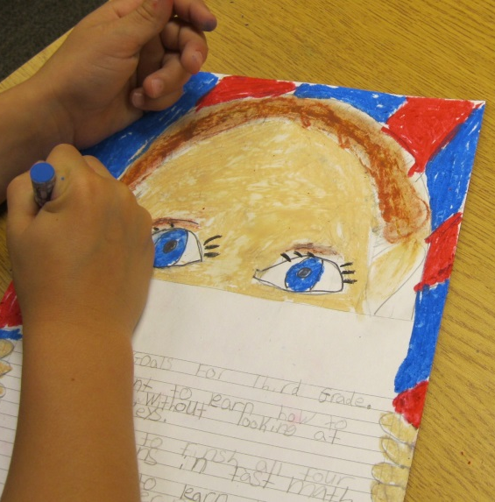
BPS Elementary Art Curriculum
Grade 3

Oil Pastels
Peek-A-Boo Portraits
Content Connections:
Writing Process – prewriting, writing, editing, proofreading, publishing
Math – measurement, symmetry
Literature Connection – Winners Never Quit by Mia Hamm – The message of this book is setting goals, and working hard to meet your goals.

Art Elements | Art Principles
__Line | __Pattern
X_Shape/Form | __Rhythm/movement
X_Color | _X_Proportion/Scale
__Value | __Balance
__Texture | __Unity
X_Space/Perspective | __Emphasis

Art Standards:
Art K-4 Standard 1.1 - Know the different techniques used to create visual art.
Art K-4. Standard1.4 Know how different visual art materials, techniques, and processes cause different responses.

Art K_4 Standard 5 - Reflecting upon and assessing the characteristics and merits of their work and the work of others.

Art K-4 Standard 6 - Making connections between visual arts and other disciplines.
Content Standards:
ELA -03.W.03 Write narratives to develop real or imagined experiences or events using effective techniques, descriptive details, and clear event sequences.
Math 3 Standard 2: Student understands and applies geometric concepts and spatial relationships to represent and solve problems in mathematical and nonmathematical situations

21st Century Skills
Creativity and Innovation – Exploration and
Imagination. Refining and improving original ideas.

Communication – The ability to read, write, present, and comprehend ideas, through a variety of mediums and audiences.
Grade: 3
Time: 1-2 hours
Materials:
Oil Pastels
White Cardstock
Pencils
Preparation
Gather copies of self-portraits for opening discussion on what a self-portrait is.
If desired, run off the writing PDF for this project.
Vocabulary:
Oil Pastels, blending, self-portrait, and symmetry

I Can Statements
I can write a story about something that has happened or a made up story.
I can use oil pastels to create a self-portrait.
I can demonstrate how to blend colors using oil pastels.
I can create facial features that are symmetrical and proportionate in size.
Lesson - This Lesson was derived from the following website.
http://www.artprojectsforkids.org/2012/08/peek-self-portrait.html
The printable PDF can be found at
http://artprojectsforkids.me/wp-content/uploads/2012/08/Peek-Face-Portrait.pdf
- Complete the writing process first.

- Have a few self -portraits for students to view. What similarities and differences do they have? Define what a self-portrait is. Go over the parts of the face with the students. Explain that they will be creating parts of their own self-portrait today and a complete self-portrait at a later date.

- Discuss symmetry and congruent shapes of the eyes, eyebrows and ears. Start by drawing the eyes in pencil, just above the sheet of paper. The two eyes should always be one eye-width apart. Use a ruler to measure the eyes and the distance between the eyes.

- Draw the top of the head, almost touching the top of the paper.

- Draw the rest of the face and fingers on the side.

- Use oil pastels to complete the self-portrait. This is a great lesson to introduce blending of the colors especially with the hair color, and as they create their background.

- Have the students create another self-portrait at a later date so they will have a completed self-portrait. They will allow them to add details such as prints on their clothing, or jewelry they might be wearing.
Teacher Background Knowledge
You may select a narrative writing for the project. You might also want to have the students write down yearly goals. Having the students write a poem about themselves in another idea for the writing connection.

A self-portrait is a picture, depicting the artist as the subject and created by the artist. Elementary-school students are just starting to understand their personal characteristics. A self-portrait art project is a great way to help students learn more about the parts of the face and how to illustrate themselves.

Oil pastels can be blended or left alone to create distinct lines.

Smudges may appear as students handle their paper. An eraser will easily erase these smudges.

Name___________________Lesson______________________
Assessment
Thumbs Down | Don’t Know | Thumbs Up | Assessment Question
 |  |  | Did you use your personal best during this lesson?
 |  |  | Did you actively listen and follow directions?
 |  |  | Did you use your creativity? (is it original?)
 |  |  | Did you complete your project?
 |  |  | Did you incorporate the art media?
 |  |  | Does the artwork show the elements and/or principles discussed?

