BPS Elementary Art Curriculum

Dream Catchers
Materials:
6-8 inch circles on manila paper
12 in. x 9 in. tan construction paper
Rulers, erasers
Graphite and color pencils
Feathers (sketches)
Illustrations and examples of dream catchers

Art Standards:
Standard 1 – Visual Art Media, Techniques, and Processes
Standard 2 – Structure and Function
Standard 3 – Subject Matter, Themes, Symbols, and Ideas in Visual Art
Standard 4 – Visual Art History and Culture
Standard 5 – Merits of Works of Visual Art
Standard 6 - Connections

Grade: 4
Time: 2 (45 minute) sessions
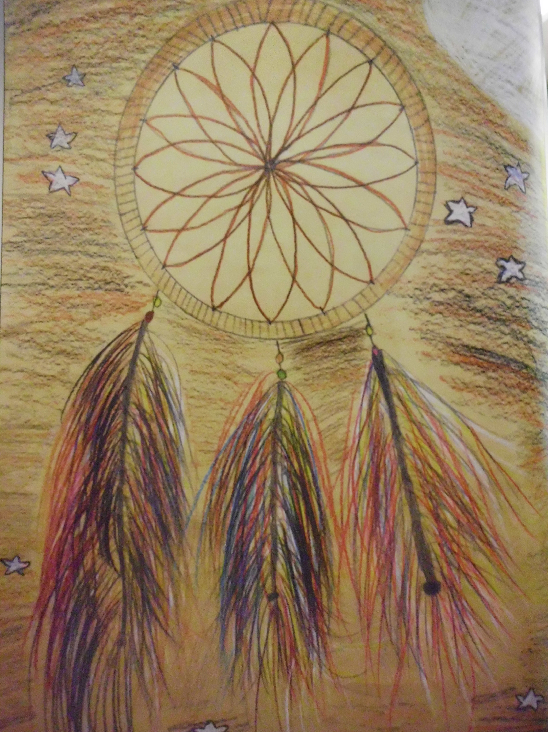Picture
Content Connections:
American Indians of North Dakota
Math

Reading:
“Grandmother’s Dream Catcher” by Becky Ray McCain

Art Elements | Art Principles
_X_Line | _X_Pattern
_X_Shape/Form | __Rhythm/movement
_X_Color | __Proportion/Scale
__Value | _X_Balance
_X_Texture | __Unity
__Space/Perspective | __Emphasis

Preparation: Precut 6-8 inch circles; gather images of dream catcher and feather designs.
Lesson
- Discuss dream catcher and show examples.
- Hand out precut circles.
- Discuss symmetry and balance by looking at online examples.
- Using cardinal and intermediate directions have students make tick marks around the outside of the circle.
- Students design “web” portion using the tick marks as a guide. Concentrate on symmetry and balance.
- Glue the web onto the top portion of the 12x9 tan paper.
- Add an outer circle to create a frame.
- Show examples of how to draw and shade a feather.
- Students draw and shade feathers hanging from the dream catcher.
- Students may design a night sky background.

Vocabulary:
dream catcher, symmetry, legend, shading

I Cans …
- …understand and apply media, techniques, and processes.
- …use knowledge of structures and functions.
- …choose and evaluate a range of subject matter, symbols, and ideas.
- …understand the visual arts in relation to history and cultures.
- …reflect upon and asses the characteristics and merits of their work and the work of others.
- Make connections between visual arts and other disciplines.

Teacher Background Knowledge
The legend of the dream catcher states that it could filter out the bad dreams and allowing only good thoughts to enter into the mind.
** Many different versions can be found online.

Name___________________Lesson______________________
Assessment
Thumbs Down | Don’t Know | Thumbs Up | Assessment Question
 |  |  | Did you use your personal best during this lesson?
 |  |  | Did you actively listen and follow directions?
 |  |  | Did you use your creativity? (is it original?)
 |  |  | Did you complete your project?
 |  |  | Did you incorporate the art media?
 |  |  | Does the artwork show the elements and/or principles discussed?

