BPS Elementary Art Curriculum

Title
Materials:
1 Scratch Art Multi-colored sheet per student (8 ½ X 11), Stylus or toothpick to scratch with, visual of The Scream
Art Standards:
4.1.4- Know how different visual art materials, techniques, or process cause different responses.
4.1.2- Know the different techniques used to creat visual art.
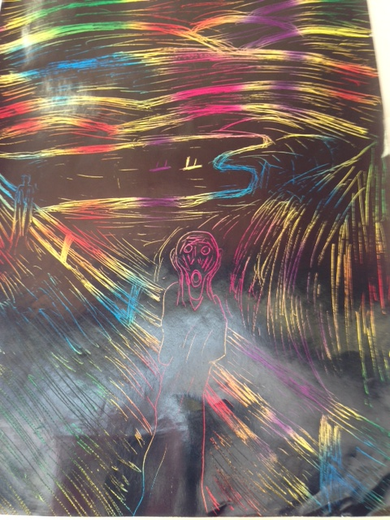
Content Connections:
Health- 4.4.02 Develop and implement strategies for resolving conflicts
When talking about Conflict Resolution in your classroom, either through Second Step or other programs, reinforce the importance of understanding the emotions or strong feelings you are experiencing and what they can do to your mind and body.

Art Elements | Art Principles
X Line | __Pattern
__Shape/Form | X Rhythm/movement
__Color | __Proportion/Scale
__Value | __Balance
__Texture | __Unity
__Space/Perspective | X Emphasis

Grade: 4th
Time: 60 min
Preparation: Find an image of The Scream for students to try to emulate. Prepare a scratch art paper and stylus for each student.
Lesson
Introduce today’s lesson by talking about the emotions that can come with conflict (fear, anger, sadness, exhaustion, etc.). These are very powerful emotions that need to be controlled and calmed when trying to work through a conflict.
Show the students an image of The Scream. Tell them that this is one of the most famous paintings in the world. It is one of four paintings that Norwegian expressionist artist Edvard Munch created between 1893 and 1910. Ask them to think to themselves what emotion the main character in the painting is feeling, and then a few of them share out. Share with the student that the subject in the painting looks as if he’s got some conflict he needs to work out and some emotions that he needs to gain control of!
Introduce to the students that today they will be trying to recreate The Scream. Before they can do that, they will need to have a discussion of the one principle (line) and two elements (emphasis and movement) of art. Put them on the board for students to refer back to. Discuss how these principles and elements work together to create this masterpiece.
Tell the students that today, their only way of recreating this painting will be through line. Every one of their strokes needs to be a line, much the same way Munch did in his painting. Hand out the papers and styli to the students and let them work, reminding them that the paper is very expensive and that they only get one piece to work with!

Vocabulary: Conflict Resolution, Line, Emphasis

I Cans
Develop and implement strategies for conflict resolution

Teacher Background Knowledge
Line - The path of a point moving through space.
Emphasis – Emphasis refers to the created center of interest, the place in a piece of art where your eye first lands.
Rhythm/Movement – Rhythm or movement refers to the suggestion of motion through the use of various elements.

Name___________________Lesson______________________
Assessment
Thumbs Down | Don’t Know | Thumbs Up | Assessment Question
 |  |  | Did you use your personal best during this lesson?
 |  |  | Did you actively listen and follow directions?
 |  |  | Did you use your creativity? (is it original?)
 |  |  | Did you complete your project?
 |  |  | Did you incorporate the art media?
 |  |  | Does the artwork show the elements and/or principles discussed?

