BPS Elementary Art Curriculum

Geometry
Materials: 9 “ X 12” or 12” X 18 white paper, pencils, erasers, straight edge, a variety of coloring utensils, Resource: Arts & Activities magazine March 2014
Grade: 4 Time: 2 hours (approximate)
Art Standards:
Understand and apply media, techniques and processes.
Choose and evaluate a range of subject matter, symbols and ideas
Make connections between visual arts and other disciplines

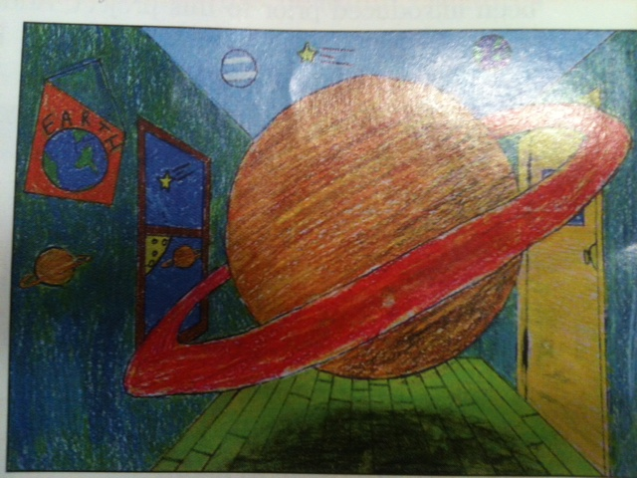
Content Connections:
Math: Geometry

Art Elements | Art Principles
_X_Line | __Pattern
__Shape/Form | __Rhythm/movement
__Color | _X_Proportion/Scale
__Value | __Balance
__Texture | __Unity
_X_Space/Perspective | __Emphasis

Lesson
Draw a vanishing point in the center area of the paper, then create a square or rectangular box around the vanishing point with a ruler, while explaining that the box would become the back wall of our room. Using a ruler, draw lines outward from the vanishing point. This creates the floor, ceiling and three walls of the room. Students then erase any lines on the “back wall”, but do not erase the vanishing point. Then draw a window on the left wall using the same vanishing point. Students create details such as tiles, rugs, curtains around the window and at the bottom and tops of the walls and pictures on the walls. After creating the basic room and its elements, students draw their chosen object so that it overlaps with the back wall. Students then begin adding color as soon as they finish their drawing of the object.
Preparation: materials and vocabulary lessons on geometry
Vocabulary: converging, parallel, vertical and horizontal lines, right, acute and obtuse angles, perspective

I Cans
Create an original composition
Learn one point perspective techniques
Apply basic geometry in their art

Teacher Background Knowledge
Geometry vocabulary
Name___________________Lesson______________________
Assessment
Thumbs Down | Don’t Know | Thumbs Up | Assessment Question
 |  |  | Did you use your personal best during this lesson?
 |  |  | Did you actively listen and follow directions?
 |  |  | Did you use your creativity? (is it original?)
 |  |  | Did you complete your project?
 |  |  | Did you incorporate the art media?
 |  |  | Does the artwork show the elements and/or principles discussed?

