BPS Art Curriculum

A Starry Night
Art Standards:
8.2.1 Know the effects of visual art structures and functions
Alignment Standards: 5.W.3 Write opinion pieces on topics or texts, supporting a point of view with reasons and information.

Materials: 9"x12" white paper
pencils
oil pastels
watercolor paint (black, blue, purple)
Grade: 5th
Time: Two 45 minute sessions
Content Connections:
5.W.3 Write opinion pieces on topics or texts, supporting a point of view with reasons and information.
( Students could view two or more of Van Gogh’s pieces and write and opinion piece on “A Starry Night.”)

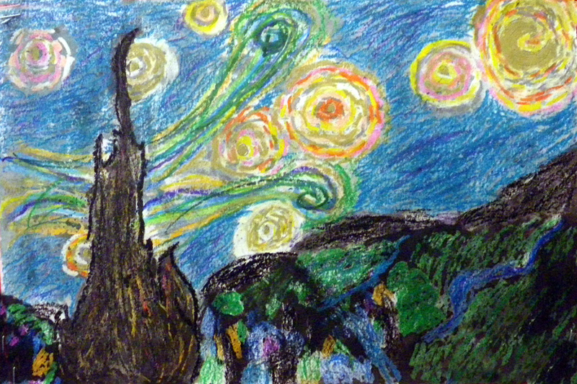

Art Elements | Art Principles
_X_Line | _X_Pattern
_X_Shape/Form | X__Rhythm/movement
_X_Color | _X_Proportion/Scale
X__Value | _X_Balance
X__Texture | _X_Unity
_X_Space/Perspective | X__Emphasis

I Cans/ Objectives
I can show line, shape, and texture by using various techniques with oil pastels.
I can use a variety of media to create a 2D piece of art.
I can use art materials in a respectful manner.
Vocabulary: horizon line, foreground, texture, shape, and line.
Preparation:
Prepare a sample ahead of time.
Have materials ready for students.
Print a biography of Vincent Van Gogh from the website: makingartfun.com and share with your students before beginning their “Starry Night” masterpiece.

Teacher Background Knowledge:
Teachers should know the vocabulary in the lesson. Teachers should also know about Vincent Van Gogh and the techniques he used in his masterpiece, “A Starry Night.”
Lesson description : Fifth graders look at the work of Vincent Van Gogh and use his famous painting "Starry Night" as inspiration for their own “Starry Night” paintings. They begin by mapping out their composition with pencil. Then they use oil pastels to create textures and swirls of colors much like the style of Van Gogh. After the oil pastels they paint on top of their artwork with watercolor paint. This creates a resist technique much like crayons.

Lesson :
- With a pencil lightly trace your hand in pencil. Make sure to extend one finger to the top of your paper.

- With a pencil lightly draw a horizon line; this is where the sky meets the ground.

- With your oil pastels draw the wind, moon, stars, and mountains. Use various colors to draw broken lines around your stars, wind, and moon. Fill in the rest of the sky with dashes and lines in various shades of blue.

- Outline your horizon line in a dark color. Color in the mountains and grass in your picture. Leave a little white space so the watercolor paint will show through.

- Now, draw houses in the foreground. They do not have to have a lot of detail but they should cover the foreground.

- Outline your tree with a dark color. Using, browns, blacks, greys fill your tree with various colors.

- Now, draw houses in the foreground. They do not have to have a lot of detail but they should cover the foreground. Use a variety of colors for your houses.

- Lastly, using water color paints; paint over your picture with a variety of night sky colors such as blue, purple, and black. You may want to use a lighter color in the background of your picture and a darker color in the foreground.
Name___________________Lesson______________________
Assessment
Thumbs Down | Don’t Know | Thumbs Up | Assessment Question
 |  |  | Did you use your personal best during this lesson?
 |  |  | Did you actively listen and follow directions?
 |  |  | Did you use your creativity? (is it original?)
 |  |  | Did you complete your project?
 |  |  | Did you incorporate the art media?
 |  |  | Does the artwork show the elements and/or principles discussed?

