BPS Elementary Art Curriculum

Picasso Face
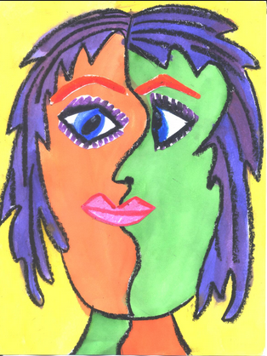

Content Connections: Art/Writing
Reading: Picasso’s life

Art Standards:
Standard 1: VISUAL ART MEDIA*, TECHNIQUES*, AND PROCESSES*
Students understand and apply visual art media*, techniques*, and processes*.
Materials:
9 x 12 white paper
Crayons, markers, or pastels

Art Elements | Art Principles
X_Line | X_Pattern
X_Shape/Form | __Rhythm/movement
X_Color | __Proportion/Scale
__Value | X_Balance
X_Texture | __Unity
X_Space/Perspective | __Emphasis

Grade: 5th
Time: 45 min
Preparation: Get materials, make your own example or examples of Picassos art
Lesson
- Draw a face on the board
- Erase half of the face
- Where the erased half of the face is, draw a portrait style face (one that is looking toward the remaining half of the face)
- Draw different shape all over the face (shapes can be any size, shape, direction, etc. The more unusual the better)
- Color in the shapes
- Outline each shape in a dark marker or sharpie

Vocabulary:
Half, direction, shape, expression

I Cans
-replicate a piece of art from a famous artist
-use various techniques in art to express different moods

Teacher Background Knowledge
Picasso, his work & life
Name___________________Lesson______________________
Assessment
Thumbs Down | Don’t Know | Thumbs Up | Assessment Question
 |  |  | Did you use your personal best during this lesson?
 |  |  | Did you actively listen and follow directions?
 |  |  | Did you use your creativity? (is it original?)
 |  |  | Did you complete your project?
 |  |  | Did you incorporate the art media?
 |  |  | Does the artwork show the elements and/or principles discussed?

