BPS Elementary Art Curriculum

Title
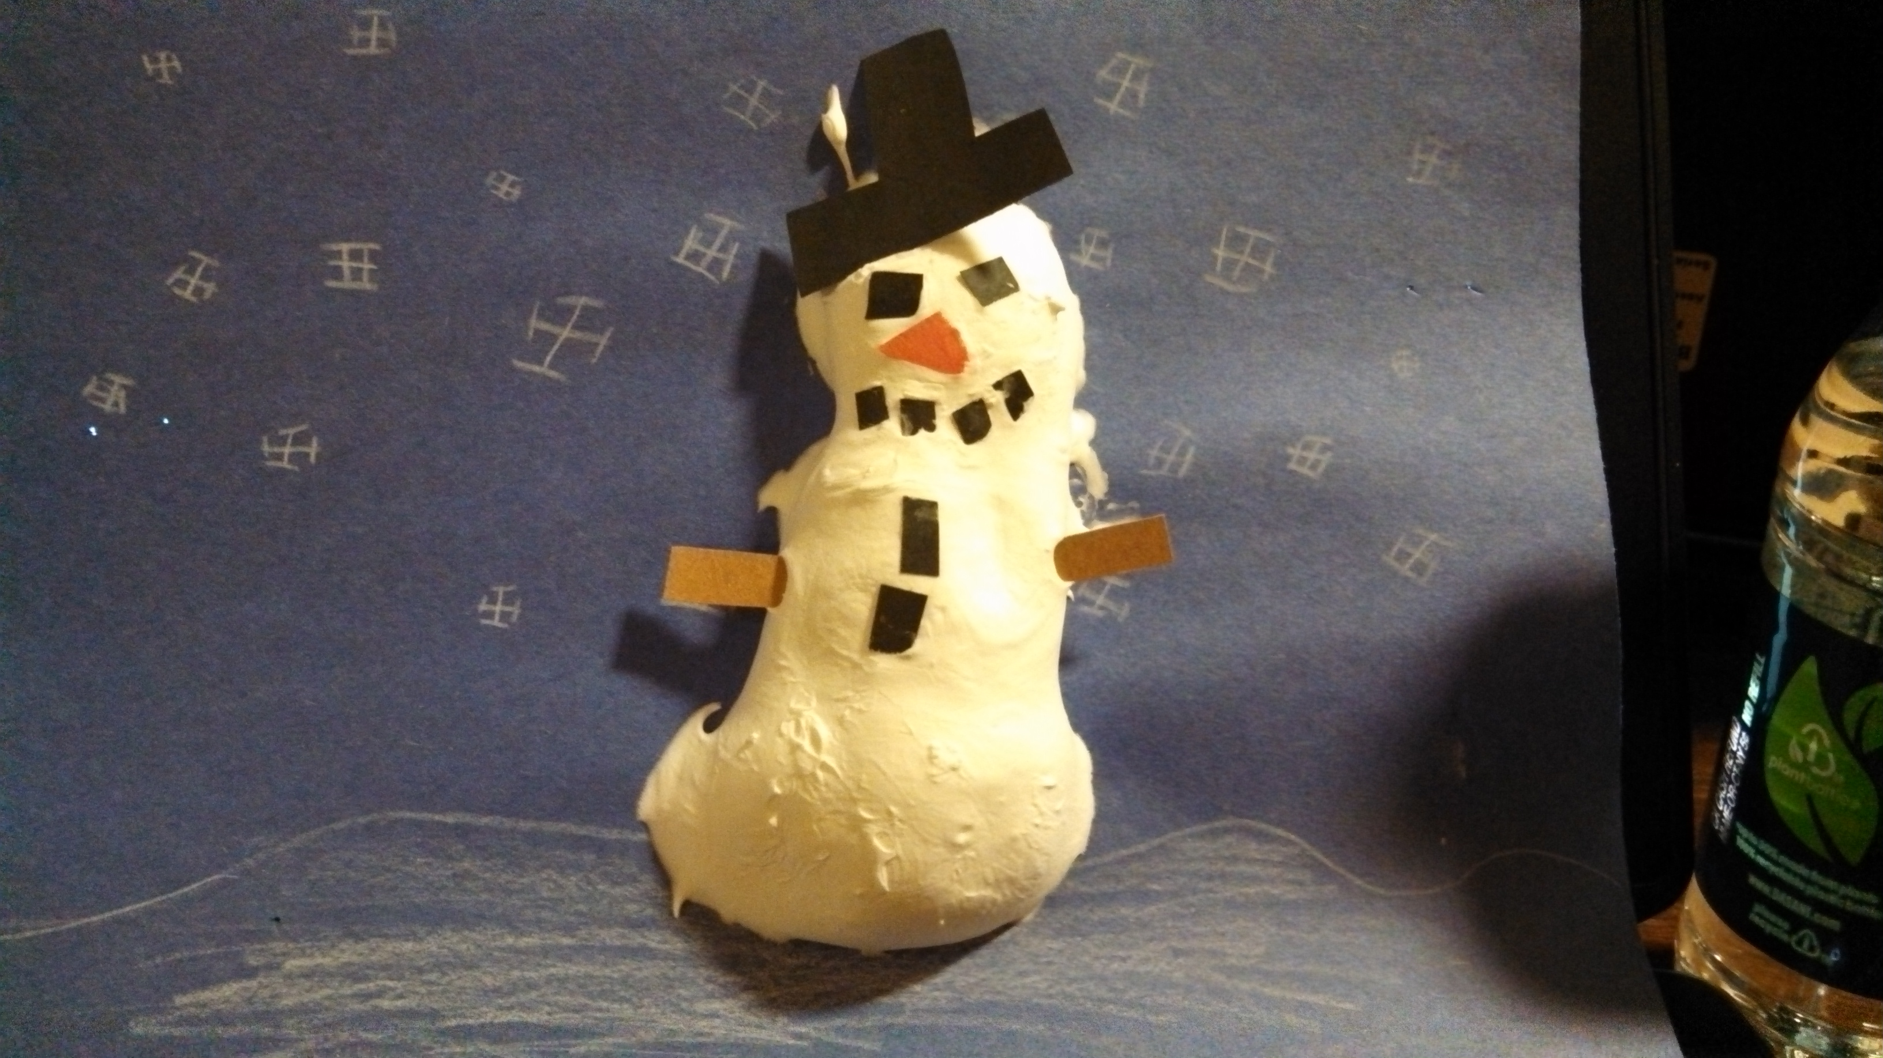
Content Connections:
Science- mixtures and solutions
Art Standards:
Standard 1: Visual Art Media, Techniques, and Processes
Standard 3: Subject matter, themes, symbols, and ideas in visual art
Standard 6: Connections
Materials:
- Shaving cream
- White glue
- Construction paper
- Colored pencils

Art Elements | Art Principles
__Line | __Pattern
_x_Shape/Form | __Rhythm/movement
__Color | _x_Proportion/Scale
_x_Value | _x_Balance
_x_Texture | _x_Unity
__Space/Perspective | __Emphasis

Grade: 5
Time: 30-60 minutes
Lesson
- In a small cup mix half a cup of shaving cream with half a cup of white liquid glue using a popsicle stick
- On blue or black paper, students should create a snow background using a white colored pencil
- When backgrounds are complete, student s will apply the shaving cream and glue using a popsicle stick
(They should apply it thick as if they were frosting a cake)
- Students can then add construction paper details directly to the snowman
- Let art totally dry. Do not touch the art because the bubbles in the shaving cream may deflate and you will end up with craters in your snowmen
Preparation: buy shaving cream, glue, small cups, and popsicle sticks
Vocabulary:

I Cans
- Create art using different mediums
- I can create the theme of winter
- I can connect the glue and shaving cream to mixtures and solutions

Teacher Background Knowledge

Name___________________Lesson______________________
Assessment
Thumbs Down | Don’t Know | Thumbs Up | Assessment Question
 |  |  | Did you use your personal best during this lesson?
 |  |  | Did you actively listen and follow directions?
 |  |  | Did you use your creativity? (is it original?)
 |  |  | Did you complete your project?
 |  |  | Did you incorporate the art media?
 |  |  | Does the artwork show the elements and/or principles discussed?

