**BPS Elementary Art Curriculum**

Lines

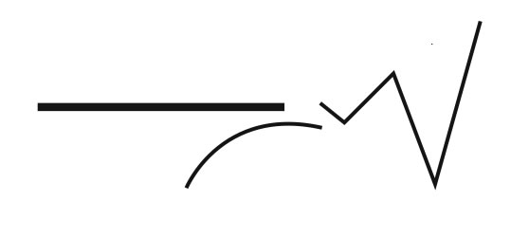

Content Connections:

This art lesson will be connected to Language Arts.

Art Standards: 4.1.1, 4.1.2, 4.2.1, 4.5.1, 4.6.1

Alignment Standards:

Materials: Colored construction paper, book and quote-bubble template, camera for student photos, any coloring utensil.

|  |  |
| --- | --- |
| **Art Elements** | **Art Principles** |
| _X_Line | __Pattern |
| _X_Shape/Form | __Rhythm/movement |
| _X_Color | _X_Proportion/Scale |
| __Value | __Balance |
| __Texture | __Unity |
| _X_Space/Perspective | __Emphasis |

Grade: 5

Time: 2 days

Preparation:

Have the students bring their favorite book, or a book they are currently reading. They will need coloring utensils of their choice. There will also need to be a choice of colored construction paper for the background. You will need to have a camera to take the student photos. Have the templates printed out and ready for them to being their art piece.

Vocabulary: Space, scale

I Cans:

I can create a replica drawing of a book.

Lesson description:

The students will create a replica drawing of one of their favorite books. They will include a quote from the book as well as a picture of them holding the actual book.

Teacher Background Knowledge:

Be able to explain the importance of space and scale. A large portion of the books will be larger than the replica template leading to them having to scale down the picture.

Lesson:

1. Students will select a book they are reading, or a favorite book they have read.
2. They will then draw the cover of the book on to a blank book template. (Template provided)
3. As they are drawing their book cover, have them give you a short quote from the book to write on a quote bubble. (Provided)-I wrote this myself so it was legible.
4. When they have finished their drawing, have the students place (glue) their drawing on a colored sheet of construction paper.
5. You will then take a picture of the student holding the book. Print these off.
6. The picture of the student will be glued in the bottom left corner of the page. The quote bubble will be glued in the top right corner of the page.

When finished, it should look like the picture provided.

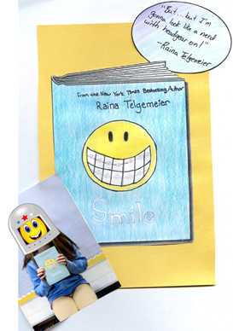

Name___________________Lesson______________________

*Assessment*

|  |  |  |  |
| --- | --- | --- | --- |
| **Thumbs Down** | **Don’t Know** | **Thumbs Up** | **Assessment Question** |
|  |  |  | Did you use your personal best during this lesson? |
|  |  |  | Did you actively listen and follow directions? |
|  |  |  | Did you use your creativity? (is it original?) |
|  |  |  | Did you complete your project? |
|  |  |  | Did you incorporate the art media? |
|  |  |  | Does the artwork show the elements and/or principles discussed? |
|  |  |  |  |
|  |  |  |  |
|  |  |  |  |

Source