BPS Art Curriculum

Face Card Symmetry
Insert 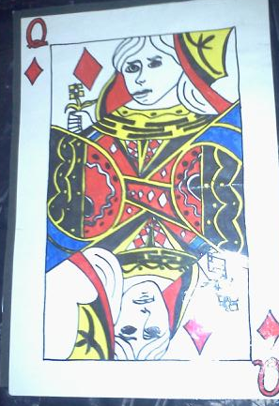ject here
Art Standards:
8.1.1, 8.1.2, 8.1.3, 8.1.4, 8.1.5,8.1.6, 8.2.1, 8.3.1, 8.6.2
Alignment Standards:
Math 5.2.7
Materials: Pencil, ruler, drawing paper, face playing cards, colored pencils, and markers
Content Connections:
Geometry

Art Elements | Art Principles
_X_Line | _X_Pattern
__Shape/Form | __Rhythm/movement
_X_Color | _X_Proportion/Scale
__Value | _X_Balance
__Texture | __Unity
_X_Space/Perspective | __Emphasis

Grade: Fifth Grade
Time: 3 Class Periods
Preparation:
Have 12”x18” white construction paper available.
Teacher will need to have enough face cards, 1 per student, for students to refer to while drawing.
Teacher will introduce symmetry to students. Have students find the symmetry of their face card.

Vocabulary: symmetry, proportion, primary colors.

I Cans/ Objectives:
I can create a drawing of a face card with symmetry.
I can use primary colors to create my face card design.

Lesson :
1.)Look at face cards and discuss the symmetry of the cards. Ask students what else they notice about each face card. What do they have in common? What is different about each card? Discuss the colors used each card? Can they name the primary colors?
2.)Hand out one piece of white 12”x18” construction paper to each student.
3.)Next, instruct students to create an outside border on their construction paper by laying their ruler next to the edge of their paper and tracing along the inside edge of their ruler.
4.) Lightly crease the center of the construction paper. Use this as a reference point for the symmetry of your card.
5.) Students begin by lightly sketching one half of their face card. When finished, turn the paper around and begin drawing second half. Each half should meet in the same spot at the crease and have equivalent proportions.
6.) As students begin drawing point out fractional relationships which will help with their card’s symmetry. ( Ex. A third of the way above the center of your drawing notice what is drawn. These details need to be in the same place when you draw the other half of your face card.)
7.) When students are finished sketching their card they should begin coloring their face card with markers and colored pencils.

Teacher Background Knowledge:
Symmetry, primary colors
Lesson description : Students will create a drawing of a face card paying attention to the symmetry and proportion of the face card.
Name___________________Lesson______________________
Assessment
Thumbs Down | Don’t Know | Thumbs Up | Assessment Question
 |  |  | Did you use your person best during this lesson?
 |  |  | Did you actively listen and follow directions?
 |  |  | Did you use your creativity? (is it original?)
 |  |  | Did you complete your project?
 |  |  | Did you incorporate the art media?
 |  |  | Does the artwork show the elements and/or principles discussed?

