Content Connections:
When studying Figurative Language, students learn how objects or animals take on human qualities. This lesson allows students to explore this idea a little more in depth and uses art to illustrate the human qualities their image takes on.

Roosevelt Elementary SALT Integrated Lesson Plan

Drawing: Coat of Arms
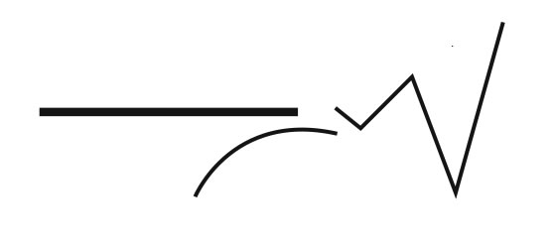
Art Standards: ART-6.1.6 Use visual art materials and tools in a safe and responsible manner
ART-6.2.1 Know the effects of visual art structures and functions
Alignment Standards: SST-06.6.02 Explain how differences among cultures often result in conflict.

21st Century Skills:
☐ Global Awareness
☒ Creativity and Innovation
☐ Critical Thinking and Problem
Solving

☒ Communication and Collaboration

☐ ICT Literacy

☐ Flexibility and Adaptability
☐ Initiative and Self-Direction
☐ Productivity and Accountability

☐ Understand the Art World

Artists Habits of Mind:
☒ Engage & Persist
☐ Envision
☒ Express
☐ Observe
☐ Reflect
☐ Stretch & Explore
☐ Understand the Art World

Materials: tag board (9X12), Tacky glue, glue stick, tinfoil, black shoe polish

Art Elements | Art Principles
_X_Line | __Pattern
_X_Shape/Form | __Rhythm/movement
__Color | __Proportion/Scale
__Value | __Balance
__Texture | __Unity
__Space/Perspective | _X_Emphasis

Grade: 6
Time: 2 hours
Preparation
Discuss Ancient Rome and the conflicts this culture experienced. Discuss what Ancient Romans wore when they went to battle and compare and contrast that with present day soldiers’ preparation.

Vocabulary: symbols, emphasis, coat of arms, format, and focal point

I Cans
I can explain what a coat of arms is and what they meant in Ancient Rome while creating a present day coat of arms for myself.

Lesson
DAY ONE:
- Discuss coat of arms
  - What was on Roman Coat of Arms?
  - What did they represent?
- Compare and contrast Roman Coat of Arms with a Middle School student’s coat of arms
  - Students are asked to think of at least 5 symbols they could draw on a coat of arms that would represent them
  - They are to imagine if they are able to take their coat of arms to their first day of Middle School what would they like their new classmates to know about them
- Quick review to see what students remember about drawing strong lines
- Students are encouraged to leave out details for this project
- Students will practice drawing their images
- Students will each get a 9 X 12 piece of tag board and they will draw a coat of arms on their tag board
- Students will draw their images onto their coat of arms, remind them to leave out details
- Once students have their images on their tag board coat of arms, they should go over their lines with Tacky Glue
- Let dry over night
DAY TWO:
- Use a glue stick and coat your coat of arms
- Wrap your coat of arms with tinfoil
- Use a Q-tip to press the tinfoil down around each glue line
- Put a small amount of black shoe polish on a rag and rub over your coat of arms

Lesson description:
Students will learn and use emphasis to show the outline of an image and the importance of keeping a symbol simple for this project.
Teacher Background Knowledge
Know the following techniques:
- Drawing images a focal point to draw the viewer’s attention
- Content of the picture expresses ideas, and feelings through the art
- Format of the art is a decision the student will make about the overall shapes and sizes of the drawing

Name___________________Lesson______________________
Assessment
Thumbs Down | Don’t Know | Thumbs Up | Assessment Question
 |  |  | Did you use your personal best during this lesson?
 |  |  | Did you actively listen and follow directions?
 |  |  | Did you use your creativity? (is it original?)
 |  |  | Did you complete your project?
 |  |  | Did you incorporate the art media?
 |  |  | Does the artwork show the elements and/or principles discussed?
Source

