BPS Elementary Art Curriculum

Title
Materials:
Brushes, acrylic paint,11 X 14 paper, 9 colors, red-orange white, yellow orange pink red white, purple blue white, blue green white, black and white,
Art Standards:

Picture: only one section is complete. This is used as a model

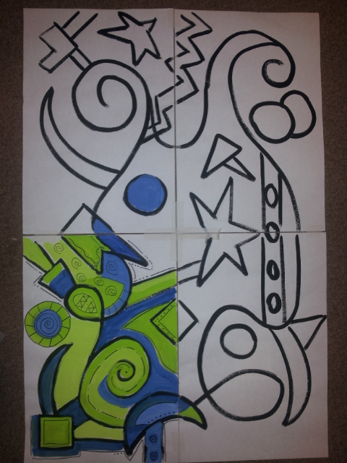
Content Connections:
Community building – beginning of school year.
Vocabulary
Elements of Art
Reading:
Frindle

Art Elements | Art Principles
_x_Line | __Pattern
_x_Shape/Form | _x_Rhythm/movement
x__Color | __Proportion/Scale
x__Value | __Balance
__Texture | __Unity
__Space/Perspective | __Emphasis

Grade: 5
Time: 2 days – 3 hours total
Preparation:
See flipchart

Vocabulary:
Gradient, value, shape, collaboration, community,
Lesson

See flipchart

I Cans

Work cooperatively in a group activity to help build community in our classroom.

Teacher Background Knowledge
Line, color, brush strokes, color wheel
Name___________________Lesson______________________
Assessment
Thumbs Down | Don’t Know | Thumbs Up | Assessment Question
 |  |  | Did you use your personal best during this lesson?
 |  |  | Did you actively listen and follow directions?
 |  |  | Did you use your creativity? (is it original?)
 |  |  | Did you complete your project?
 |  |  | Did you incorporate the art media?
 |  |  | Does the artwork show the elements and/or principles discussed?

