BPS Art Curriculum

Liberty Bell
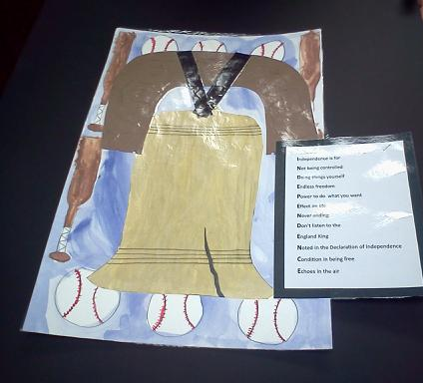
Art Standards: 8.1.1, 8.1.2, 8.1.3, 8.1.4, 8.1.5, 8.1.6, 8.2.1, 8.2.2, 8.3.1, 8.4.1, 8.5.1, 8.5.2 8.6.1, 8.6.2
Alignment Standards: SST 5.4.3, 5.4.4,
Materials:
Drawing Paper 12”x 18” or tag board
Watercolors
Metallic Gold Tempera Paint
Brown, Black & White Construction Paper 9”x12”

Markers
Scissors
Bottled White Glue
Paint Brushes

Grade: 5th

Time:
Content Connections:
Social Studies
Language Arts

Art Elements | Art Principles
_x Line | _x Pattern
_x Shape/Form | __Rhythm/movement
_x Color | _x Proportion/Scale
_x Value | _x Balance
_x Texture | _x Unity
_x Space/Perspective | _x Emphasis

Preparation
Research the history of the liberty bell.

Vocabulary
Balance, Line, Shape, Texture, Proportion, American Symbols

I Cans/ Objectives
- I can sketch the liberty bell shape.
- I can identify and draw American symbols in my background.
- I can paint the background with watercolors.
- I can paint, cut out and glue the bell shape to my background paper.
- I can include details like the wooden beam, leather strips and crack.

Lesson description
Students will create the Liberty Bell using mixed media.
Teacher Background Knowledge

Teacher should explore the creation and history of the Liberty Bell.
Lesson
- Show students images of the Liberty Bell.
- Students sketch a bell shape on scratch paper.
- Brainstorm American symbols for the background.
- Lightly sketch symbols on the 12”x18”drawing paper. Students need to visualize where the bell will be placed. The bell will cover parts of the symbols in the background.
- Students fill in background symbols and negative space with watercolors.
- Students draw the bell shape on the 9”x 12” white construction paper.
- The bell shape is painted with gold metallic tempera paint and set aside to dry.
- Once bell is dry, cut it out and glue to background paper.
- Draw shape representing the wooden beam on the brown construction paper. Draw lines for the wood grain with black marker.
- Cut out wooden beam and paste to background paper.
- Cut two small strips of black construction paper to represent the leather straps the secure the bell.
- Lastly, students are encouraged to add details including the crack in the bell.
Name___________________Lesson______________________
Assessment
Thumbs Down | Don’t Know | Thumbs Up | Assessment Question
 |  |  | Did you use your personal best during this lesson?
 |  |  | Did you actively listen and follow directions?
 |  |  | Did you use your creativity? (is it original?)
 |  |  | Did you complete your project?
 |  |  | Did you incorporate the art media?
 |  |  | Does the artwork show the elements and/or principles discussed?

