BPS Art Curriculum

Microscopic Jewels
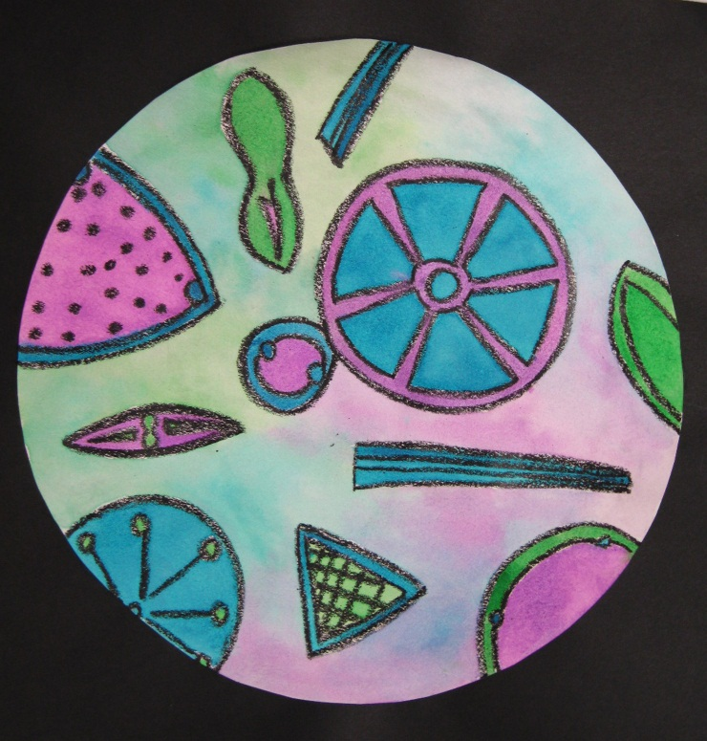
Art Standards: 8.1.1, 8.1.2, 8.1.3, 8.1.5, 8.1.6, 8.2.1, 8.2.2, 8.3.1, 8.5.1, 8.6.2
Alignment Standards:
Science 5.4.1, 5.4.2
Math 5.2.1
ELA 5.2.1
Materials:
8”x8” drawing paper
9”x9” black construction paper
7.5” Circle Template
Black Crayon
Scissors
Bottled White Glue
Watercolor Paint Set

Grade: 5th

Time:
Content Connections:
Science

Art Elements | Art Principles
__ Line | _x Pattern
_x Shape/Form | __Rhythm/movement
_x Color | __ Proportion/Scale
__ Value | _x Balance
__Texture | _x Unity
__ Space/Perspective | _x Emphasis

Vocabulary
Analogous Color, Shape, Pattern, Symmetry, Diatom, Resist, Optical Microscope, van Leeuwenhoek, watercolor wash

Preparation
- Familiarize yourself with the life and work of van Leeuwenhoek.
- Make a 7.5” circle template on tagboard for students to use to trace around.
- Find a variety of images of diatoms to use as a reference for the art projects.
- Find a color wheel to reference with the class.

I Cans/ Objectives
- I can draw diatoms including the parts of a cell.
- I can choose an analogous color scheme.
- I can use black crayon to make a wax resist.
- When using watercolors: I can paint in a wet technique and a dry technique.

Teacher Background Knowledge

Read biographical information to students about van Leeuwenhoek (Lay-wen-hook). Make sure to emphasize these points about van Leeuwenhoek:
- He had artists make accurate drawings to record his discoveries.
- He is credited with discovering red blood cells and bacteria.
- He is known as the father of microbiology.
Have basic knowledge of the Analogous Color Scheme.
- Analogous colors are neighbors, next to each other on the color wheel.
- Many analogous color schemes are just two colors. Ask students to name pairs of color ‘neighbors’. Red/Orange, Red/Violet, Violet/Blue, Blue/Green, Green/Yellow, Yellow/Orange.
Lesson description
Make a painting of diatoms in a drop of water.
Lesson
- Have students trace a circle onto white drawing paper using a circle template.
- Cut out and glue to black construction paper.
- Discuss and view images of diatoms.
- Lightly draw diatoms on the white circular paper. Remind students to include the parts of a cell.
- Trace around pencil lines with a black crayon.
- Discuss analogous colors. Show them on the color wheel. Have students choose an analogous combination prior to painting.
- Wet a portion of the background by carefully ‘painting’ clean water around the diatoms. This is called a watercolor wash. It should be wet but without puddles. The waxy black crayon will resist the water and paint, keeping diatoms dry.
- Add drops of three analogous colors letting them blend without stroking too much.
- Continue wetting portions of the background and adding color until it is complete.
- Set projects to side to dry.
- Once dry use regular painting technique to paint diatoms. Purposely make the diatoms darker so they stand out.
- When projects are complete, students should read the poem, “The Microscope” by Maxine Kumin.

Name___________________Lesson______________________
Assessment
Thumbs Down | Don’t Know | Thumbs Up | Assessment Question
 |  |  | Did you use your personal best during this lesson?
 |  |  | Did you actively listen and follow directions?
 |  |  | Did you use your creativity? (is it original?)
 |  |  | Did you complete your project?
 |  |  | Did you incorporate the art media?
 |  |  | Does the artwork show the elements and/or principles discussed?

Source:
Project Articulate
The Microscope
By Maxine Kumin

Anton Leeuwenhoek was Dutch.
He sold pincushions, cloth and such.
The waiting townsfolk fumed and fussed
As Anton’s dry goods gathered dust.

He worked, instead of tending store,
At grinding special lenses for
A microscope. Some of the things
He looked at were: mosquitos’ wings,
the hairs of sheep, the legs of lice,
the skin of people, dogs and mice;
ox eyes, spiders’ spinning gear,
Fishes’ scales, a little smear
of his own blood, and best of all,
The unknown, busy, very small
bugs that swim and bump and hop
inside a simple water drop.

Impossible! Most Dutchmen said.
This Anton’s crazy in the head!
We ought to ship him off to Spain!
He says he’s seen a housefly’s brain!
He says the water that we drink
Is full of bugs! He’s mad, we think!

They called him dumkpf, which means dope.

That’s how we got the microscope.

7.5” Circle Template
Copy and cut out on tag board.

