**BPS Elementary Art Curriculum**

Number Art

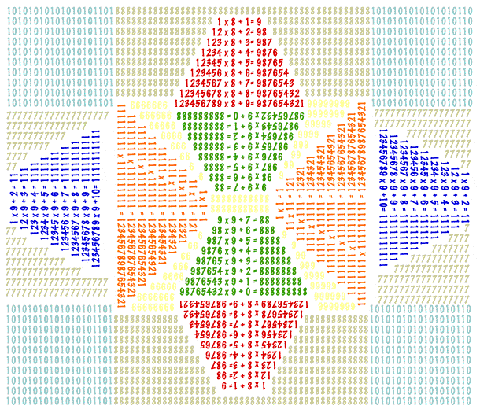

Content Connections:

Math

Technology

Art Standards: 4.3.1, 4.6.2, 4.5.1

Math: 4.OA.4

Materials:

Paper, computers, colored pencils

|  |  |
| --- | --- |
| **Art Elements** | **Art Principles** |
| __Line | _x_Pattern |
| _x_Shape/Form | _x_Rhythm/movement |
| _x_Color | _x_Proportion/Scale |
| __Value | _x_Balance |
| __Texture | __Unity |
| __Space/Perspective | __Emphasis |

Grade: 5th

Time: 3 sessions

Preparation:

Student need to know their multiplication facts.

Vocabulary: pattern

I Cans

I can multiply by more than single digits.

I can use math facts to create a design.

Lesson description:

Some artists have used numbers in their art. Artists such as [Charles Demuth](http://www.amazon.com/gp/product/B0027Z8JYK?ie=UTF8&tag=incredibleart-20&linkCode=as2&camp=1789&creative=9325&creativeASIN=B0027Z8JYK) andhttp://www.assoc-amazon.com/e/ir?t=incredibleart-20&l=as2&o=1&a=B0027Z8JYK [Robert Indiana](http://www.amazon.com/gp/product/B000UIBOJS?ie=UTF8&tag=incredibleart-20&linkCode=as2&camp=1789&creative=9325&creativeASIN=B000UIBOJS)http://www.assoc-amazon.com/e/ir?t=incredibleart-20&l=as2&o=1&a=B000UIBOJS use large numbers in several of their paintings. There is another way to use numbers. You can use numbers to create geometric shapes and other designs. See the examples below:

Teacher Background Knowledge

Lesson

Some mathematical equations create symmetry and repetition. If you multiply a number by eight and multiply and add numbers in increments, you get an interesting answer (see above top). As you add more numbers, the shape becomes triangular and the numbers repeat themselves. There are several other number shapes that can be created (see below). You can have students solve the problems themselves to create the shapes or you can simply show these examples on a white board or overhead.

9 x 9 + 7 = 88  
98 x 9 + 6 = 888  
987 x 9 + 5 = 8888  
9876 x 9 + 4 = 88888  
98765 x 9 + 3 = 888888  
987654 x 9 + 2 = 8888888  
9876543 x 9 + 1 = 88888888  
98765432 x 9 + 0 = 888888888  
  
1=1  
1 x 1 = 1  
11 x 11 = 121  
111 x 111 = 12321  
1111 x 1111 = 1234321  
11111 x 11111 = 123454321  
111111 x 111111 = 12345654321  
1111111 x 1111111 = 1234567654321  
11111111 x 11111111 = 123456787654321  
111111111 x 111111111 = 12345678987654321

After students practice with the problems for a time, tell them that they are going to take those same problems to create a geometric work of art. Only numbers may be used in creating the art. They don't necessarily need to have only the problems above. A rectangle could include all 0's for example.

Students will then lightly draw their numbers on their 18" x 24" paper with a pencil. Once they are sure they have the design they want, they may then color over the lines with either thin tipped markers or colored pencils. This lesson can also coincide with a lesson on pattern and repetition in art.

Name___________________Lesson______________________

*Assessment*

|  |  |  |  |
| --- | --- | --- | --- |
| **Thumbs Down** | **Don’t Know** | **Thumbs Up** | **Assessment Question** |
|  |  |  | Did you use your personal best during this lesson? |
|  |  |  | Did you actively listen and follow directions? |
|  |  |  | Did you use your creativity? (is it original?) |
|  |  |  | Did you complete your project? |
|  |  |  | Did you incorporate the art media? |
|  |  |  | Does the artwork show the elements and/or principles discussed? |
|  |  |  |  |
|  |  |  |  |
|  |  |  |  |

Source

incredibleart.org